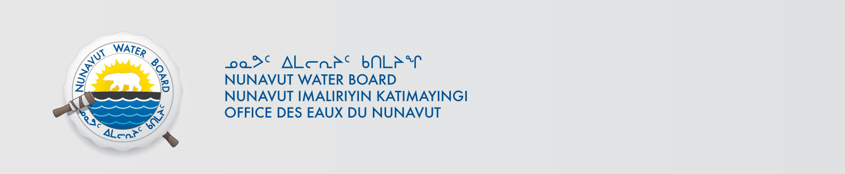

January 23, 2020 NWB File No: 2BE-ARN0507

2BE-LAU0507
Susan Ball, Geologist
Kennecott Canada Exploration Inc.
#354 – 200 Granville Street
Vancouver, BC V6C 1S4
Email: susan.ball@kennecott.com

Subject: Final Inspection – Cancellation of Licence and Closure of NWB Files

Dear Ms. Ball:

On March 08, 2013 and January 21, 2015 the Nunavut Water Board (NWB) received recommendation from Crown Indigenous Relations and Northern Affairs Canada (CIRNAC) covering the above noted files recommending closure of the files as there are no outstanding reclamation issues associated with the projects. Further, there are no outstanding NWB administrative matters that require attention.

In accordance with section 43.(i)(c) of the Nunavut Waters and Nunavut Surface Rights Tribunal Act (NWNSRTA), the Board may cancel a licence in certain specific cases.

The NWB hereby notifies all parties that the aforementioned licence is now cancelled and that the corresponding NWB file is now considered closed. Any future relevant activities on this site will require a new Water Licence or Approval Without a Licence.

Sincerely,

Richard Dwyer
Manager Licensing

Cc: Kitikmeot Kivalliq Distribution List
CIRNAC Enforcement

