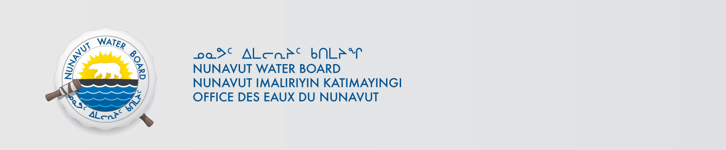
February 11, 2014 NWB File Number: 2BE-ASH0611
Robin Hopkins
VP Exploration
Unit 116 – 980 West 1st Street
North Vancouver, BC, V7P 3N4
Email: rhopkins@stornowaydiamonds.com

Subject: Request for Cancellation of Water Licence 2BE-ASH0611– Vaaldiam Mining Inc.

Dear Mr. Hopkins:

This letter acknowledges receipt on February 3, 2014 of an application from Vaaldiam Mining Inc. to cancel Water Licence 2BE-ASH0611. In accordance with Section 43(1) (c) of the Nunavut Waters and Nunavut Surface Rights Tribunal Act, the Nunavut Water Board (Board or NWB) may cancel a licence on application by the licensee.

The application can be obtained from our ftp site under PRUC with Username: publicPassword: registry.

To ensure this application is dealt with in a timely fashion, the NWB forwards notice of all documentation to regulators and council of the municipality(ies) most affected by the project, inviting interested parties to make representation directly to the NWB within 30 days from the date of this letter. The NWB may provide additional procedural instructions once the application has been reviewed by interested parties.

The Board further requests that Aboriginal Affairs and Northern Development Canada advise the Board when a final site inspection is complete. At that time the Board will make a determination on the Application.

Sincerely,

Original signed by:

Robin Ikkutisluk
Licence Administrator Assistant

Cc: Distribution - Kitikmeot

