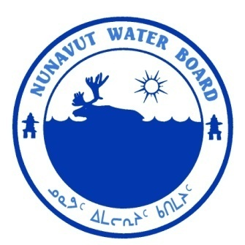  P.O. Box 119 | kNK5 wmoEp5 vtmp5
Gjoa Haven, NU X0B 1J0 | NUNAVUT WATER BOARD
Tel: (867) 360-6338 | NUNAVUT IMALIRIYIN KATIMAYIT
Fax: (867) 360-6369 | OFFICE DES EAUX DU NUNAVUT

File: 2BE-BAF1116/TR/B2, H2, I2

August 10, 2012

Saz Yaqzan
Burnstone Ventures Inc.
Suite 800-1199 West Hastings,
Vancouver BC, V6E 3TS
E-mail: GeotargetConsulting@gmail.com

Subject: Licence No. 2BE-BAF1116 “North Central Baffin (Erichsen Lake) Project”, Burnstone Venture Inc.
Submission of the 2011 Annual Report and up to date Spill Prevention and Response, and Abandonment and Restoration Plans

Dear Ms. Yaqzan:

The Nunavut Water Board (“NWB”) received on July 3, 2012 the 2011 Annual Report for the above-mentioned project. The following documents were included with the annual report:

- Up to date Spill Prevention and Response Plan; and
- Up to date Abandonment and Restoration Plan.

The submissions were found to be meeting the reporting requirements of licence 2BE-BAF1116.

Should you have any questions, please feel free to contact the undersigned at (867) 360-6338 or k.kharatyan@nunavutwaterboard.org, at your earliest convenience.

Yours truly,

Original signed by:

Karén Kharatyan
Technical Advisor

cc: Distribution List – Qikiqtani

