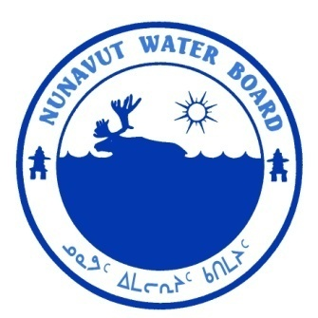  P.O. Box 119 | kNK5 wmoEp5 vtmp5
Gjoa Haven, NU X0B 1J0 | NUNAVUT WATER BOARD
Tel: (867) 360-6338 | NUNAVUT IMALIRIYIN KATIMAYIT
Fax: (867) 360-6369 | OFFICE DES EAUX DU NUNAVUT

File: 2BE-BEL1114/TR/B2, H2, I2

June 19, 2012

Gordon McKinnon
Canadian Orebodies Inc.
3130 Airport Road, Box 1130
Timmins, ON P4N 7H9
E-mail: gordmckinnon@gmail.com

Subject: Licence No. 2BE-BEL1114 “Belcher Islands Project”, Canadian Orebodies Inc.; Submission of the 2011 Annual Report and Addendums to Spill Contingency and Abandonment and Restoration Plans.

Dear Mr. McKinnon:

The Nunavut Water Board (“NWB”) received on March 28, 2012 the 2011 Annual Report for the above-mentioned project. The following documents were included with the annual report:

- 2011 Water Usage Summary;
- Addendum to Spill Contingency Plan ; and
- Addendum to Abandonment and Restoration Plan.

The submissions were found to be meeting the reporting requirements of licence 2BE-BEL1114.

Should you have any further questions, please feel free to contact the undersigned at (867) 360-6338, at your earliest convenience.

Yours truly,

Original signed by:

Karén Kharatyan
Technical Advisor

cc: Distribution List – Qikiqtani

