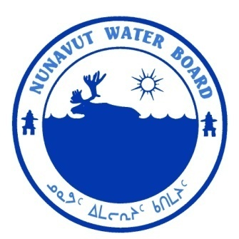  P.O. Box 119 | kNK5 wmoEp5 vtmp5
Gjoa Haven, NU X0B 1J0 | NUNAVUT WATER BOARD
Tel: (867) 360-6338 | NUNAVUT IMALIRIYIN KATIMAYIT
Fax: (867) 360-6369 | OFFICE DES EAUX DU NUNAVUT

File: 2BE-BUG0712
July 19, 2011

Mr. Paul Pitman
UR-Energy Inc.
341 Main Street, Suite 206
Brampton, ON L6X 3C7

Email: pwpconsulting@bellnet.ca

Subject: Licence No. 2BE-BUG0712 “Bugs Project”, Kivalliq Region, Nunavut; Cancellation of the Licence

Dear Mr. Pitman:

On December 22, 2010, the Nunavut Water Board (“NWB or Board”) received from UR-Energy Inc. an application to cancel the water licence for the above-mentioned project, located 340 kilometers east-southeast of Arviat in the Kivalliq Region of Nunavut. On March 1, 2011, the Board distributed the application for a thirty day comment period. Before the deadline for comments, submissions were received from Environment Canada (EC) and from Indian and Northern Canada (INAC). EC expressed no objections to the cancellation of the licence. INAC Waters Resources recommended that the licence not be cancelled / closed until INAC provides confirmation that no compliance issues associated with the project are outstanding.

On July 06, 2011, INAC Field Operations Section informed the NWB that the file may be approved for closure. Upon review of all information, NWB determined that the application fulfills the requirements of s. 43(1)(c) of Nunavut Waters and Nunavut Surface Rights Tribunal Act (Act) and NWB Guide 7. The NWB has, therefore, approved the application for water licence cancellation through Board Motion No. 2011-11-L04, dated July 19, 2011.

Should you have any questions, please feel free to contact the Board at (867) 360-6338 or licensing@nunavutwaterboard.org, at your earliest convenience.

Sincerely,
Thomas Kabloona
Nunavut Water Board
Chair

TK/kk
cc: Distribution – Kivalliq

Environment Canada (EC), March 4, 2011 and Indian and Northern Affairs Canada (INAC), March 28, 2011.
The s. 43(1)(c) indicates when the Board may cancel a licence.
The minimum information requirements set out in the NWB Guidance Document- Guide 7 – Licensee Requirements Following the Issuance of a Water Licence, April 2010, see Part 11 and Table 4.

