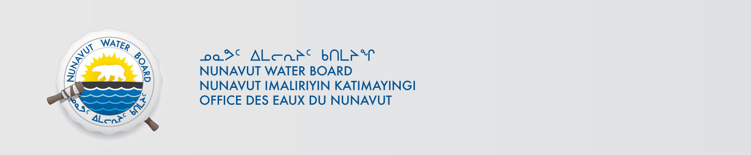

February 19, 2018 NWB File No: 2BE-CHI1218

David Willis, Manager Lands
Peregrine Diamonds Ltd.
Suite 564-999 Canada Place
Vancouver BC V6C 3E1
E-mail: dave@pdiam.com

Subject: 2BE-CHI1218 Water Licence Renewal Chiliak Project

Dear Mr. Willis:

The Nunavut Water Board (“NWB”) acknowledges receipt on January 30, 2018 of your renewal water licence application, for the Chidliak Project. This application has been assigned file number 2BE-CHI1218. Please refer to this number on future submissions. Application documents received are as follows:

180130 2BE-CHI1218 Map 1 - Project Location Map-ILAE.pdf
180130 2BE-CHI1218 Map 2 - Project Area Map-ILAE.pdf
180130 2BE-CHI1218 Map 3 - Permitted Locations-ILAE.pdf
180130 2BE-CHI1218 Map 4 - Permitted Locations with Satellite Imagery-ILAE.pdf
180130 2BE-CHI1218 Renewal Cover Letter-ILAE.pdf
180130 2BE-CHI1218 Schedue 1 - Critical Locations & Coordinates-ILAE.pdf
180130 2BE-CHI1218 Schedule 10 - Corporate Certificates-ILAE.pdf
180130 2BE-CHI1218 Schedule 11 - Environmental Baseline Studies-ILAE.pdf
180130 2BE-CHI1218 Schedule 12 - English Summary-ILAE.pdf
180130 2BE-CHI1218 Schedule 14 - Spill Contingency Plan-ILAE.pdf
180130 2BE-CHI1218 Schedule 15 - Abandonment and Restoration Plan-ILAE.pdf
180130 2BE-CHI1218 Schedule 16 - Remote Camp Questionarie-ILAE.pdf
180130 2BE-CHI1218 Schedule 2 - Letter From NPC dated January 5, 2018-ILAE.pdf
180130 2BE-CHI1218 Schedule 3 - Chidliak NWB Licence History-ILAE.pdf
180130 2BE-CHI1218 Schedule 4 - List of Authorized Activities-ILAE.pdf
180130 2BE-CHI1218 Schedule 5 - Waste Management Plan-ILAE.pdf
180130 2BE-CHI1218 Schedule 6 - Potential Environmental Impacts-ILAE.pdf
180130 2BE-CHI1218 Schedule 7 - Consultation Catalogue-ILAE.pdf
180130 2BE-CHI1218 Schedule 8 - Security Information-ILAE.pdf
180130 2BE-CHI1218 Schedule 9 - Financial Statements-ILAE.pdf
180130 2BE-CHI1218 Water Licence Renewal Application-ILAE.pdf
180206 2BE-CHI1218 application fee receipt-ILAE.pdf
180217 2BE-CHI1218 Schedule 13 - Inuktitut Summary-ILAE.pdf
Please be advised that under the Agreement Between the Inuit of the Nunavut Settlement Area and Her Majesty the Queen in Right of Canada (Nunavut Agreement) Article 11, Section 11.5.9 and s. 76 (1) of Nunavut Planning and Project Assessment Act (NuPPAA), the proponent of a project governed by NuPPAA is also required to submit a project proposal document (which may include the water licence application) directly to the Nunavut Planning Commission (NPC or Commission) for the NPC’s determination regarding the applicable land use planning requirements and/or directions regarding whether the project is subject to screening by the Nunavut Impact Review Board. In particular, please note that as established under Articles 11, 12 and 13 of the Nunavut Agreement, NuPPAA and Part 3 of the Nunavut Waters and Nunavut Surface Rights Tribunal Act, until the project has completed the applicable land use planning and assessment process required by the NPC and the NIRB, the NWB cannot issue a water licence.

The NWB confirms receipt of NPC conformity under NuPPAA on January 5, 2018 and NIRB determination through NPC under NuPPAA on January 5, 2018. This application is now ready for review and comments. Deadline for submissions is March 21, 2018.

Please call the undersigned at (867) 360-6338 or email to licensing@nwb-oen.ca if you have any questions.

Sincerely,

Richard Dwyer

Licence Administrator

Copy Qikiqtani Distribution List

