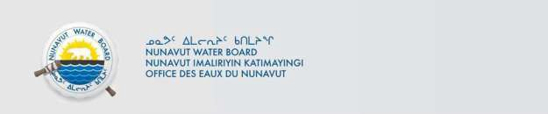
NWB File No: 2BE-CHI2333

March 05, 2026

Chad Corson
De Beers Canada Inc. 1601 Airport Road NE Suite 300
Calgary, Alberta T2E 6Z8

E-mail: Chad.Corson@debeersgroup.com

Re: Acknowledgement and Receipt of Water Use Fee for water licences 2BE-CHI2333

Dear Mr. Corson:

The Nunavut Water Board acknowledges receipt on March 05, 2026 of your credit card information for water use fee payments. Your information for payments has been forwarded to Crown Indigenous Relations and Northern Affairs Canada in Iqaluit for processing.

- 2BE-CHI2333 $1091.25 2025 water use fee

A receipt will be issued through their office for fees totaling $1091.25

Please refer to the calculation for water use fees, in the Nunavut Waters Regulations, Section 12, to ensure that the correct fee has been submitted. A copy of this regulation is available from our ftp site or by contacting this office. This is an annual fee which is required to be submitted yearly on the anniversary of the issuance of your water licence.

Please call the undersigned at (867) 360-6338 or e-mail licensing@nwb-oen.ca if you have any questions.

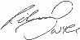
Sincerely,
Richard Dwyer

Cc: Andrew Keim, CIRNAC Margaret Mike, CIRNAC CIRNA Inspectors

