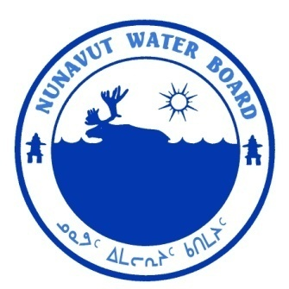  P.O. Box 119 | kNK5 wmoEp5 vtmp5
Gjoa Haven, NU X0B 1J0 | NUNAVUT WATER BOARD
Tel: (867) 360-6338 | NUNAVUT IMALIRIYIN KATIMAYIT
Fax: (867) 360-6369 | OFFICE DES EAUX DU NUNAVUT

File: 2BE-CHI0813/F10
January 29, 2013

David Willis
Peregrine Diamonds Ltd.
201 – 1250 Homer ST.
Vancouver, BC V6B 1C6

Email: dave@pdiam.com

Subject: Licence No. 2BE-CHI0813 “Chidliak Project” Qikiqtani Region, Nunavut – Peregrine Diamonds Ltd.; Submission of the Trenching Plan

Dear Mr. Willis:
The Nunavut Water Board (“NWB”) has completed a technical review of the Trenching Plan for the above-mentioned project, which was received on December 7, 2012 as a requirement of Part F, Item 10 of water licence 2BE-CHI0813.
The submission is available on the NWB’s ftp-site at the following link: ftp://nunavutwaterboard.org/1%20PRUC/2%20MINING%20MILLING/2B/2BE%20-%20Exploration/2BE-CHI0813%20Peregrine/3%20TECH/11%20DRILLING%20(F)

The Trenching Plan was distributed for fifteen (15) day comment period on January 8, 2013, and comments were received from Aboriginal Affairs and Northern development Canada (AANDC) on January 23, 2013 that expressed no concerns with the planned activities.

NWB technical review determined that the Plan fulfills the requirements of Part F, Item 10 of Licence 2BE-CHI0813. The NWB has, therefore, approved the plan through Board Motion No. 2012-B1-015, dated January 28, 2013.

Should you have any questions, please feel free to contact the undersigned at 867-360-6338 ext. 30 or by email at k.kharatyan@nunavutwaterboard.org.

Yours truly,

Original signed by:

Karén Kharatyan
Technical Advisor

cc: Distribution List – Qikiqtani

