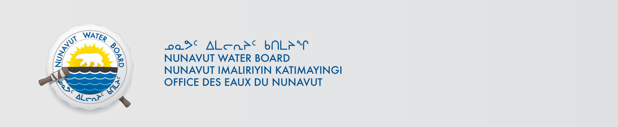

August 12, 2021 NWB File No: 2BE-COP1721

Mark Gibson
Tundra Copper Corporation (a subsidiary of Kaizen Discovery Ltd.
654-999 Canada Place
Vancouver BC V6C 3E1
E-mail: mark@kaizendiscovery.com

Subject: Application Acknowledgement for the Coppermine Project, Coppermine River Area

Dear Cathy Fitzgerald:

The Nunavut Water Board (“NWB”) acknowledges receipt on May 10, 2021 of renewal water licence application, for the Coppermine Project, Coppermine River Area. This application has been assigned file number 2BE-COP1721. Please refer to this number in future submissions. Application documents received are as follows:

- 210510 Figure 1_Coppermine_Claims and DDH_20210506
- 210510 Figure 2_Coppermine_TKW_claims_50K_20210507
- 210510 Figure 3_Coppermine_TKE_claims_50K_20210507
- 210510 Figure 4_Coppermine_RML_claims_50K_20210507
- 210510 Item 22a_Tundra Certificate of Incorporation and Name Change
- 210510 Item 22b_Certificate of Registration Nunavut ET10247
- 210510 Item 2_NPC_Authorization letter_20210427
- 210510 Item 7_2021-05-06-NPC #149531-Coppermine Decision
- 210510 Item 8 _NIRB Screening Decision
- 210510 Item 9 - Description of Undertaking
- 210510 Item23b_2015-05-01-COP_ Wildlife and Environmental Mitigation Plan v2
- 210510 Item23c_TUNDRA COPPER CORP FUEL SPILL CONTINGENCY PLAN_2021
- 210510 Water Licence Renewal Application
- 210810 Annual Water Use Report and Fee
- 210810 FUEL SPILL CONTINGENCY PLAN_2021

Please be advised that under the Agreement Between the Inuit of the Nunavut Settlement Area and Her Majesty the Queen in Right of Canada (Nunavut Agreement) Article 11, Section 11.5.9 and s. 76 (1) of Nunavut Planning and Project Assessment Act (NuPPAA), the proponent of a project governed by NuPPAA is also required to submit a project proposal document directly to the Nunavut Planning Commission (NPC or Commission) for the NPC’s determination regarding the applicable land use planning requirements and/or directions regarding whether the project is subject to screening by the Nunavut Impact Review Board. In particular, please note that as established under Articles 11, 12 and 13 of the Nunavut Agreement, NuPPAA and Part 3 of the Nunavut Waters and Nunavut Surface Rights Tribunal Act, until the project has completed the applicable land use planning and assessment process required by the NPC and the NIRB, the NWB cannot issue a water licence/approval.

The NWB confirms receipt of NPC conformity under NuPPAA on May 6, 2021 and NIRB determination through NPC under NuPPAA on May 6, 2021. This application is now ready for review and comments. Deadline for submissions is September 13, 2021.

Please call the undersigned at (867) 360-6338 or email to licensing@nwb-oen.ca if you have any questions.

Sincerely,

Originally Signed By:

Richard Dwyer

Copy Kitikmeot Region Distribution List

