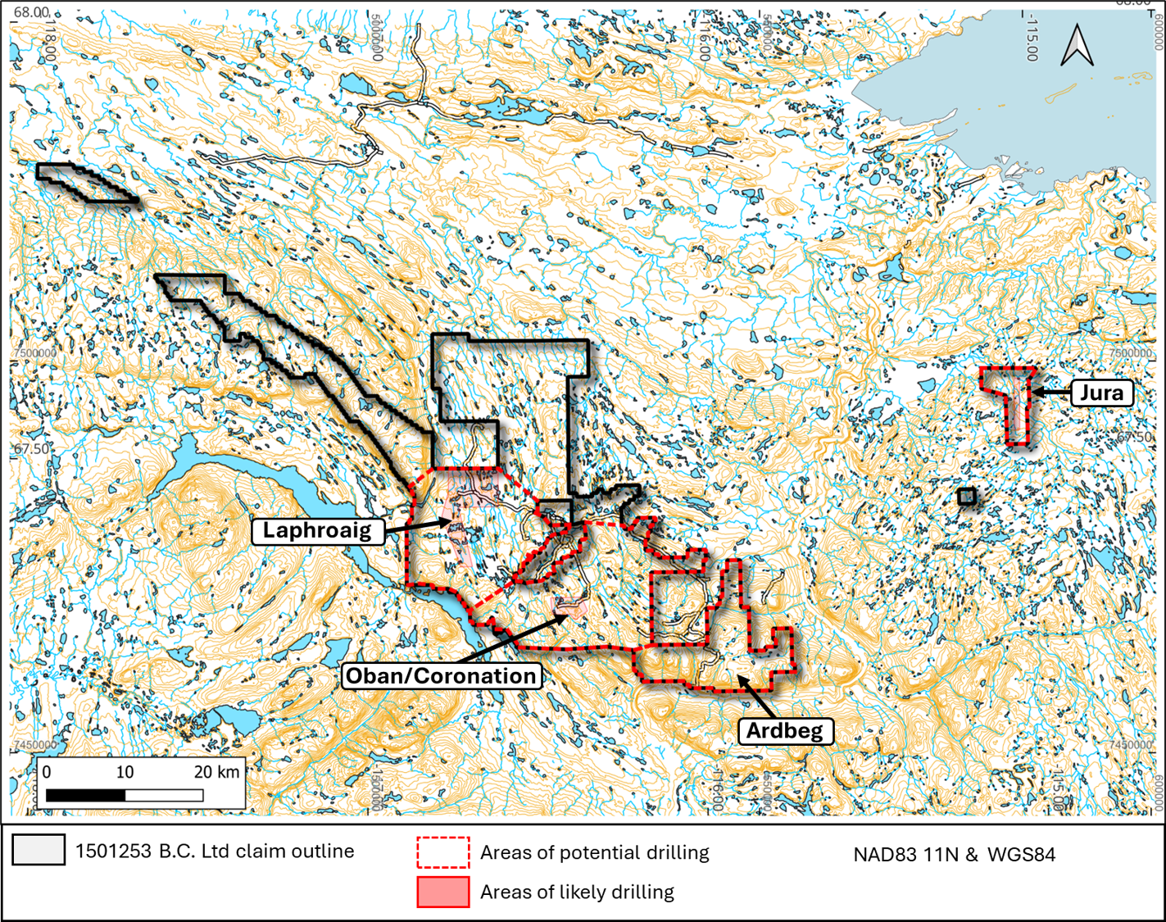
Overview. 1501253 B.C. Ltd claims and areas of likely and potential drilling, prospecting and funding dependent. Helicopter-based prospecting may take place anywhere in the Company’s claims.

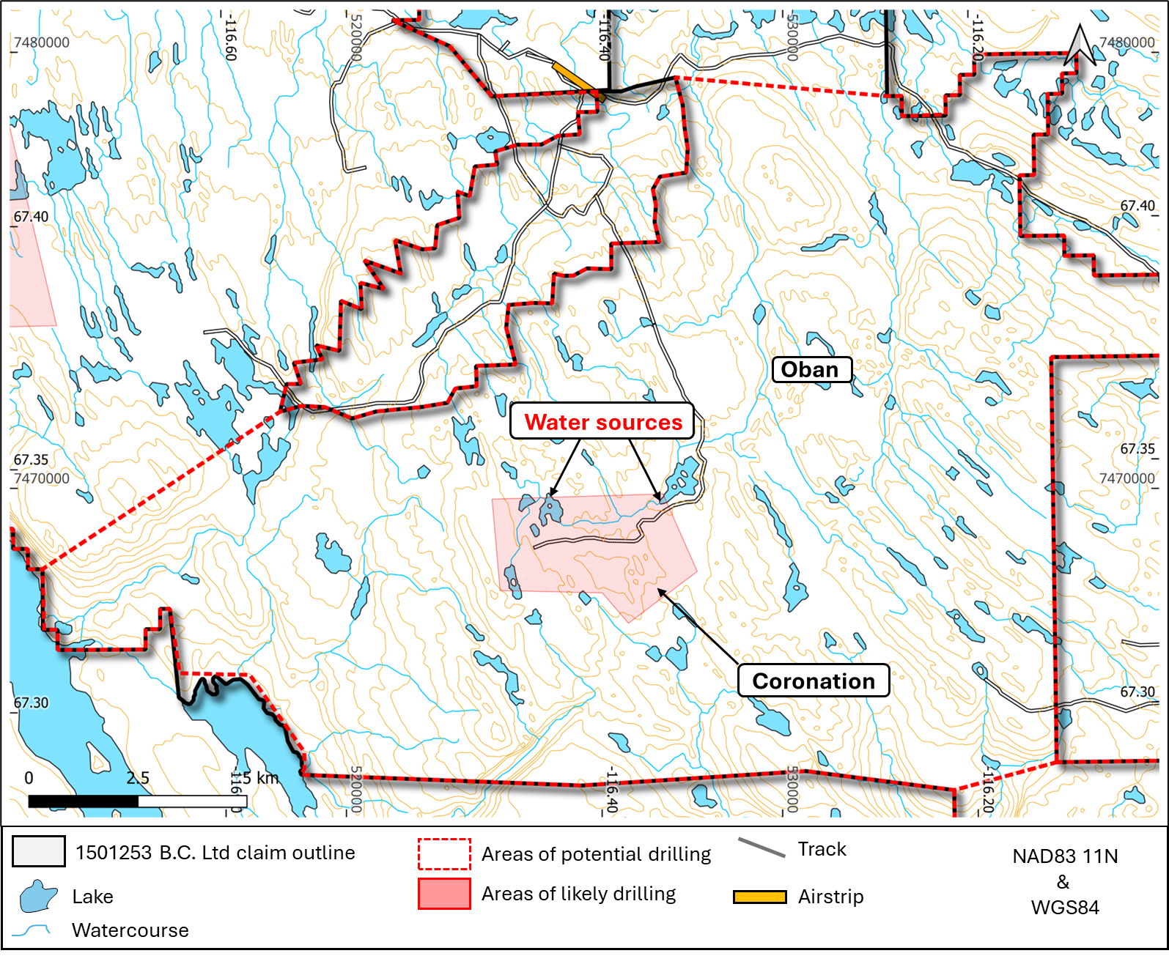
First priority. Oban district showing the Coronation prospect, where the company would like to drill approximately up to 15 short holes, prospecting and funding dependent. This sits on Inuit owned land parcels CO-54 and CO-53. The Company has an Exploration and Mining agreement in place for CO-54.
-No holes drilled within 31m of any water body
-No waste or drill water deposited into any water body
-Up to 15 holes

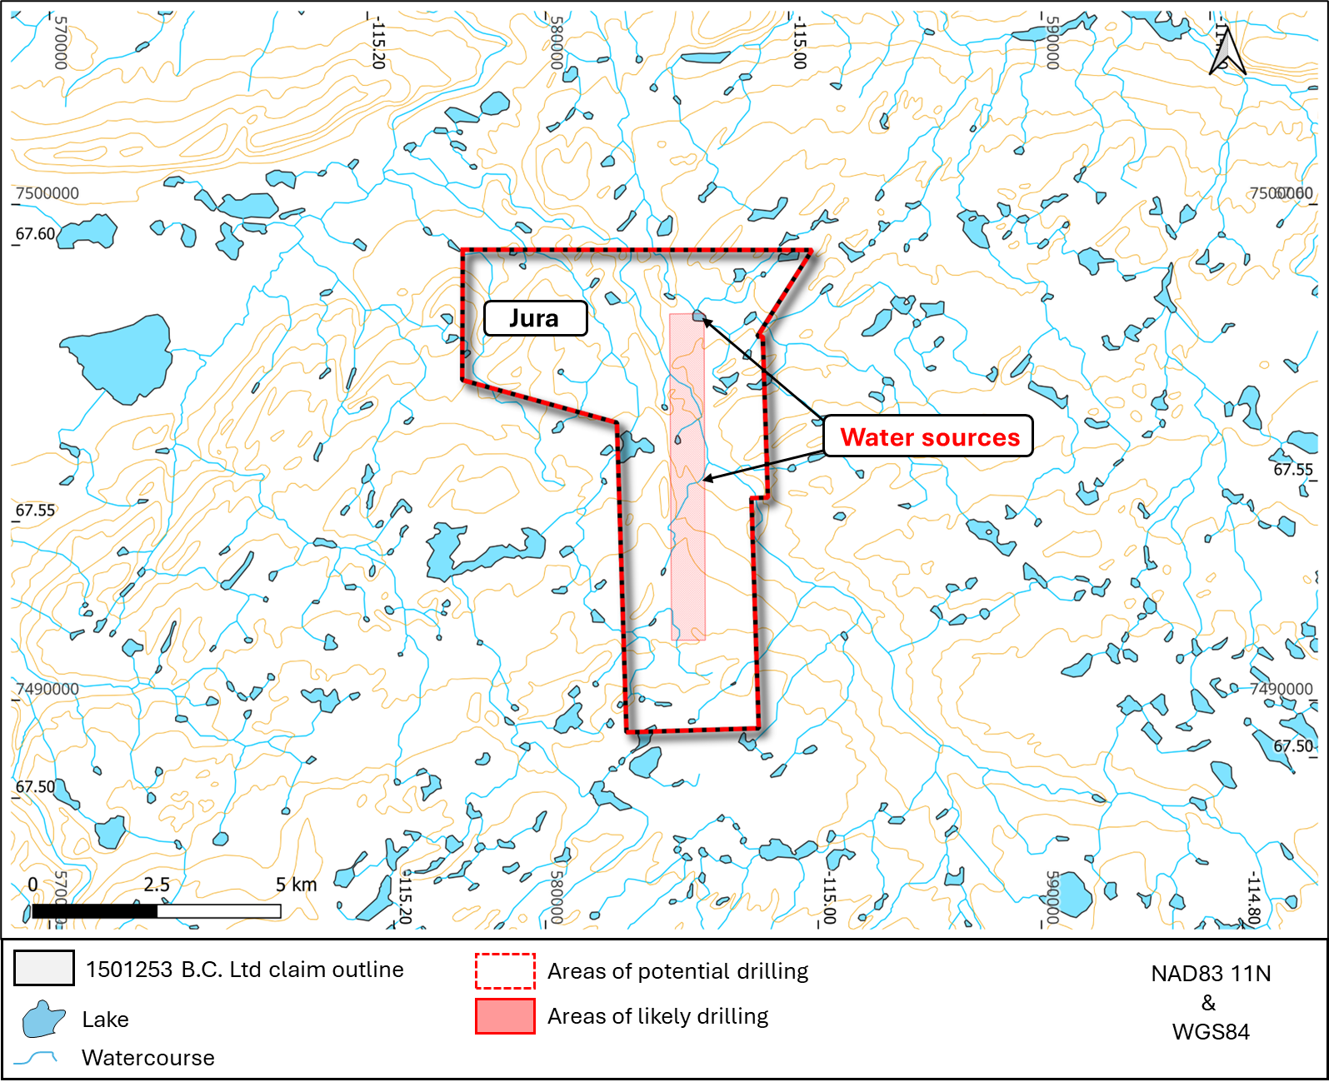
Second priority. Jura district, where the company would like to drill approximately up to 15 short holes, prospecting and funding dependent.
-No holes drilled within 31m of any water body
-No waste or drill water deposited into any water body
-Up to 15 short holes

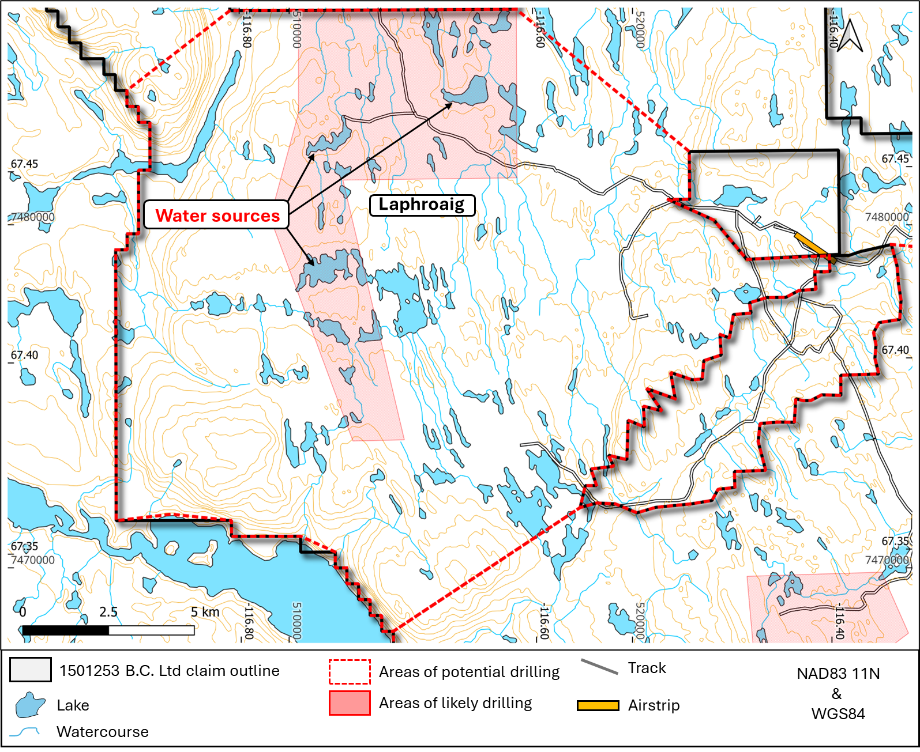
Third priority. Laphroaig district, where the company may possibly drill 1-5 holes, prospecting and funding dependent.
-No holes drilled within 31m of any water body
-No waste or drill water deposited into any water body
-Possibly 1-5 holes

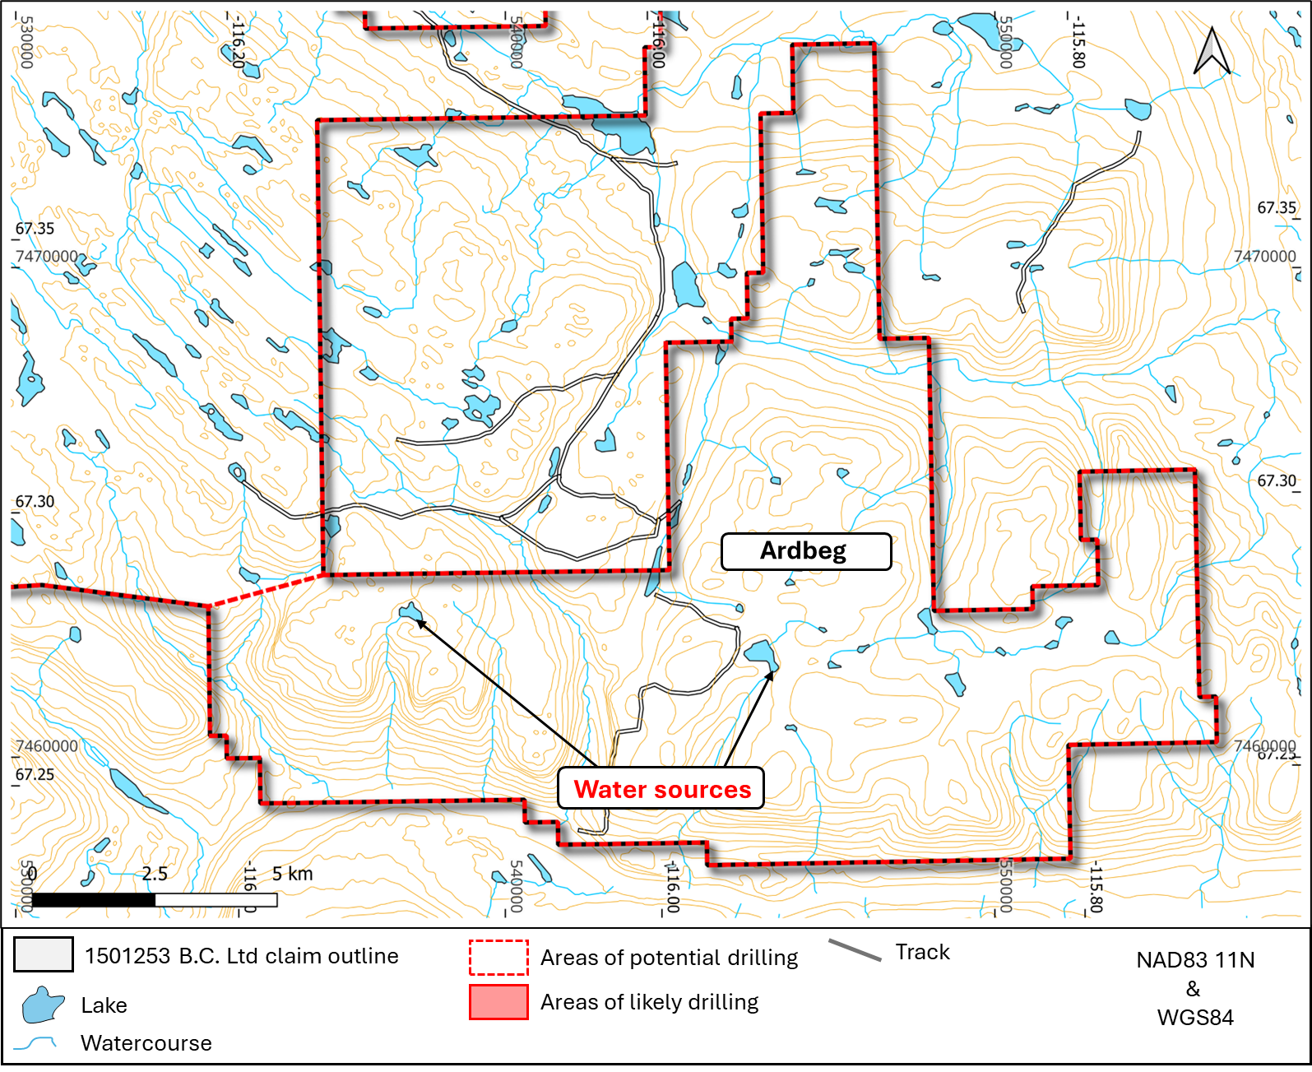
Fourth priority. Ardbeg district, where the company may possibly drill 1-2 holes.
-No holes drilled within 31m of any water body
-No waste or drill water deposited into any water body
-Possibly 1-2 holes

