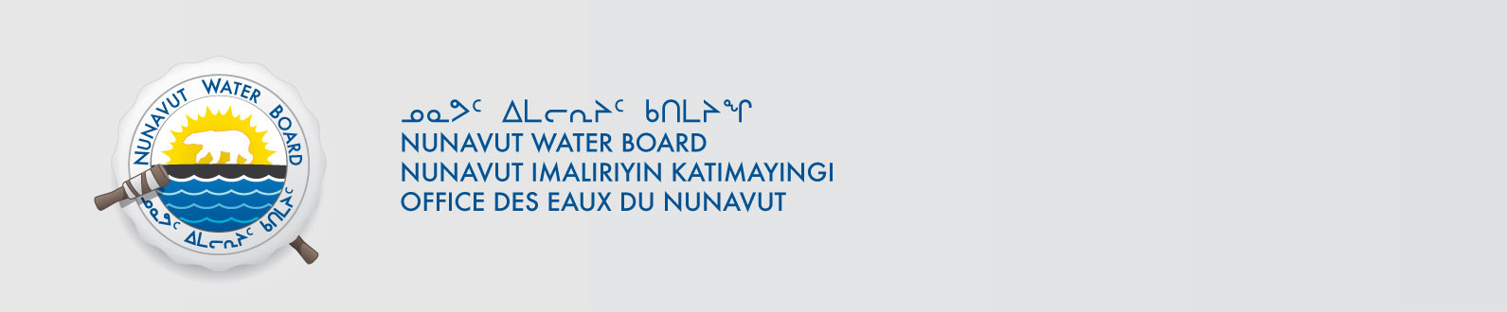

February 26, 2018 NWB File No: 2BE-CRA1520

Brian Atkinson, B.S.c., P.Geol
Exploration Manager
600-1199 West Hastings Street
Vancouver, BC V6E 3T5
E-mail: Bryan.Atkisnson@aurynresources.com

Re: Acknowledgement and Receipt of Water Use Fees for Water Licence Application –2BE-CRA1520 Kitikmeot

Dear Mr. Atkinson:

The Nunavut Water Board acknowledges receipt on February 26, 2018 of your water use fees, cheque number 000454, for the above project. Your payment has been forwarded to Indigenous and Northern Affairs Canada in Iqaluit for processing. A receipt will be issued through their office for fees totaling $1076.75 for water use fees.

Please refer to the calculation for water use fees, in the Nunavut Waters Regulations, Section 12, to ensure that the correct fee has been submitted. A copy of this regulation is available from our ftp site or by contacting this office. This is an annual fee which is required to be submitted yearly on the anniversary of the issuance of your water licence.

Please call the undersigned at (867) 360-6338 or e-mail licensing@nwb-oen.ca if you have any questions.

Sincerely,

Licence Administrator

Cc: Sarah Forté, INAC

