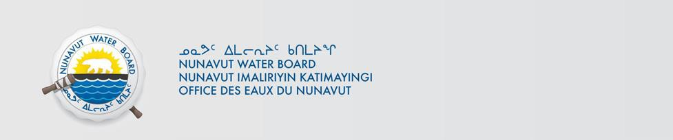

NWB File No: 2BE-CRA2025
February 13, 2023

Bryan Atkinson SVP Exploration
North Country Gold Corp
1630-1177 West Hastings Street Vancouver, BC V6E 2K3
E-mail: Bryan.Atkinson@furygoldmines.com

Re: Acknowledgement and Receipt of Water Use Fee for 2BE-CRA2025

Dear Mr. Atkinson:

The Nunavut Water Board acknowledges receipt on February 13, 2023 of your credit card information for water use fees for the above project. Your information for payment has been forwarded to Crown Indigenous Relations and Northern Affairs Canada in Iqaluit for processing. A receipt will be issued through their office for fees totaling $1076.75.

Please refer to the calculation for water use fees, in the Nunavut Waters Regulations, Section 12, to ensure that the correct fee has been submitted. A copy of this regulation is available from our ftp site or by contacting this office. This is an annual fee which is required to be submitted yearly on the anniversary of the issuance of your water licence.

Please call the undersigned at (867) 360-6338 or e-mail licensing@nwb-oen-ca if you have any questions.

Sincerely,
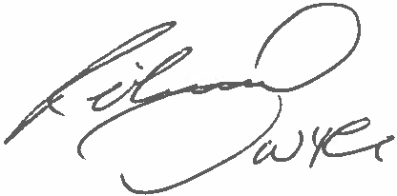
Richard Dwyer Manager Licensing

Copy Andrew Keim, CIRNAC
Napassi Joseph, CIRNAC
Annie MA North Country Gold

