 | Rescan™ Environmental Services Ltd.
 | Sixth Floor, 1111 West Hastings Street  Vancouver, British Columbia  Canada, V6E 2J3  Telephone: (604) 689-9460  Facsimile: (604) 687-4277  e-mail: rescan@rescan.com | 908 – 5201, 50th Avenue  Yellowknife, Northwest Territories  Canada, X1A 3S9  Telephone: (867) 920-2090  Facsimile: (867) 920-2015

ATTENTION: | Trevor Boyd (Canadian North Resources Dev.)
FROM: | François Landry (Project Director), Tonia Robb (Project Manager)
DATE: | August 14th, 2013
PROJECT: | Ferguson Lake Atmospherics and Water Quality
PROJECT #: | 0212259-0001
TRIP DATES: | August 6-10, 2013
PERSONNEL: | Calvin Pin (Rescan)
ASSISTANTS: | Various provided by Canadian North Resources Dev.

OBJECTIVES: | - Replace sensors on meteorological station near Ferguson Lake Camp with newly calibrated ones  - Download existing data from CR10x datalogger, replace with CR1000 datalogger and perform routine maintenance  - Conduct water quality sampling at multiple points within Ferguson Lake Camp including from the primary fuel berm and under the crushed fuel barrels  - Deliver windsock to Ferguson Lake Camp for eventual installation on airstrip
TASKS: | August 6  - Travel from Vancouver to Winnipeg  August 7  - Travel from Winnipeg to Ferguson Lake Camp  - Gathered supplies and shipments from Rankin Inlet  - Sorted and organized water quality sampling sets  August 8  - Travelled to meteorological station near Ferguson Lake Camp by helicopter  - Inspected integrity of meteorology tower and foundation  - Structural integrity of the tower was good; no signs of metal fatigue or fracture (plate 1)  - Notable wildlife damage to sensor wiring including the SPLite and NRlite probes as well as to the cooler used to store the battery. (plate 2)  - Tipping bucket rain gauge (TBRG) was knocked out of vertical alignment and the alter windscreen was dismantled (plate 3)  - Datalogger enclosure box and internal wiring were in good condition (plate 4)  - Removed existing sensors and replaced with calibrated ones (plate 5 & 6)  - Installed new CR1000 datalogger and battery (plate 7)  - Download of existing data from CR10x datalogger was unable to be completed on-site therefore the CR10x datalogger was shipped to the Rescan’s Vancouver office for more extensive analysis  August 9  - Deployed portable water pump within fuel berm to evacuate water  - Containment area water level was approximately at half of the overall capacity (plate 8)  - Sampled water at four points within the fuel berm  - Site 1: East side of fuel berm (plate 9)  - No visible sheen on surface of water  - No noticeable odour  - Pumped water does not appear to have any visible suspended solids  - Site 2 : Center area of fuel berm (plate 10)  - No visible sheen on surface of water  - No noticeable odour  - Pumped water does not appear to have any visible suspended solids  - Note: Maintenance worker may have caused minor perturbation of the sediment on the bottom of the fuel berm holding area upon moving pump equipment  - Site 3: North side of fuel berm (plate 11)  - No visible sheen on surface of water  - No noticeable odour  - Pumped water does not appear to have any visible suspended solids  - Site 4: West side of fuel berm (plate 12)  - No visible sheen on surface of water  - No noticeable odour  - Pumped water does not appear to have any visible suspended solids  - Fuel berm containment area appears to be well built and there are no signs of embankment erosion or geotextile shearing (plate 13)  - Sampled water from under crushed fuel barrels on eastern side of Ferguson Lake Camp (plate 14)  - Visible sheen of fuel on surface of water  - Noticeable amber color of water likely caused by the rusting fuel barrels (plate 15)  - Minor fuel smell originating from crushed fuel barrel area  August 9  - Shipped water quality samples and previous meteorology sensors to Vancouver for further processing and analysis  Travelled from Ferguson Lake Camp to Vancouver
Summary: | - Visited Ferguson Lake meteorological station and swapped sensors for newly calibrated ones as well as replaced the battery  - Replaced CR10x datalogger with upgraded CR1000 datalogger  - Performed routine maintenance on meteorological station  - Conducted water quality testing at various sites within Ferguson Lake Camp  - Delivered windsock to Ferguson Lake Camp for eventual installation on airstrip

Site | UTM (NAD83)
Ferguson Lake Meteorological Station | 14V 0603920 6975829
Ferguson Lake Camp | 14 V 0606540 6975336

Locations

Plates
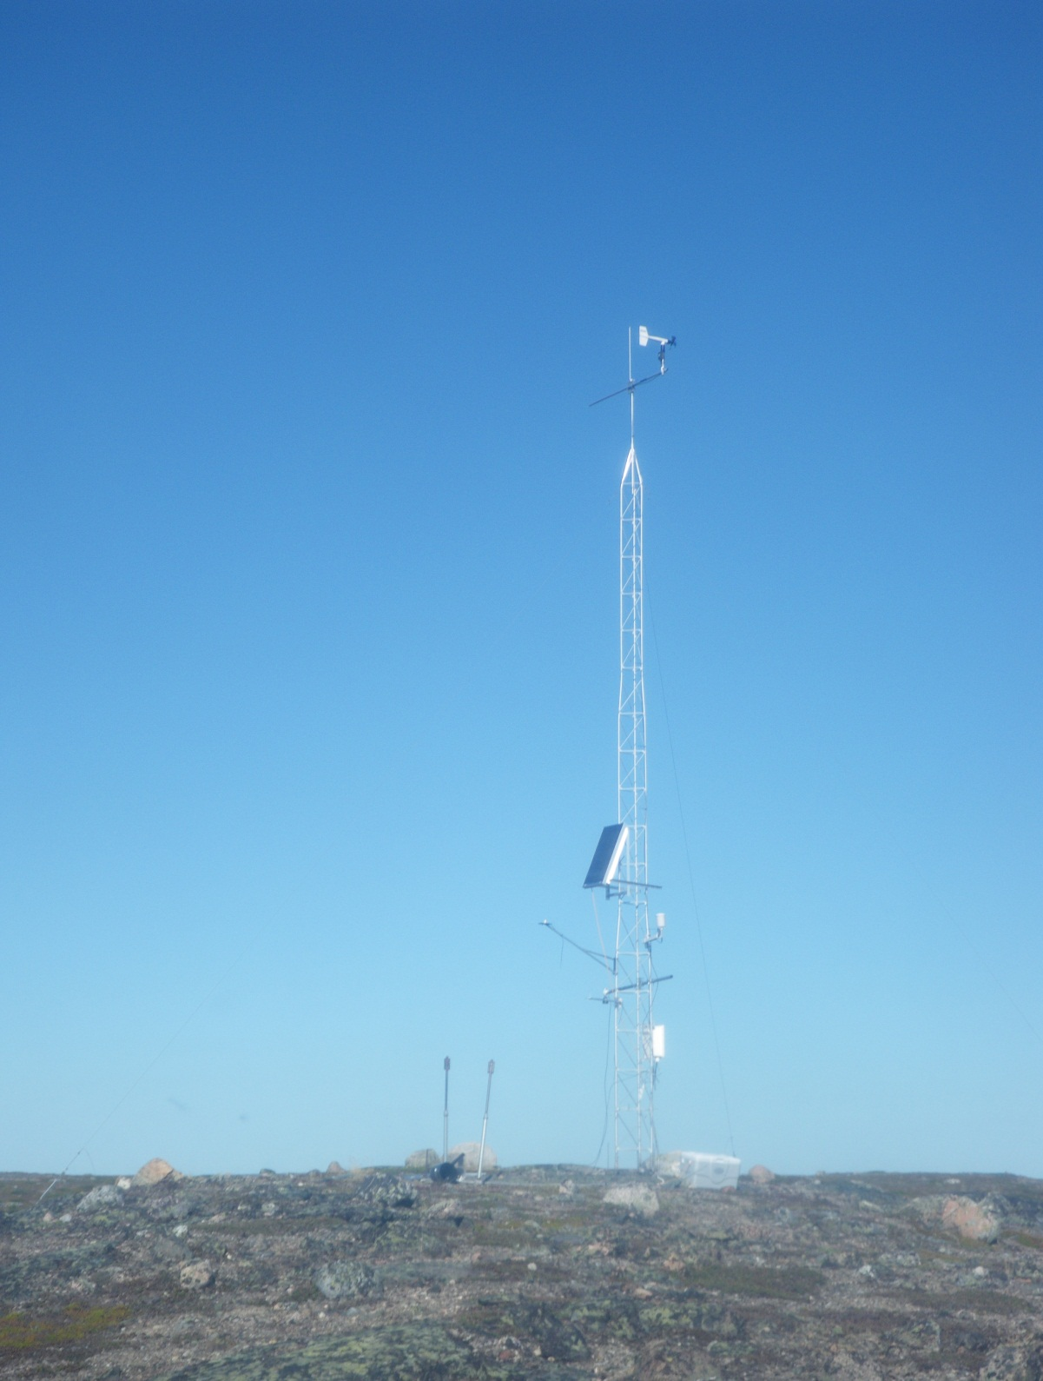
Plate 1. Ferguson Lake meteorological tower

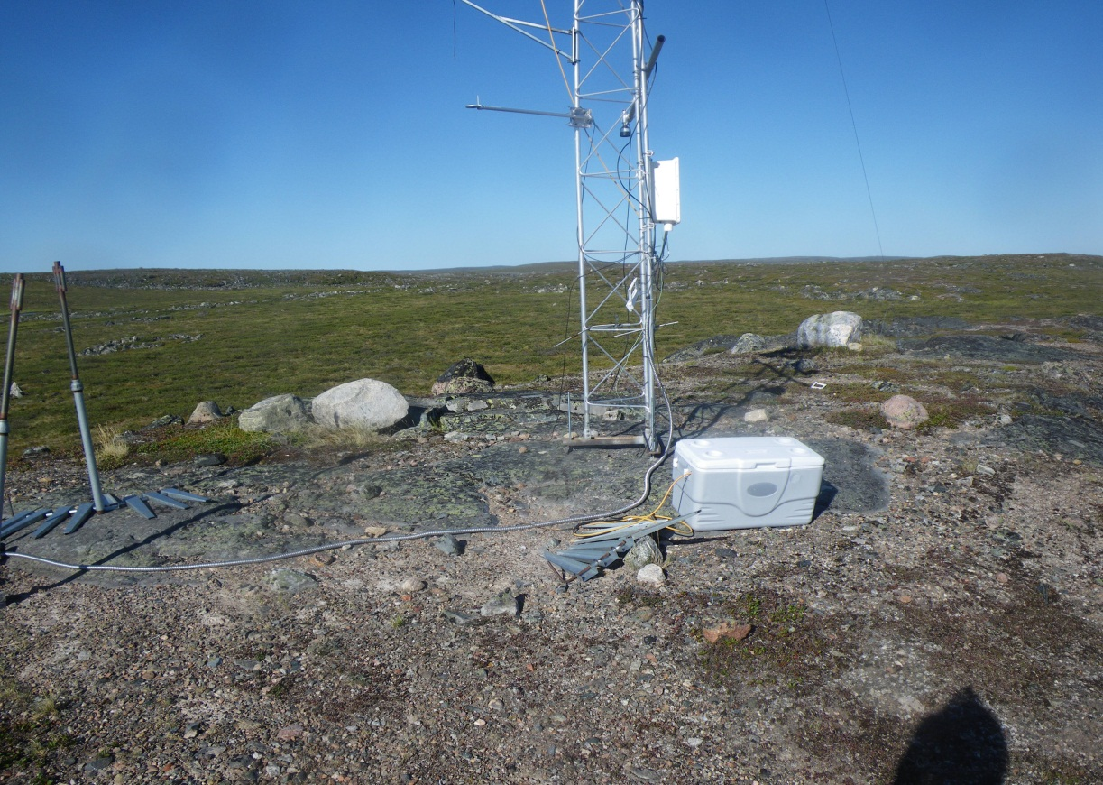

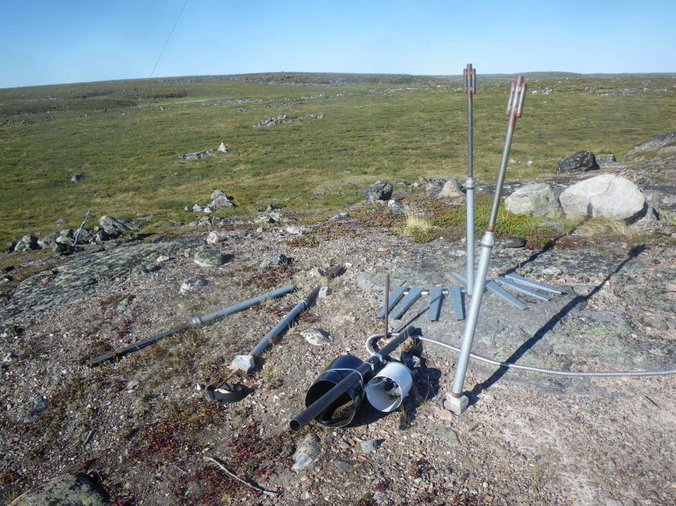
Plate 2. Meteorological tower with battery cooler knocked over onto the ground and wires dangling from multiple sensors

Plate 3. TBRG knocked over on to the ground likely caused by wildlife activity

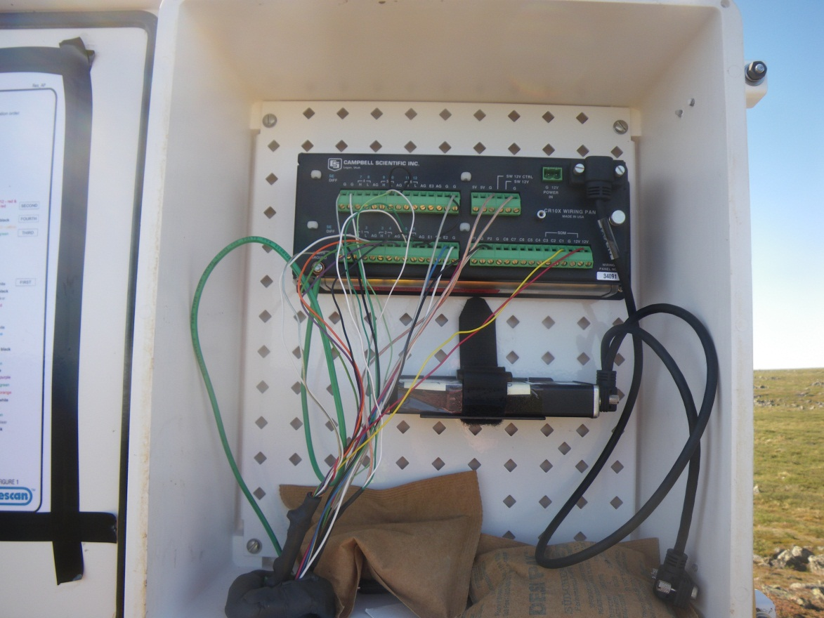

Plate 4. CR10X and datalogger enclosure
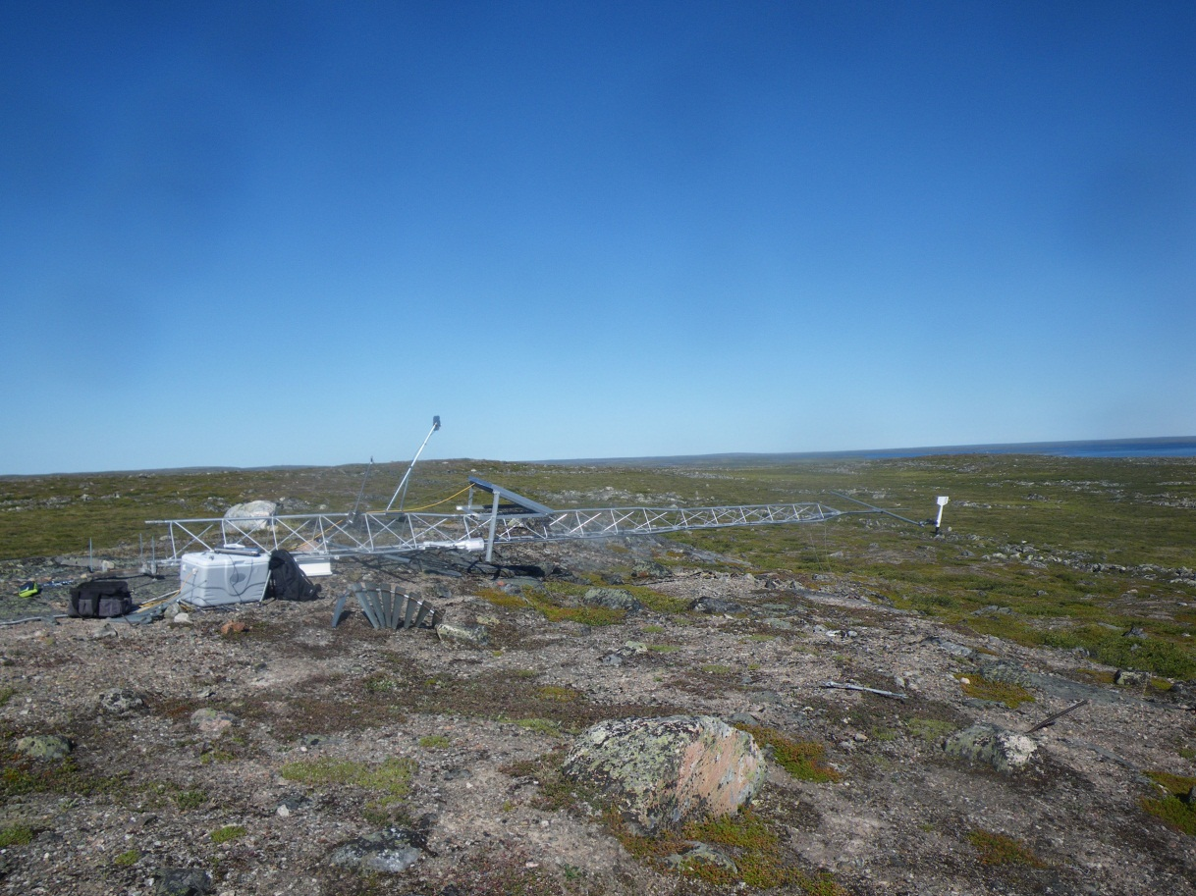

Plate 5. Installation of new sensors facilitated by lowering the meteorological tower
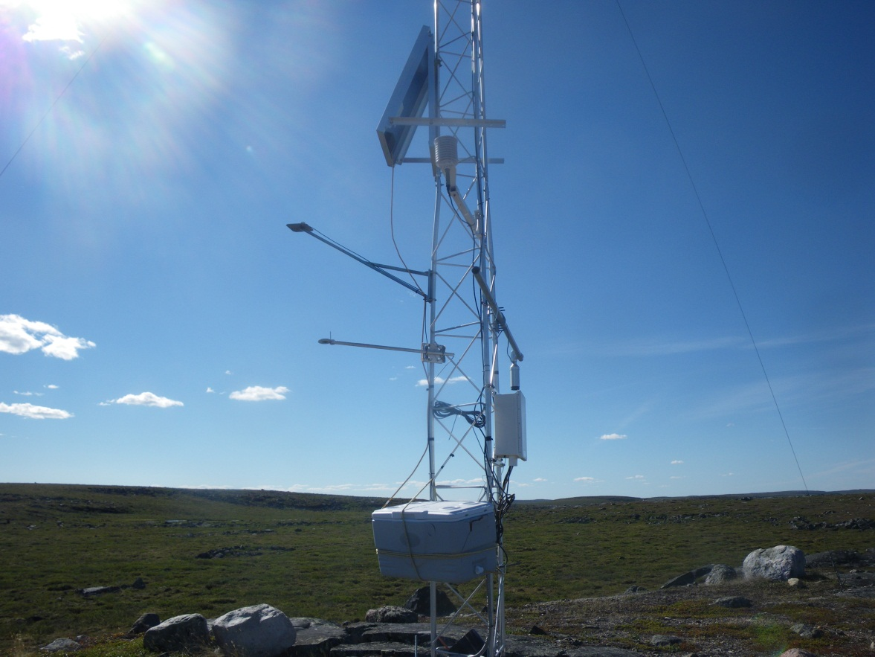

Plate 6. Picture of recently swapped meteorological sensors installed on tower
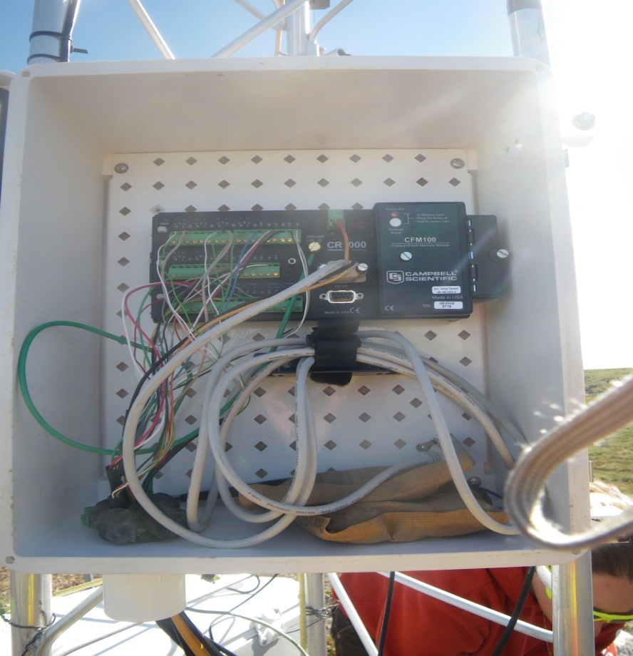

Plate 7. Newly installed CR1000 data logger with CF card reader attachment
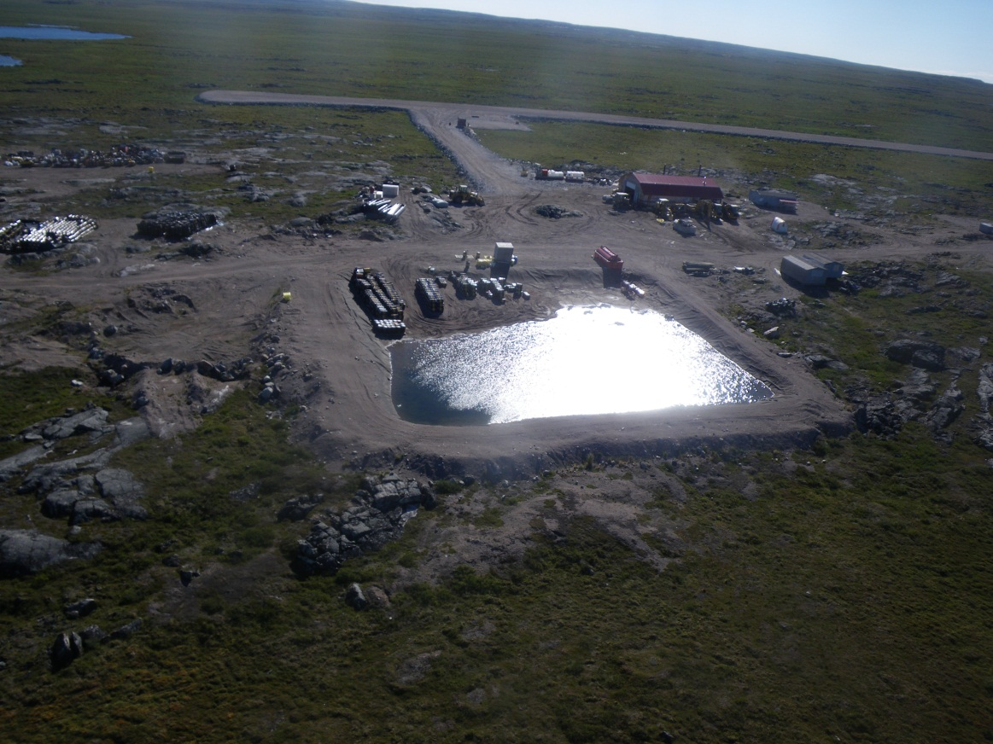

Plate 8. Fuel berm containment area aerial shot
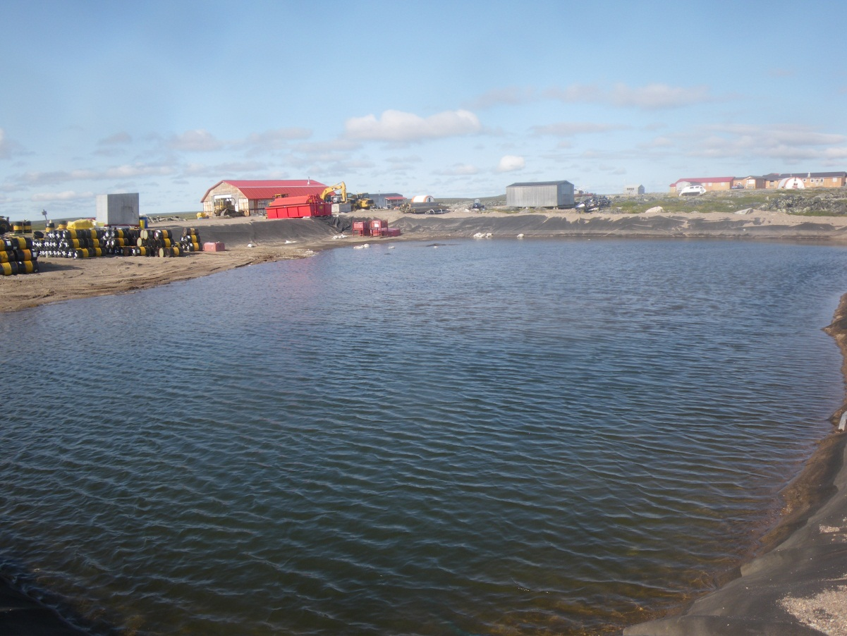

Plate 9. Fuel berm containment area taken from east bank
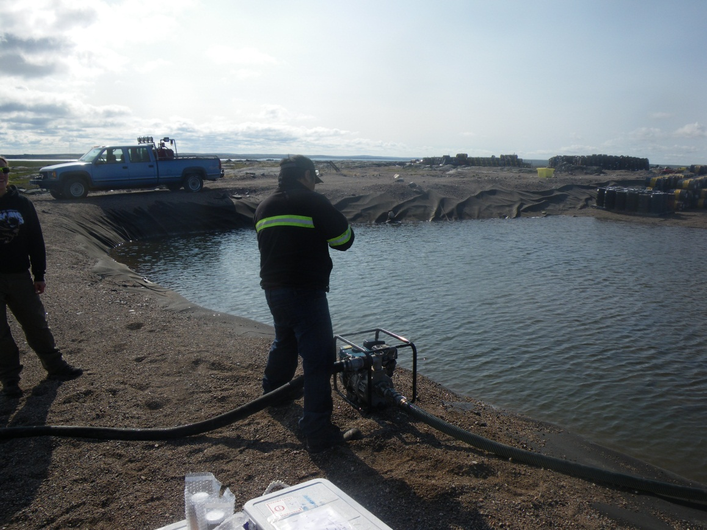

Plate 10. Maintenance worker setting up pump at the center of the northern edge of the fuel berm area
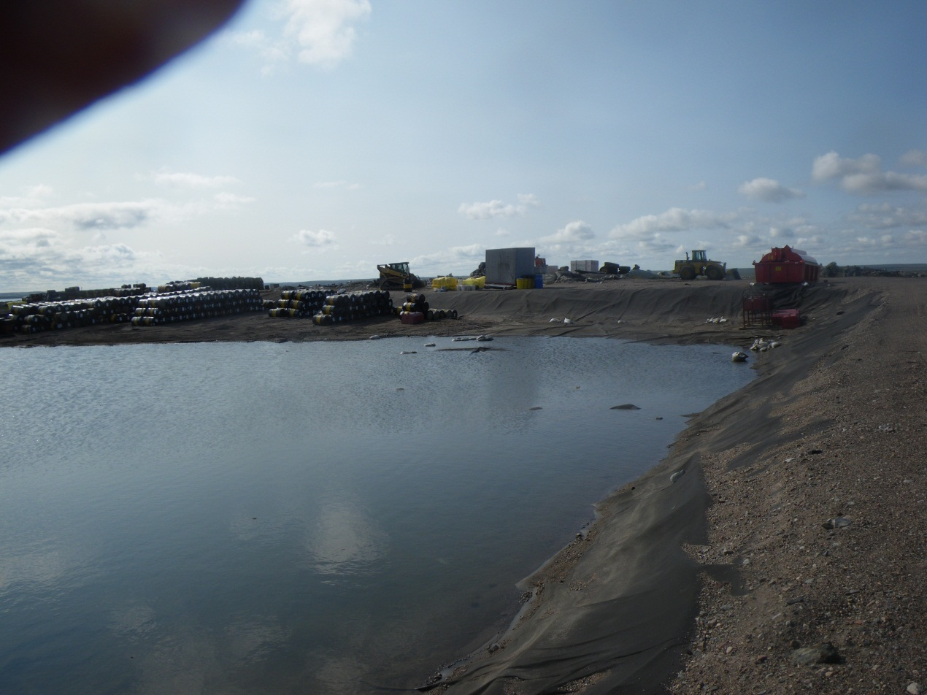

Plate 11. Facing north side of fuel berm

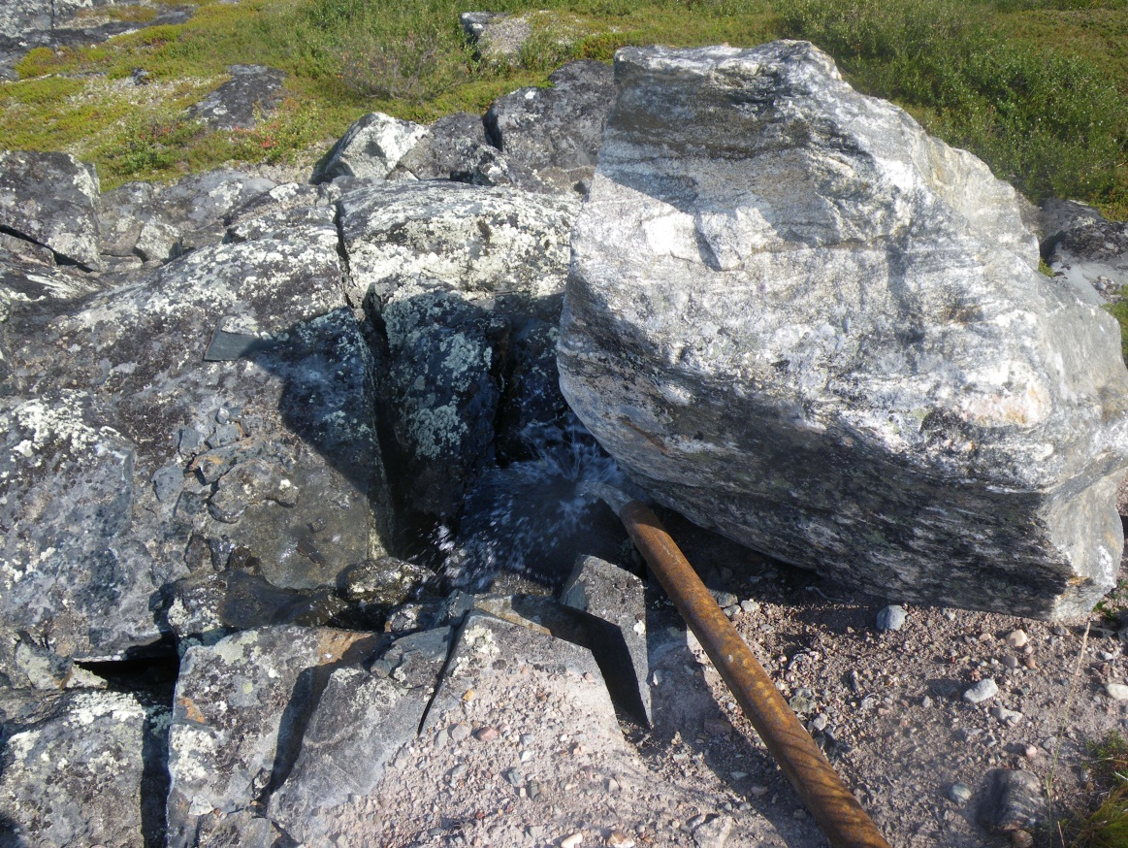

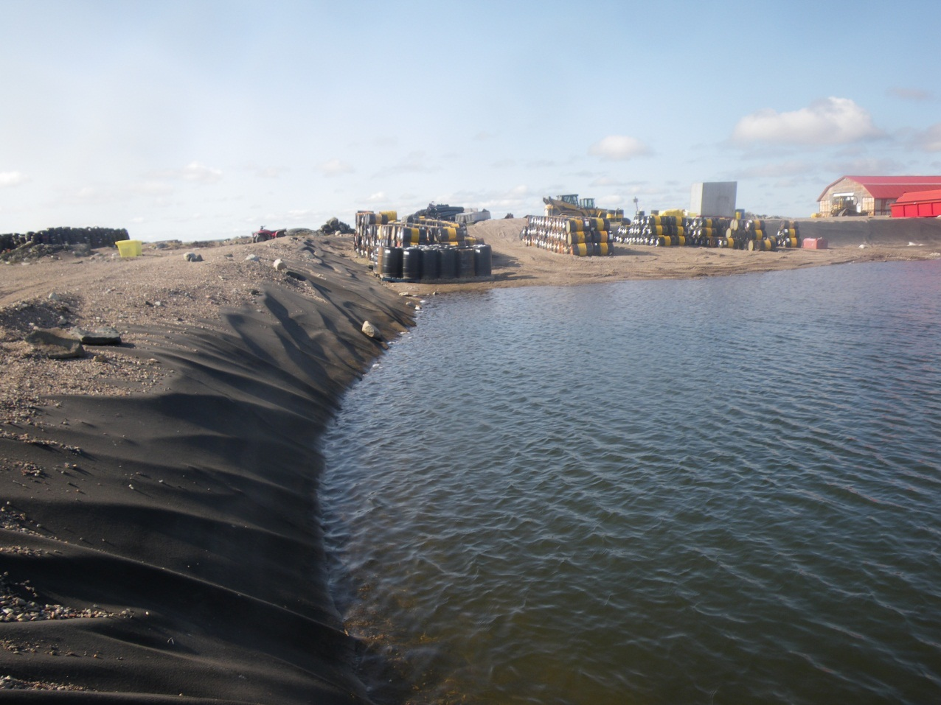
Plate 12. Pumped water from west side of fuel berm

Plate 13. East bank of fuel containment berm
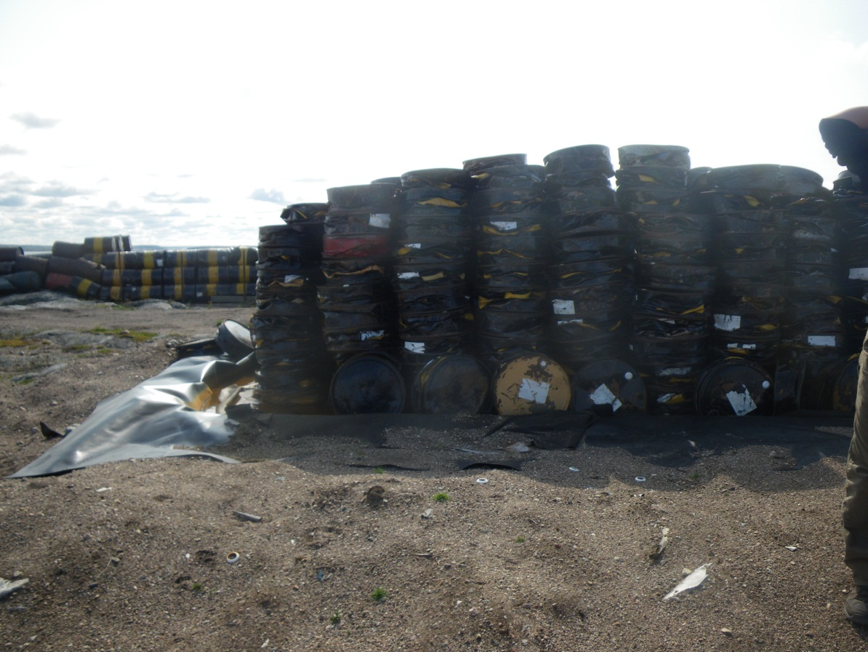

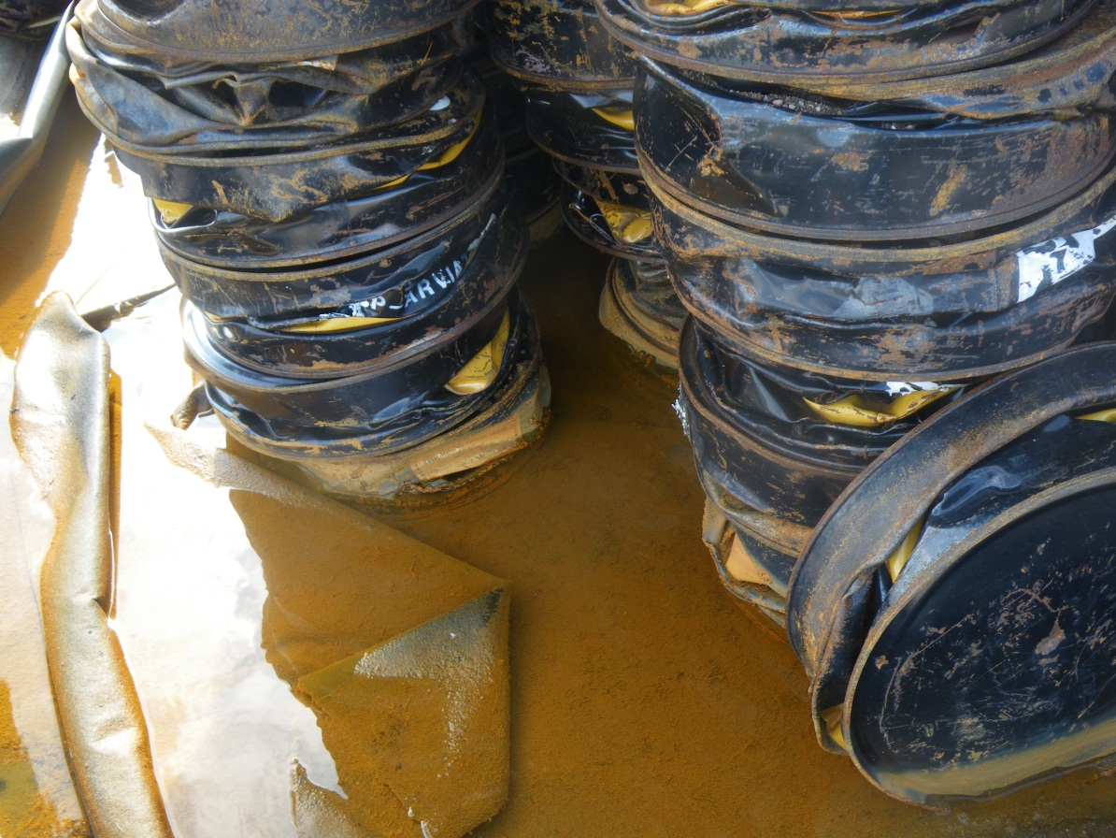
Plate 14. Crushed fuel barrel storage area

Plate 15. Standing water in crushed fuel barrels berm with amber color and visible oil sheen

