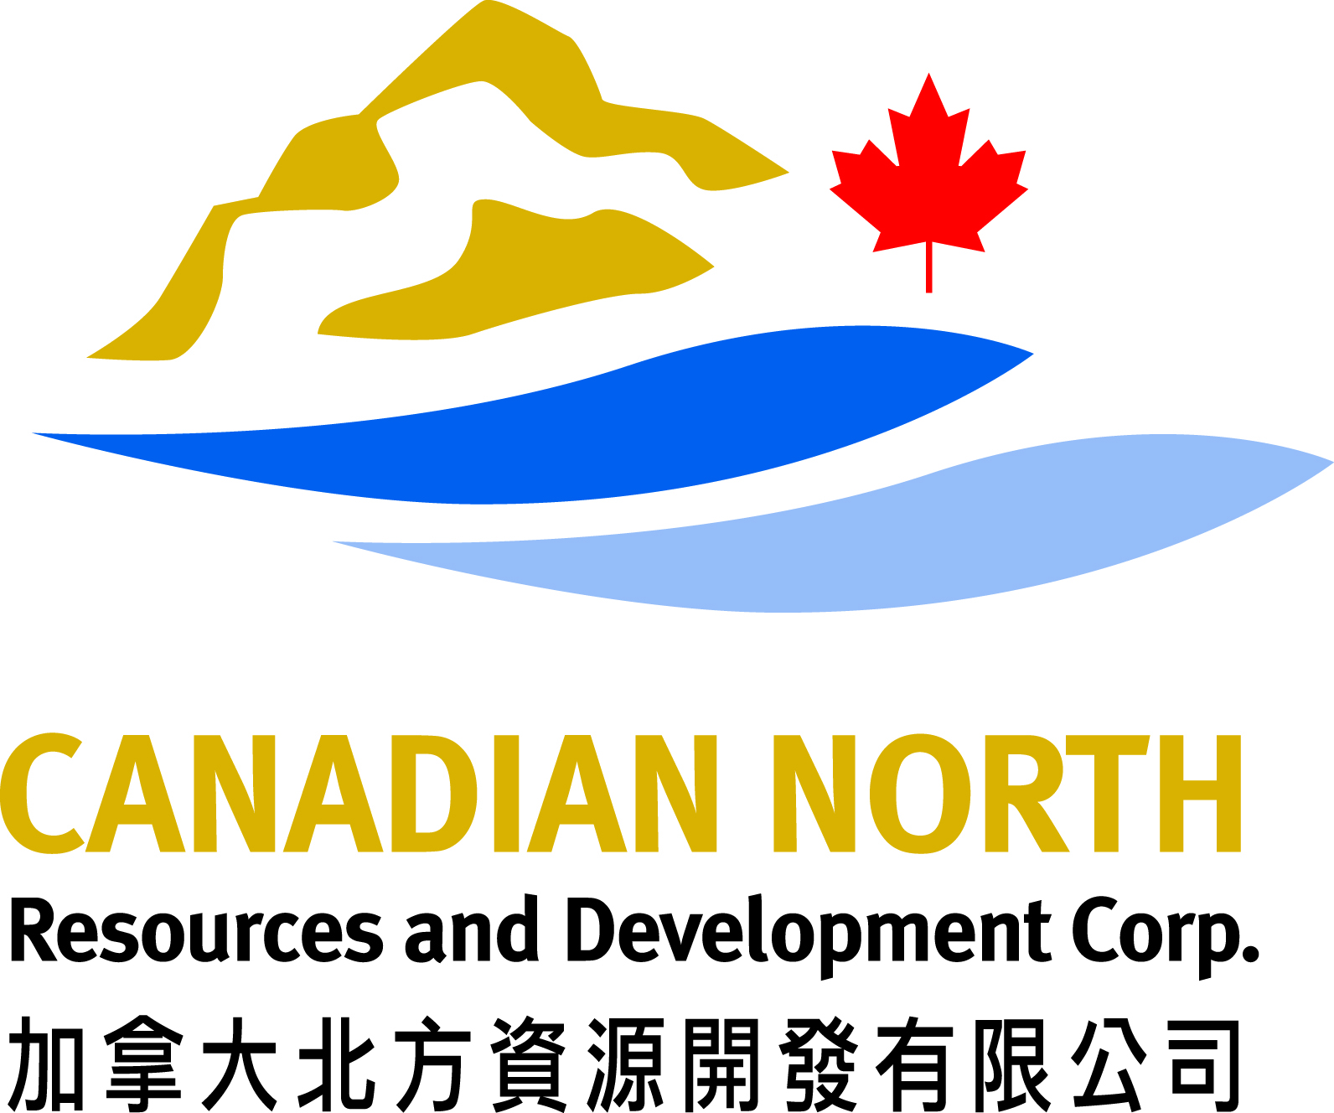
Mississauga Office
299 Courtneypark Drive East, Mississauga, Ontario, Canada L5T 2T6
Tel: 905-565-5968 Fax: 905-565-8812
Toronto Office
9/F, 34 King Street East, Toronto, Ontario, Canada M5C 2X8

September 19, 2013
Christine Wilson
Water Resource Officer- Kivalliq Region
Aboriginal Affairs and Northern Development Canada
Nunavut Regional Office
P.O. Box 100
Iqaluit, Nunavut X0A 0H0

Re: Inspection of Water License 2BE-FER0712
Dear Ms. Wilson,
In response to your letter of May 7th, 2013, Starfield Resources Inc. is in bankruptcy and the Ferguson Lake Property and Project has been purchased by Canadian North Resources and Development Corp., a private Ontario incorporated company based in Mississauga, Ontario. The company is now registered with the Nunavut Government as an extra-territorial corporation and carries a prospector license.
During July 29 – August 12, 2013, the Ferguson lake Camp was opened and the following work pertaining to the 2012 site inspection was completed on the camp and project area during this period. An application for renewal of water license was submitted to the Nunavut Water Board by Starfield Resources in 2012, and an application for assignation of this license to Canadian North Resources and Development Corp. was submitted in July, 2013. Both are presently under review. The camp presently holds a permit from the Nunavut Water Board for the use of waters or deposit of waste without a license. All of the contractors used during this program are registered with the WSCC and the mine inspector, Martin van Rooy, was notified of this program prior to opening the camp. A helicopter was stationed at the camp and an accredited first aid attendant with medical oxygen was on-site.
The following persons were working at the camp during the program:
Trevor Boyd Canadian North Resources and Development Corp., Geologist
Tyler Power Canadian North Resources and Development Corp., Geologist
Roger Pilakapsi Nuna M & T Enterprises Ltd., Equipment Operator / Mechanic
Chris Papak Nuna M & T Enterprises Ltd., Equipment Operator / Mechanic
Luke Issaluk Nuna M & T Enterprises Ltd., Equipment Operator / Mechanic
Sean Hawkes Peter’s Expediting Ltd., Cook and First Aid Attendant
Calvin Pin Rescan Environmental Services Ltd., Environmental Technician
Vic Cobb Custom Helicopters Ltd., Helicopter Pilot
The following work was completed while the camp was open:
      - The camp was checked for winter damage, and maintenance and repair work was undertaken on mechanical equipment and vehicles. Garbage and debris, domestic waste and hazardous waste noted in the inspection report were found to be removed or cleaned-up upon arriving and opening the camp. Nuna M & T Enterprises had three technicians / mechanics in camp during the program working on the camp, equipment, and airfield, and supporting the environmental survey work.
- The remediation work on the camp and old camp area, previously outlined by Ray Irwin, was confirmed to have been conducted including the clean-up of scrap metal, contaminated soil, bottles and empty barrels. The contaminated material, scrap metal, empty barrels and propane bottles were found to be piled, consolidated, and organized in the vicinity of the core storage area with the exception of five barrels of waste which was found located by the runway hanger. These were moved up to the staging area with the other material while the camp was open. The staging and consolidation work had been conducted in preparation for their removal by snow cat train during the winter. The vehicles were correctly parked on lined material with drip traps placed under their carriages. The camp was closed in similar condition. Attached below are photographs taken by myself, while the camp was open, of fuel berm area and staging areas showing the organization of the waste material. Included also with this letter is the KIA inspection report of the camp area dated September 9, 2013 with photographs taken by the inspector, Jeff Tulugak. It is believed that the office of the Mines Inspector have also conducted an inspection in the area this summer focusing on the old island air strip and camp area although we have not seen this report.
- Water sampling for hydrocarbon contamination was completed by Rescan Environmental Services in the fuel berm and crushed barrels catchment area. The water level for the berm was approximately at half of overall capacity. No signs of hydrothermal contamination were identified in the fuel berm. The containment area appears to be well built with no indications of erosion. Signs of hydrothermal contamination were identified in the containment directly under the crushed fuel barrels and over-limit hydrocarbon levels were measured at that location. The preliminary field and analytical reports by Rescan including photographs of the berm area are provided with this letter. Based upon these results, it is believed the water in the berm can be safely discharged onto the tundra, but the water in the crushed barrels containment requires treatment using the oil / water separator with the oil placed in container for safe removal with the other contaminated material.

      - The runway was found to have significant warps and exposed rocks requiring the placement of additional gravel, smoothing of bumps, and grading. All equipment including the front loader, grader, excavator, haul truck, bulldozer and stem-ster were utilized to do this work. The runway is now operational and a wind sock has been placed on the runway apron. It is recommended that a test plane landing be completed before full usage.

      - The weather station was fixed by the Rescan technician, including all sensors and batteries being replaced. Upon closing up the camp, the weather station was checked again, and found to be still in good standing.

Future short-term plans are to apply for the appropriate Crown Land usage permit and remove the barrels and remediation material by snow cat train during the winter of 2013-14. Planning is still underway for the 2014 work program, but the budget being considered includes the completion of borehole geophysical surveys and diamond drilling during the next summer-fall season using the two drills already located on the property.
Overall this was a successful field program, with no accidents, incidences or lost time injuries. Camp safety meetings were held on August 1st and 6th while the camp was open.
Please feel free to email or call me directly at 416 919 9017 with comments and concerns.

Best regards,

Trevor Boyd, P. Geo.
Canadian North Resources and Development Corp.

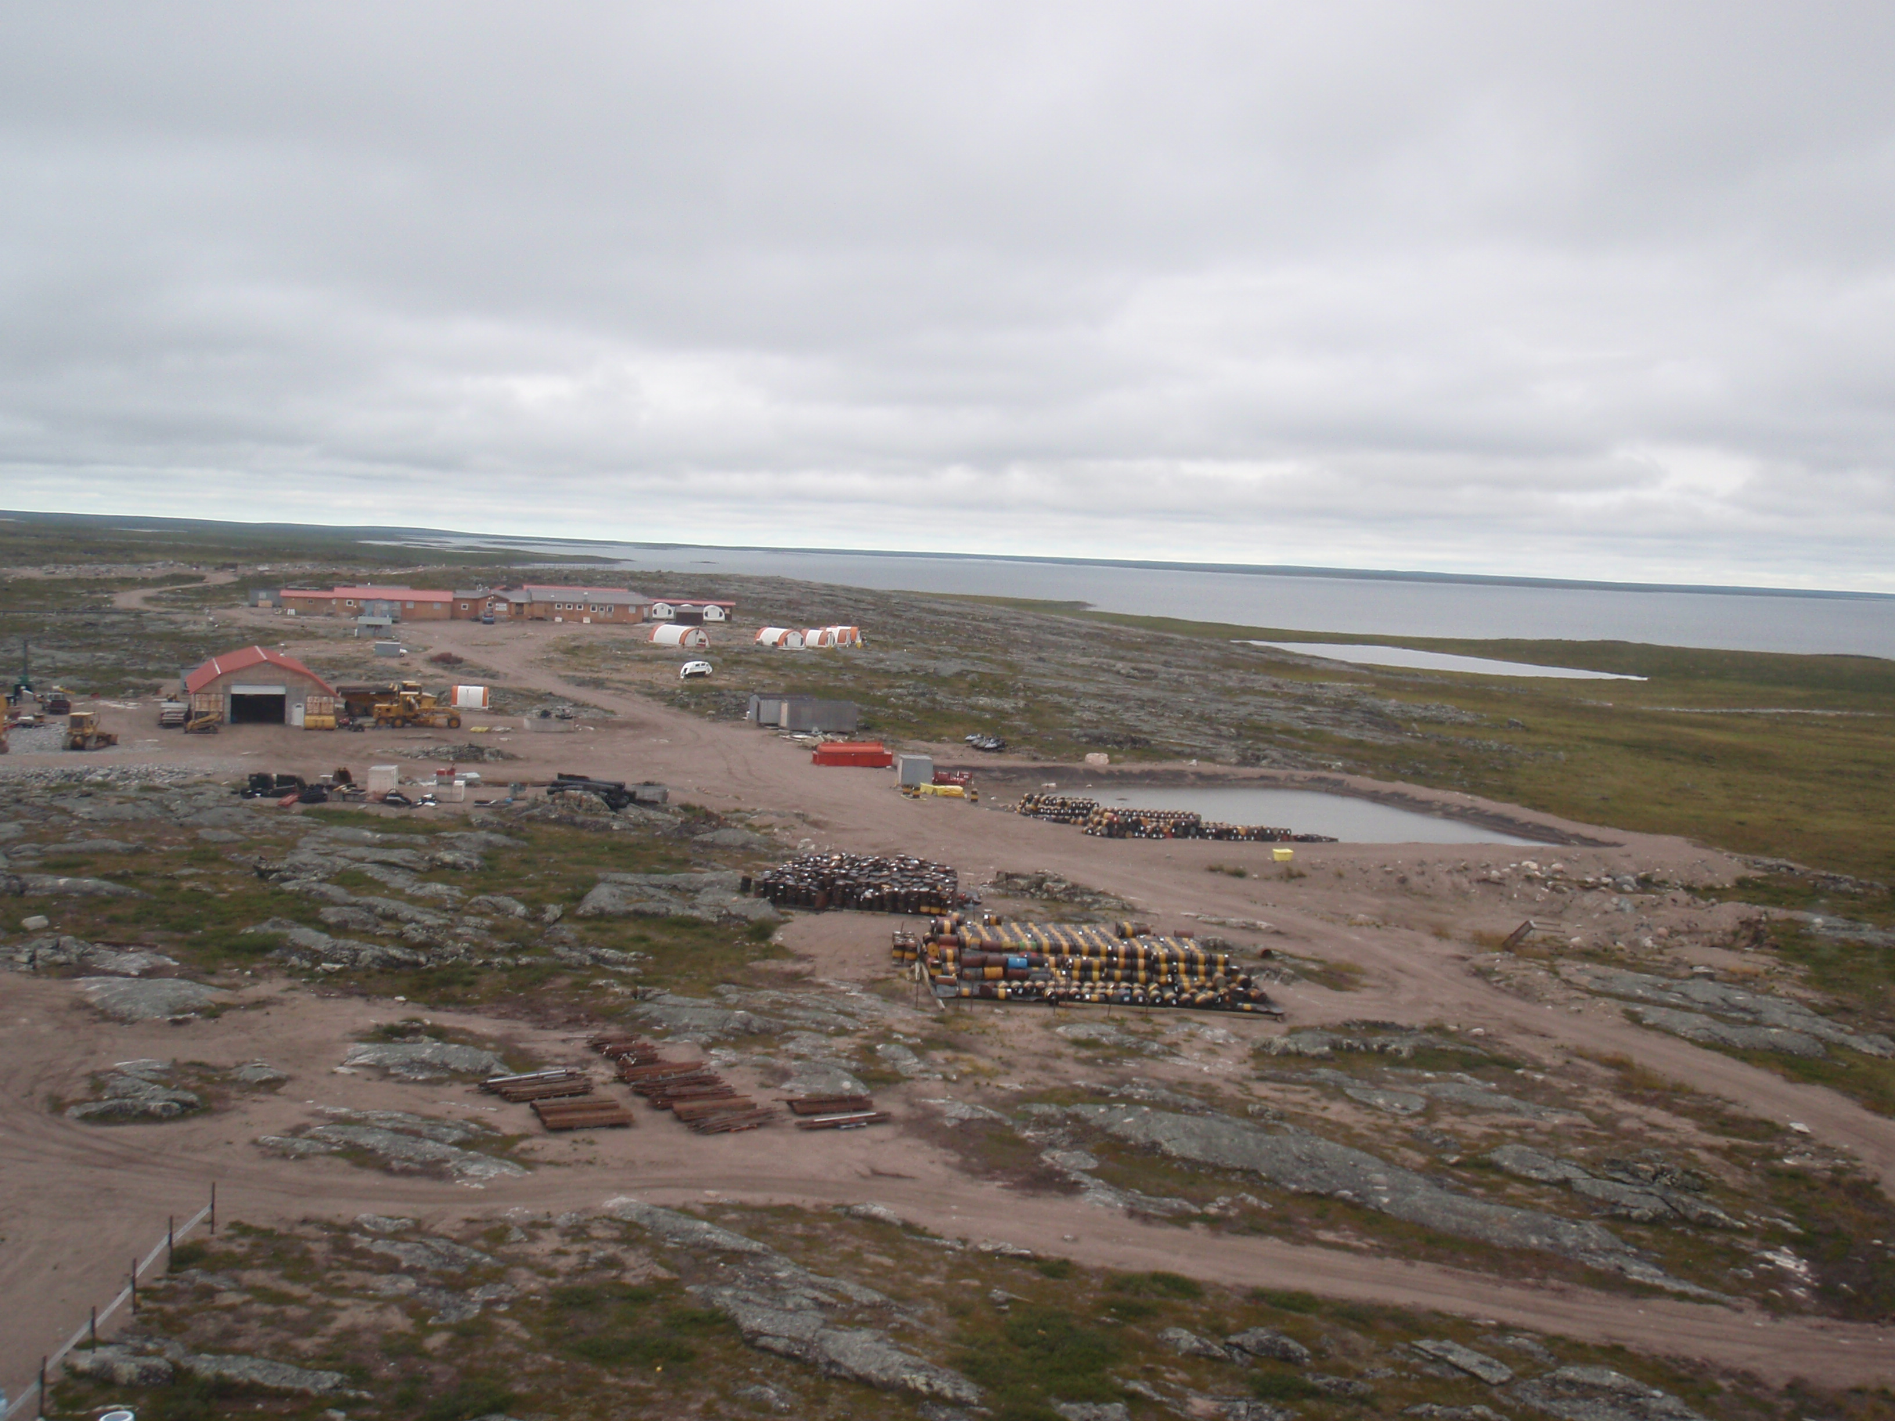 Photograph of open camp and fuel storage / berm containment with drill rods, crushed and uncrushed barrels at forefront.
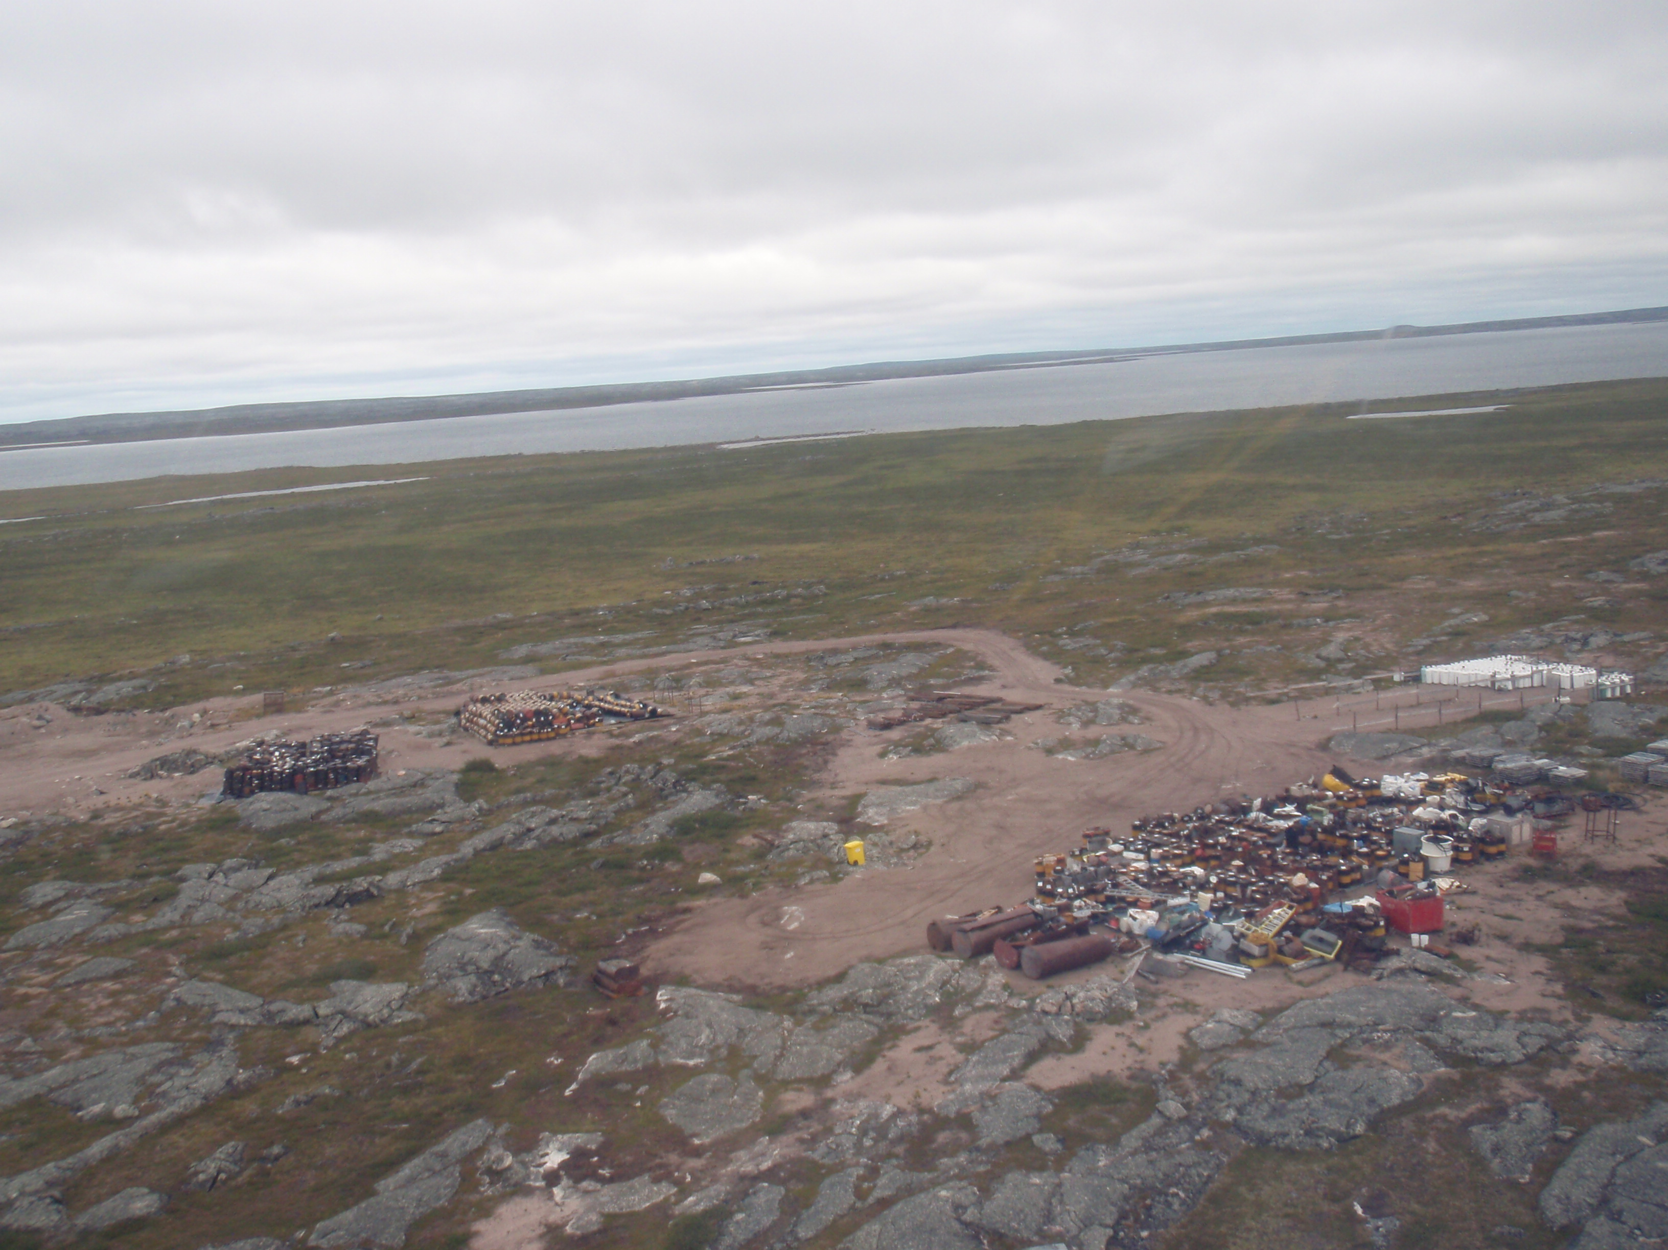 Photograph of crushed and uncrushed barrels, waste pile with remediation material / scrap metal, and propane bottles in preparation for removal from camp by snow train during winter 2013-14.

