Canadian North Resources Ferguson Lake

__________________________________________________________________

Land Use Type: | Commercial Lease KVCL305H27
Land Use Activity: | Diamond Drilling, Bulk Fuel Storage, Airstrip Construction, Mini Bulk Sample and Quarry
Site Contact: | Luc Paquet
Location: | Ferguson Lake, NU
Coordinates: | 62º 53.551’ N 96º 54.263’ W
Inspector(s): | Jeff Tulugak Craig Beardsall
Inspection Date: | August 18, 2015 11:23AM

_____________________________________________________________________________

SITE DESCRIPTION:

The camps main building is comprised of roughly 7 different buildings put together along with 6 weather havens. The main building incorporates all the lodging, bath, kitchen, office, entertainment and some lab space in the camp. Aside from the main building there are 9 wooden framed buildings, 5 weather havens. These buildings are used either for storage, work stations, generators and some for lodging. 1 large mechanical shop.

The distance to the nearest body of water is approximately 300 m with no major potential sources of contamination.

Large bulk fuel storage is also situated at camp, alongside a crushed drum and empty drum storage all in a secondary containment, there is also a propane storage area, and a waste site that is organized to be hauled out in Sea-Cans.

SITE INSPECTION FINDINGS:

Fuel Storage

The fuel storage is in good condition, water has accumulated approximately to the half way mark and is approximately 6 inches deep, water will be pumped if it not contaminated, and if contaminated it will be pumped into drums and shipped out.
The Hazmat equipment is present for spill response. Fuel is currently stored in 45 gallon drums, and they plan to ship in 16,000Litre fuel tanks that are double walled for easier access and a much cleaner, also less chance of spills to happen.

Empty Fuel Drums

The empty drums have been organized and stacked properly from previous years. They are also in secondary containment (linear), along with 15 batteries inside secondary containment (linear).
Propane tanks are also organized well, they are standing up right and chained together. Approximately 80 empties, and 350 full tanks, 300M and beyond from any water bodies.

Waste Site (Garbage)

The waste site at camp is well organized. Much of the waste is metals, and miscellaneous stored in drums to ensure wildlife can’t get to it, and also things aren’t blown away.

Waste Water Discharge

The waste water discharge are pact in Pacto toilets and are incinerated. And the gray water sump is in good condition.

Incinerator

The incinerator is in good condition and the area is well maintained with no garbage laying around. All burnable garbage is burnt in the incinerator along with the pacto toilets.

Heavy Equipment

Heavy equipment is on lined material and has secondary containment, the linear has some oil residue on it along with soil, and the contaminated soil will be placed in barrels to be shipped out.

Drill Site

The drill site is well organized with the rig and pipes stored properly.

Wildlife

There were no wildlife spotted in the area.

ADDITIONAL NOTES:

Overall the site was in good condition, plans are still being made to make it better as in more organized, and shipping out waste that doesn’t need to be there. All fuel drums that were used for heating the buildings and weather havens are in secondary containment and all valves are shut off.

RECOMMENDATIONS:

- KIA recommends the fuel storage to be in double-walled tanks instead of the 45 gallon drums to avoid spill accidents and to be more environmentally friendly.
- We also recommend that all the crushed drums and waste that can’t be burnt to be shipped out in sea-cans to avoid waste getting into the environment.
- Also KIA recommends that a maximum of 10% of empty drum be stored at site.
- And for the fuel bulk storage we recommend that the water be tested before discharging into environment and if contaminated it should be stored in drums to be shipped out.

Ferguson Lake Camp

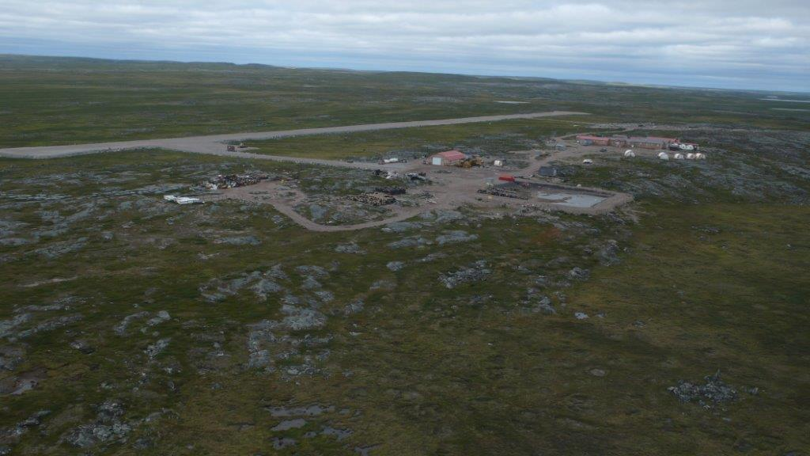

Waste site, Propane Storage

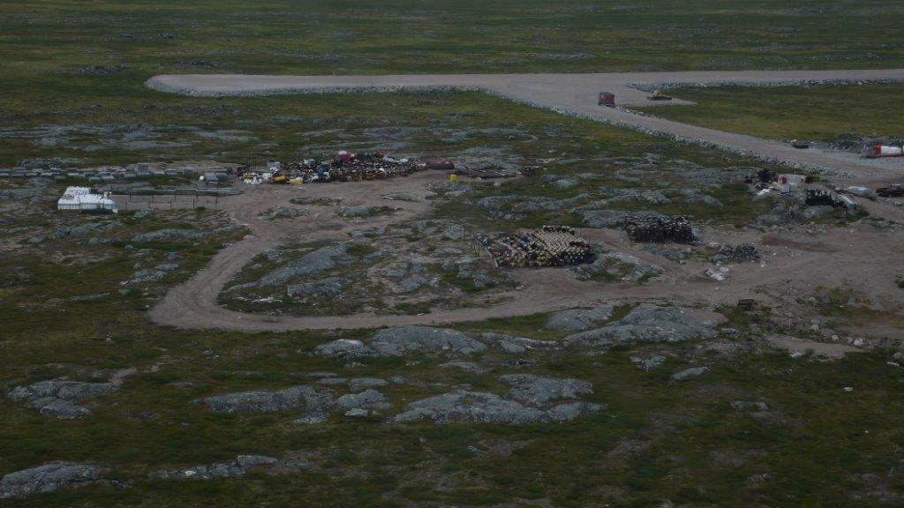

Fuel Bulk Storage

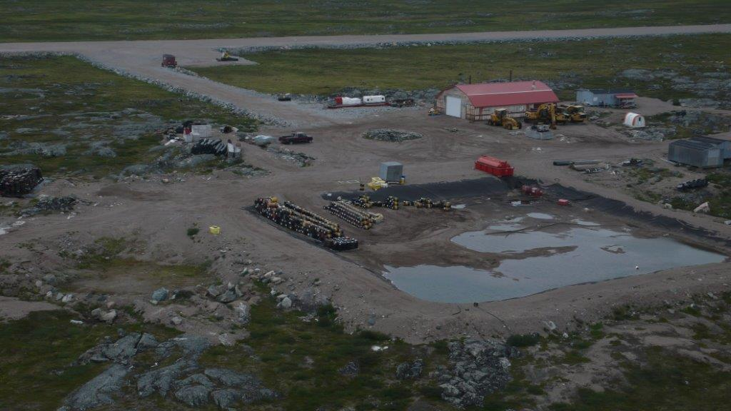

Heavy Equipment And Garage Area

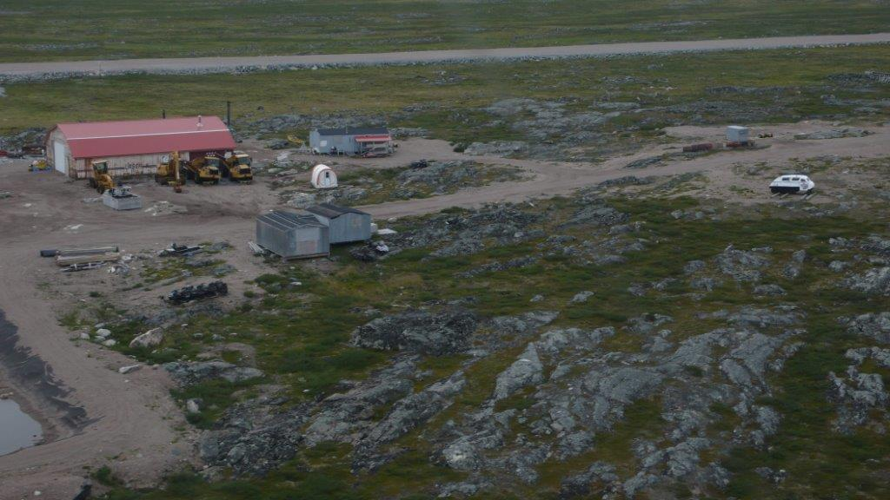

Site Camp

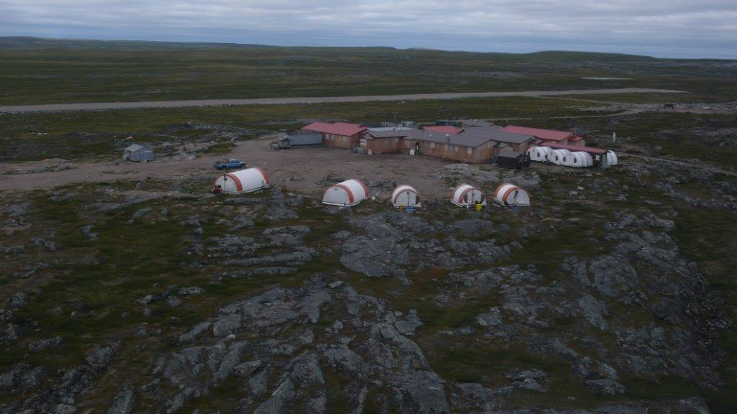

Quarry

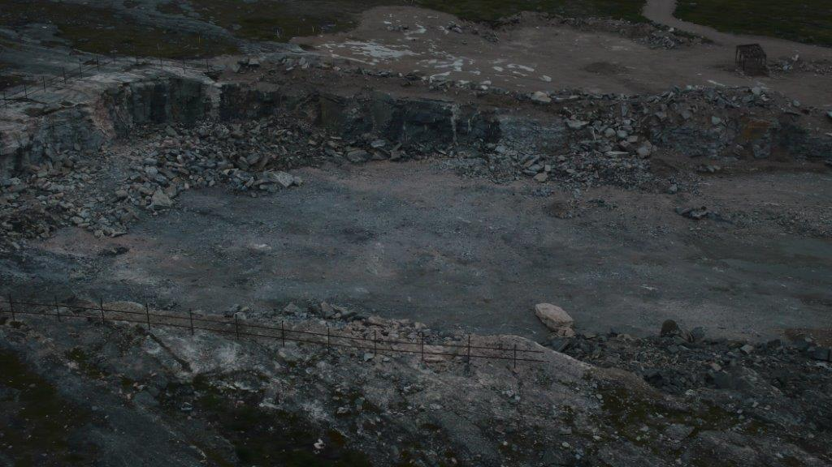

Runway

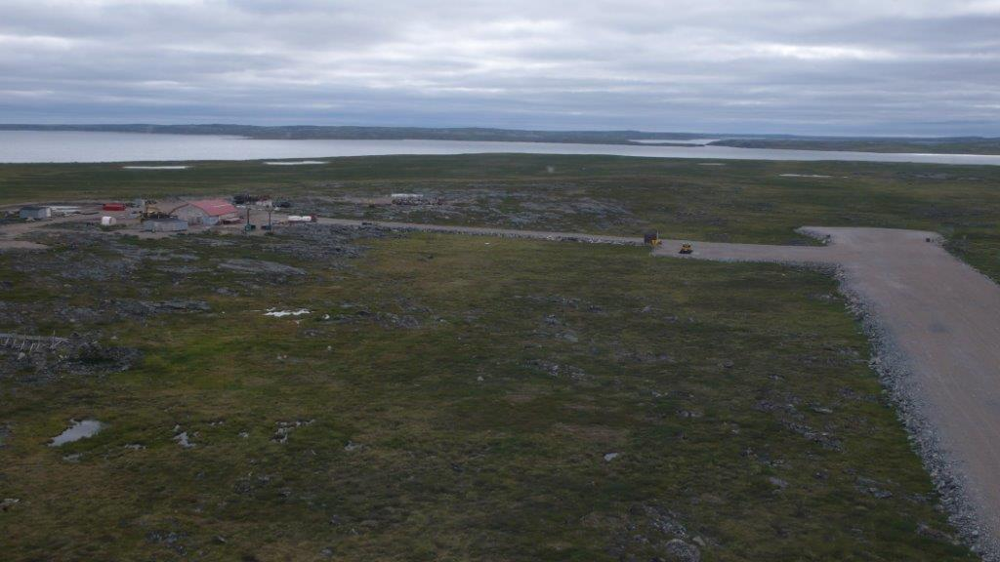

Grey Water Sump

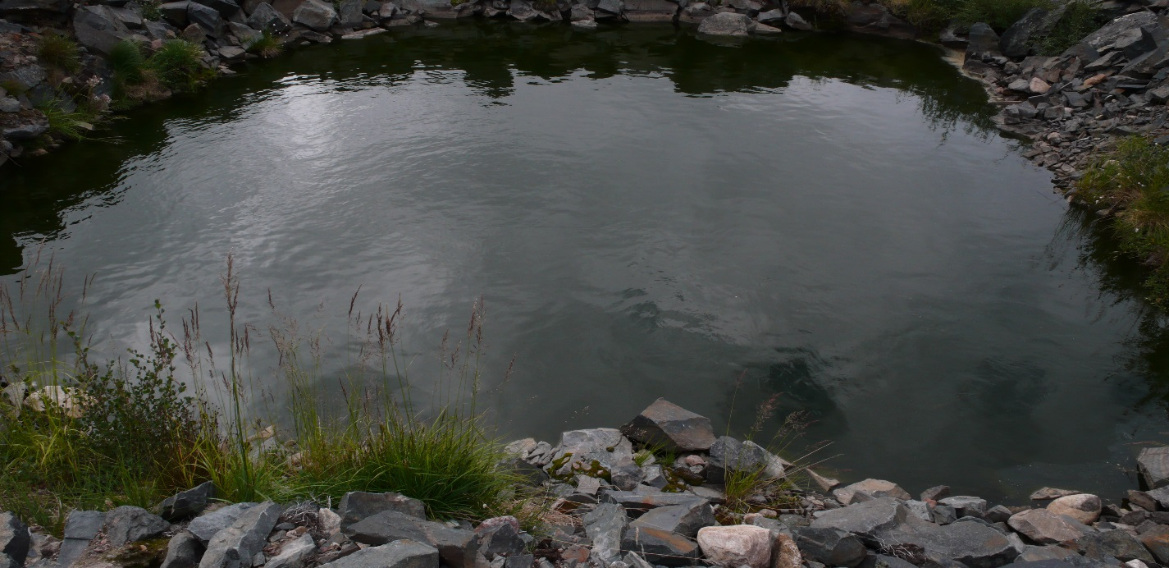

Heavy Equipment Fuel/Oil Residue

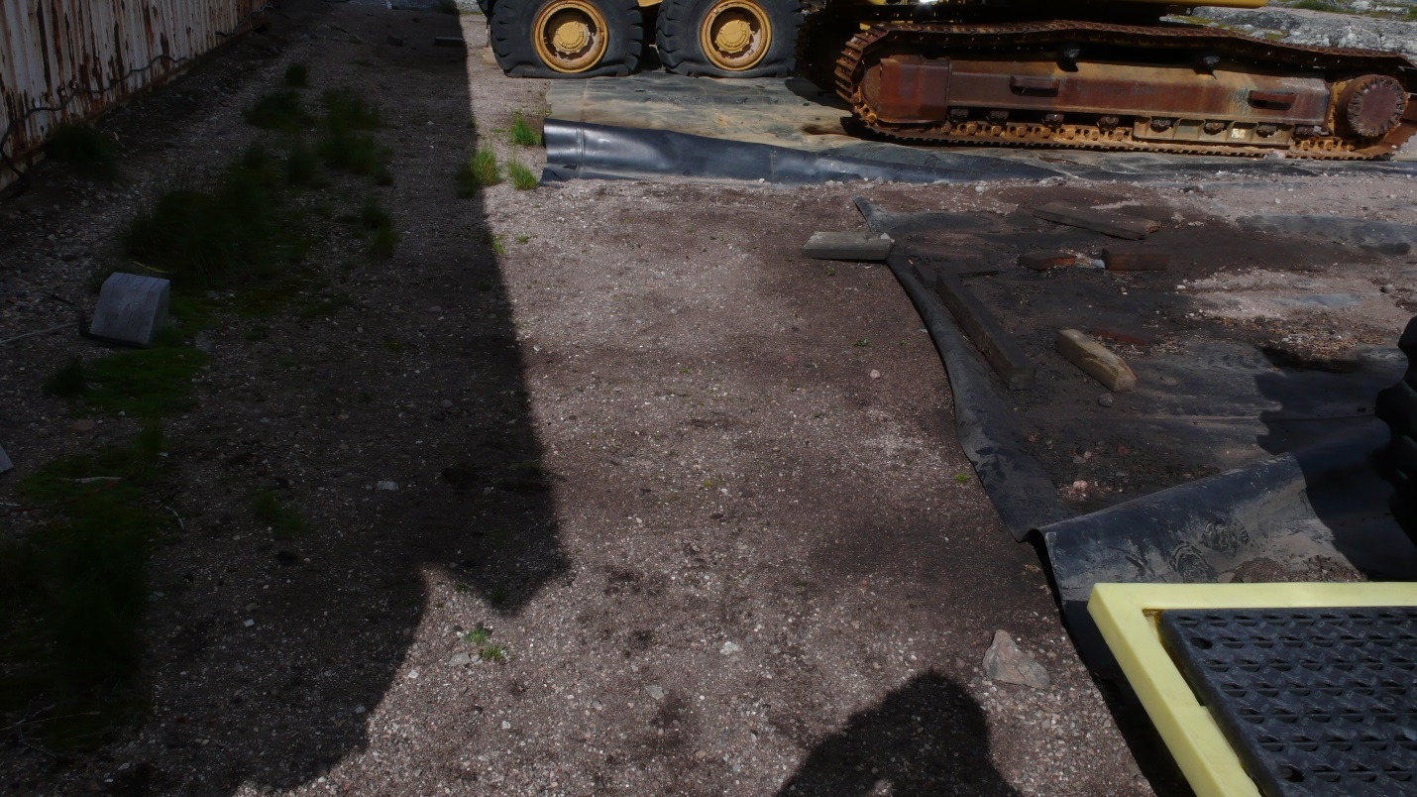

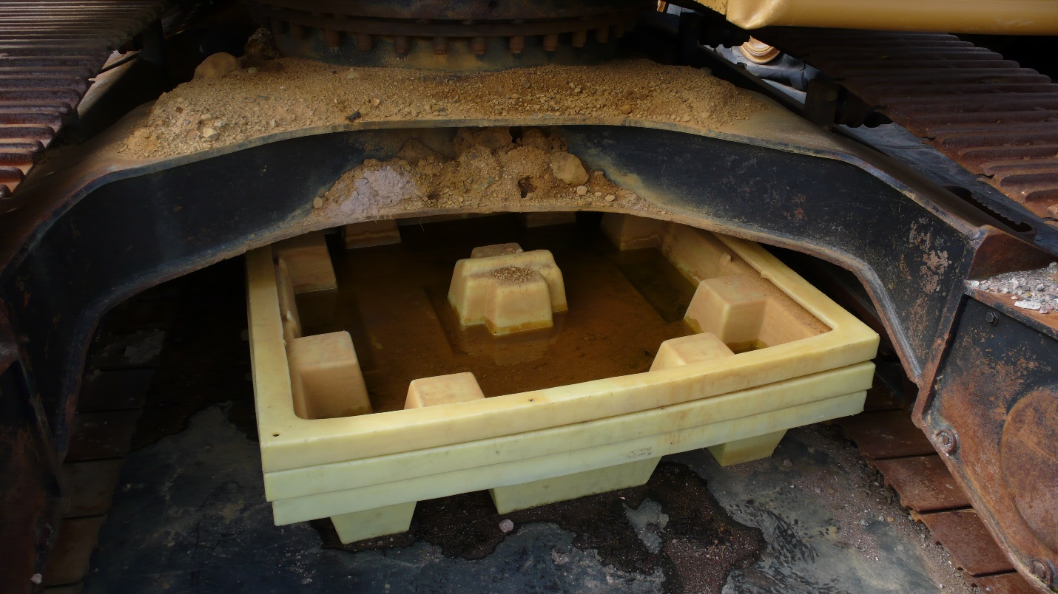

Empty barrels in secondary containment

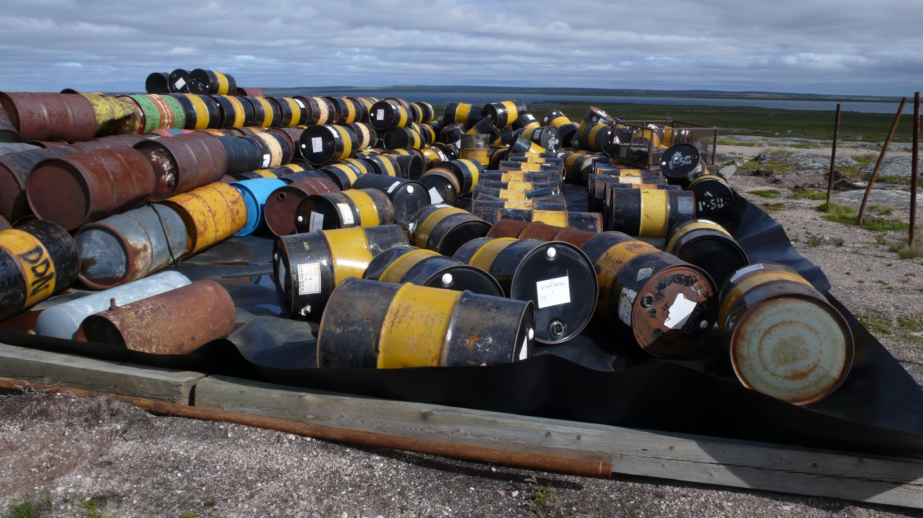

Batteries in secondary containment

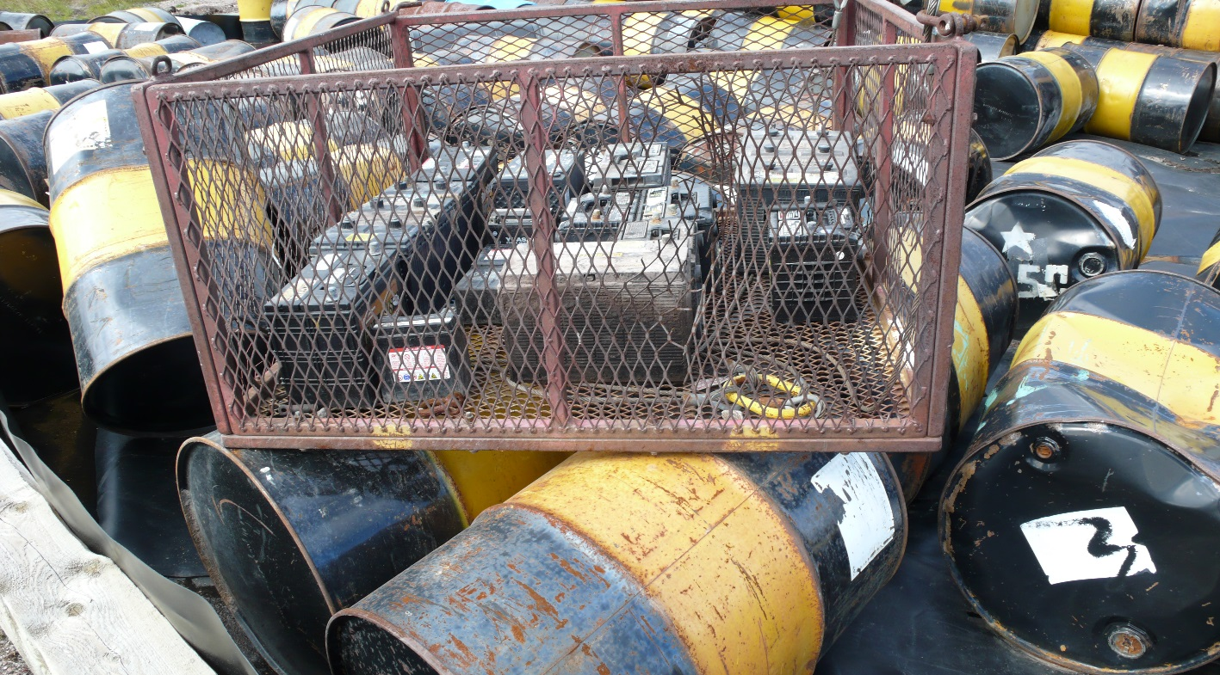

Fuel Bulk Storage in Secondary Containment

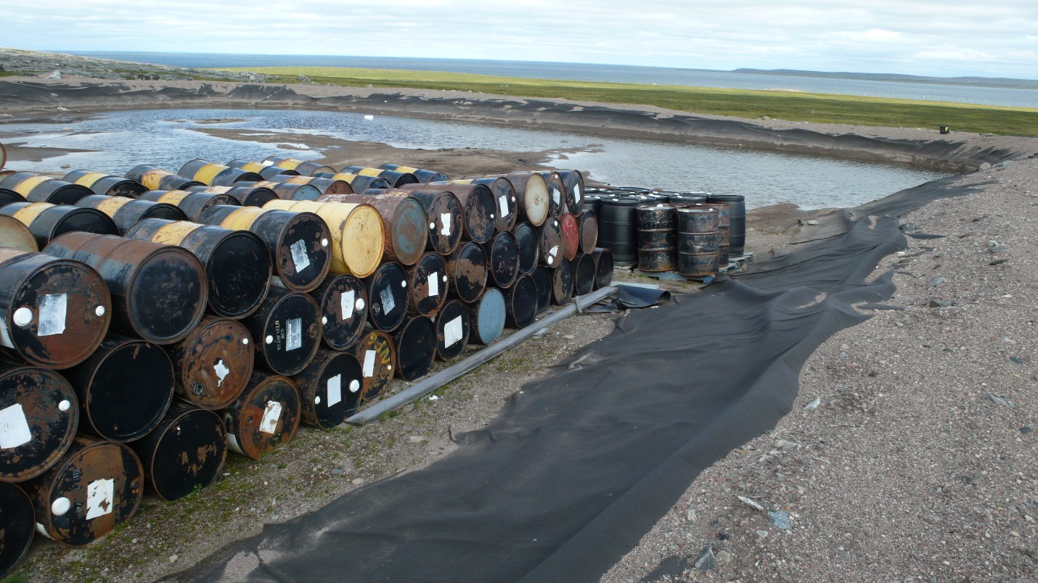

Water on top of linear
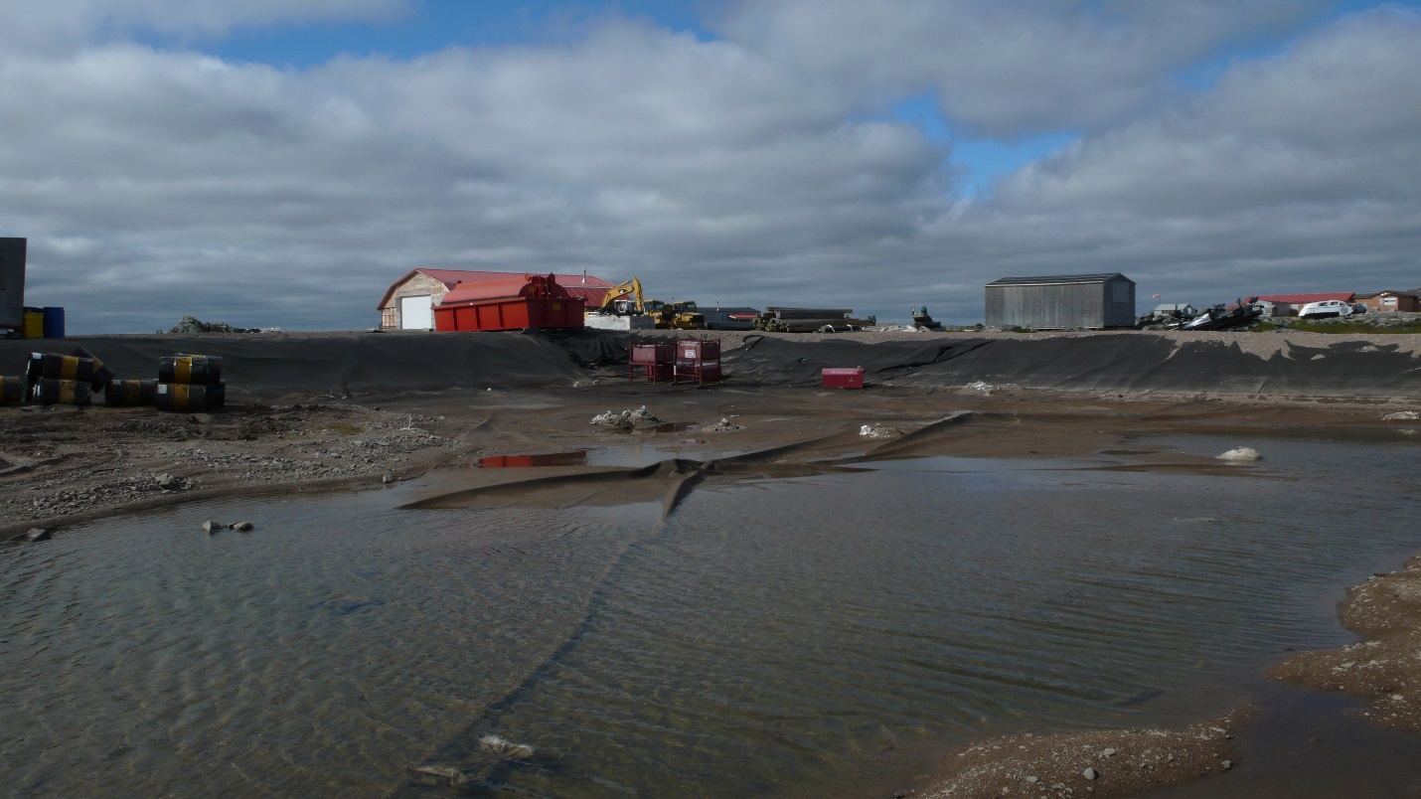

Water discharge area if not contaminated

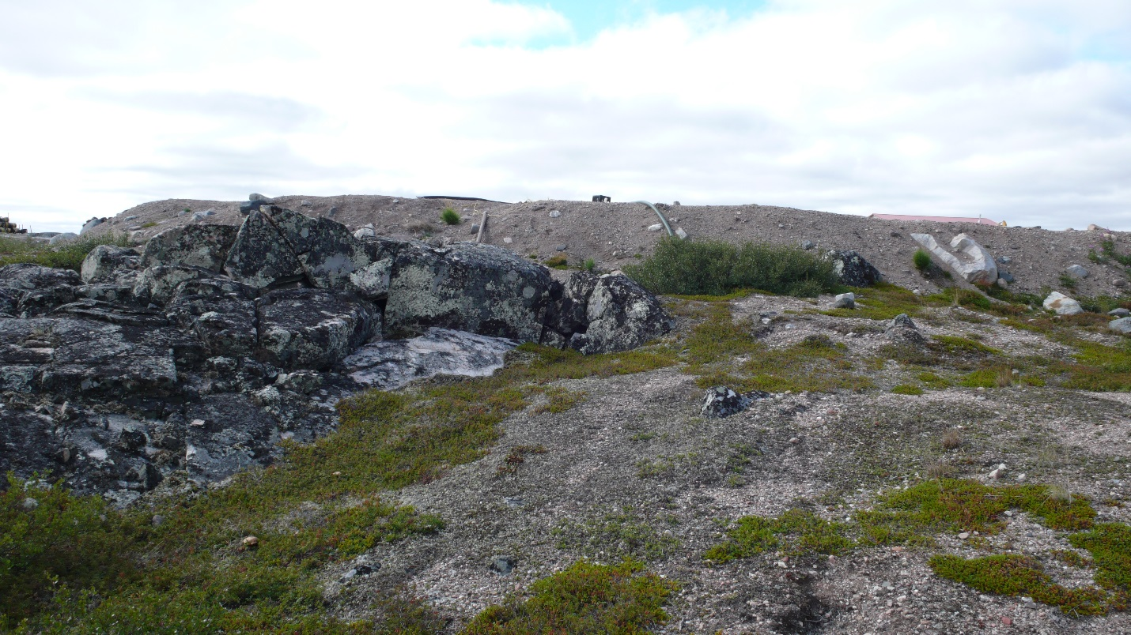

Drilling Area

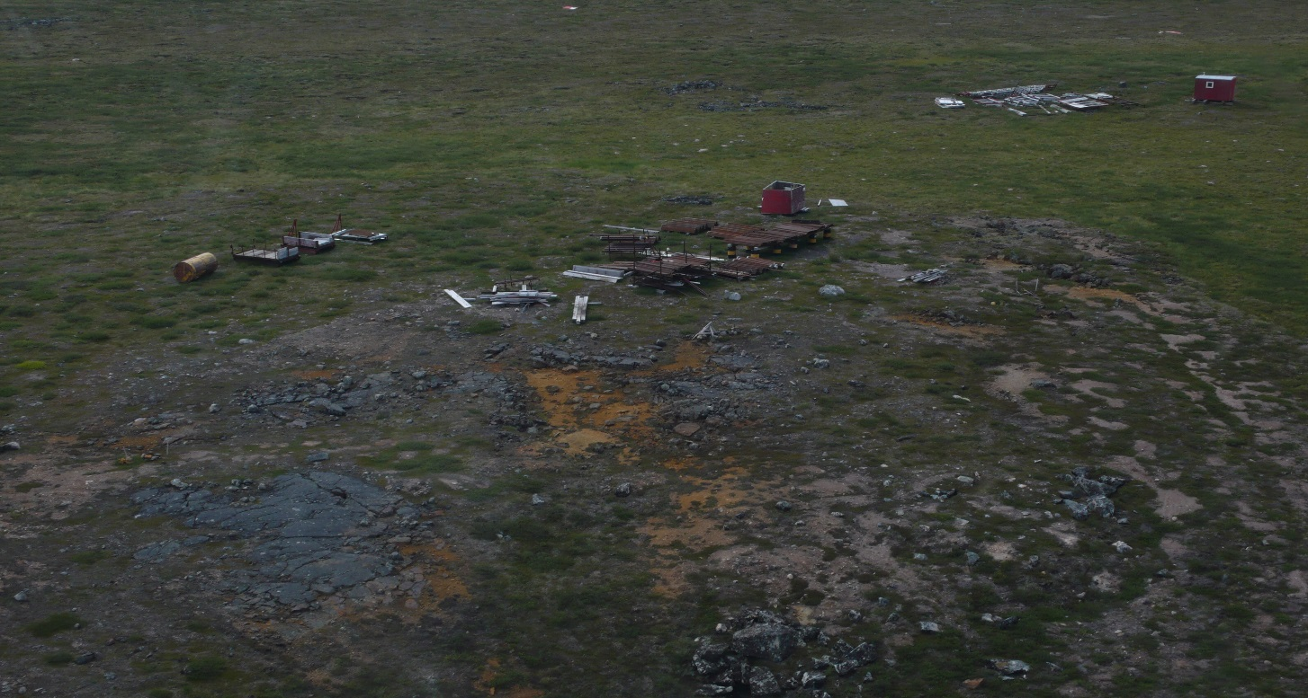

Crushed, Empties, Full Barrels

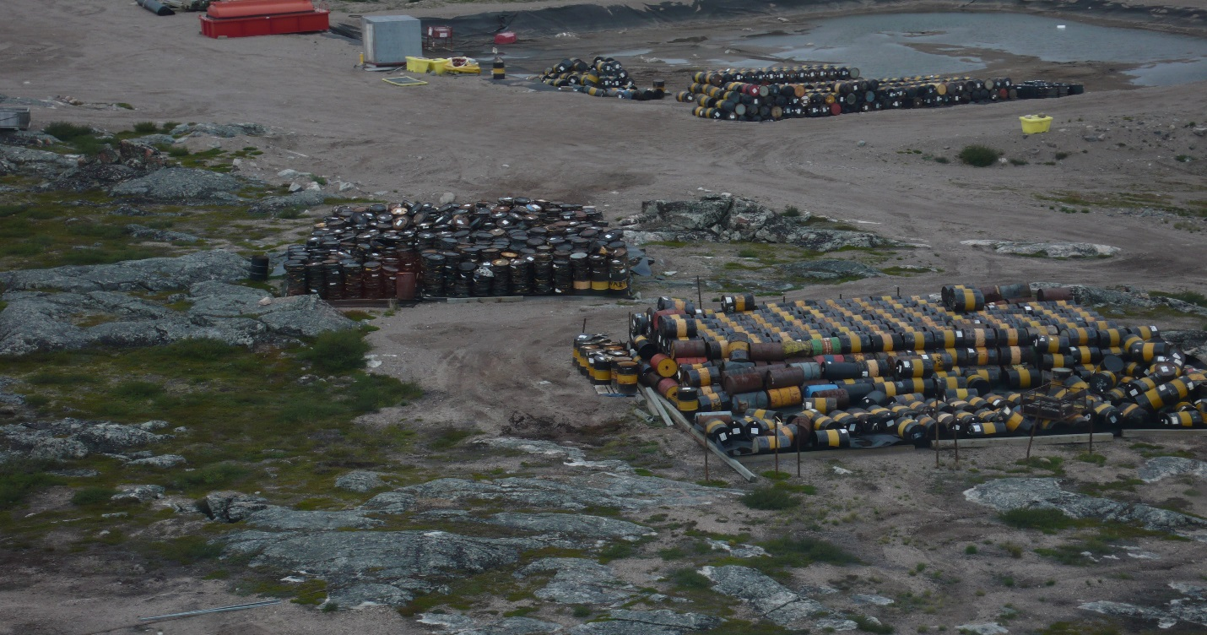

Double walled fuel tank

