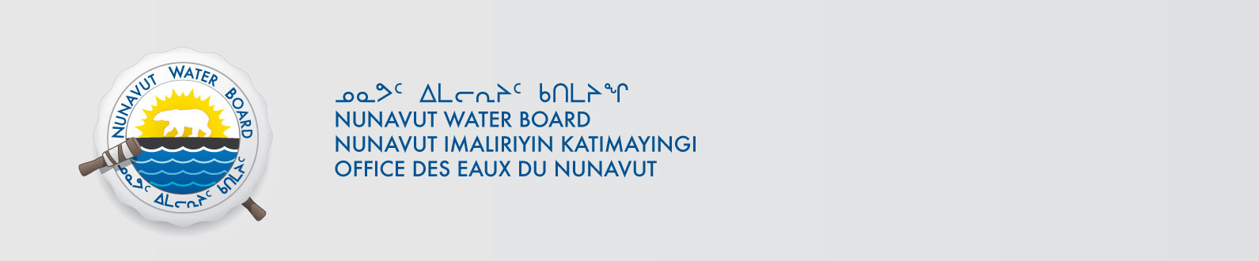

January 16, 2023 NWB File No: 2BE-GAR0710

Larry Lahusen, CEO
Uravan Minerals Inc.
Suite 204, 2526 Battleford Ave. SW
Calgary, AB T3E 7J4
Office: (403) 264-2630
E-mail: llahusen@uravanminerals.com

Subject: Final Inspection –Closure of NWB File

Dear Mr. Lahusen:

On April 24, 2017 the Nunavut Water Board (NWB) received a final water inspection report from Crown Indigenous Relations and Northern Affairs Canada (CIRNAC) covering the above noted file. The report indicates there are no outstanding reclamation issues associated with the project. Further, there are no outstanding NWB administrative matters that require attention.

In accordance with section 43.(i)(c) of the Nunavut Waters and Nunavut Surface Rights Tribunal Act (NWNSRTA), the Board may cancel a licence in certain specific cases.

The NWB hereby notifies all parties that the aforementioned licence is now considered closed. Any future relevant activities on this site will require a new Water Licence or Approval Without a Licence.

Sincerely,

Original signed by:

Robert Hunter
Licensing Administrator

Cc: Kivalliq Distribution List
CIRNAC Enforcement

