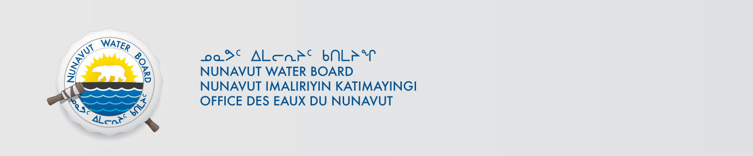

April 24, 2017 NWB File No: 2BE-GAR0710

Larry Lahusen
CEO President
Uravan Minerals Inc.
240-70 Shawville Blvd. SE
Calgary, AB T2Y 2Z3
E-mail: llahusen@uravanmineralsinc.com

Subject: Final Inspection – Cancellation of Licence and Closure of NWB File

Dear Mr. Lahusen:

On April 24, 2017 the Nunavut Water Board (NWB) received a final water inspection report from Indigenous and Northern Affairs Canada (INAC) covering the above noted file. The report indicates there are no outstanding reclamation issues associated with the project. Further, there are no outstanding NWB administrative matters that require attention.

In accordance with section 43.(i)(c) of the Nunavut Waters and Nunavut Surface Rights Tribunal Act (NWNSRTA), the Board may cancel a licence in certain specific cases.

The NWB hereby notifies all parties that the aforementioned licence is now cancelled and that the corresponding NWB file is now considered closed. Any future relevant activities on this site will require a new Water Licence or Approval Without a Licence.

Sincerely,

Licence Administrator

Cc: Kivalliq Distribution List
INAC Enforcement

