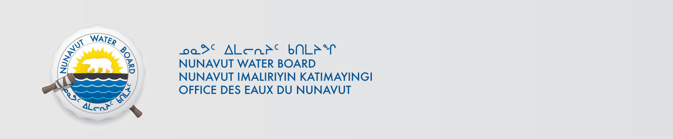

January 29, 2020 NWB File No: 2BE-GEO1520

Merle Keefe
Manager, Environmental Permitting
Sabina Gold & Silver Corporation
Suite 1800 – 555 Burrard Street, Box 220
Vancouver, BC V7X 1M7
E-mail: mkeefe@sabinagoldsilver.com

Subject: Application Acknowledgement for renewal of water licence 2BE-GEO1520 George Lake Project

Dear Mr. Keefe:

The Nunavut Water Board (“NWB”) acknowledges receipt on January 29, 2020 of your renewal water licence application, for the George Lake Project. This application has been assigned file number 2BE-GEO1520. Please refer to this number on future submissions. Application documents received are as follows:

- Attachment 1 –Application Form
- Attachment 2 - Project Map
- Attachment 3 – January 21, 2010 NPC Conformity Determination (NPC File # 149278)
- Attachment 4 - May 15, 2006 NIRB Screening Decision Report (File No. 06EN033)
- Attachment 5 - August 5, 2010 NIRB letter Re: Exemption from Screening (File No. 08EA084)
- Attachment 6 – April 17, 2015 NIRB Exemption from Screening Determination (File No. 08EA084)
- Attachment 7 - Comprehensive Spill Contingency Plan
- Attachment 8 - Abandonment and Restoration Plan George Camp and Exploration Project
- Attachment 9 - Plain Language Summaries
- Attachment 10 – Table of Leases and Authorizations
- Attachment 11 – Certificate of Amendment of Registration
- Attachment 12 – Engagement Record

Please be advised that under the Agreement Between the Inuit of the Nunavut Settlement Area and Her Majesty the Queen in Right of Canada (Nunavut Agreement) Article 11, Section 11.5.9 and s. 76 (1) of Nunavut Planning and Project Assessment Act (NuPPAA), the proponent of a project governed by NuPPAA is also required to submit a project proposal document directly to the Nunavut Planning Commission (NPC or Commission) for the NPC’s determination regarding the applicable land use planning requirements and/or directions regarding whether the project is subject to screening by the Nunavut Impact Review Board. In particular, please note that as established under Articles 11, 12 and 13 of the Nunavut Agreement, NuPPAA and Part 3 of the Nunavut Waters and Nunavut Surface Rights Tribunal Act, until the project has completed the applicable land use planning and assessment process required by the NPC and the NIRB, the NWB cannot issue a water licence/approval.

The NWB confirms receipt of NPC conformity under NuPPAA on January 21, 2020 and NIRB determination through NPC under NuPPAA on January 21, 2020. This application is now ready for review and comments. Deadline for submissions is February 29, 2020.

Please call the undersigned at (867) 360-6338 or email to licensing@nwb-oen.ca if you have any questions.

Sincerely,

Richard Dwyer
Licensing Manager

Copy Kitikmeot Distribution List

