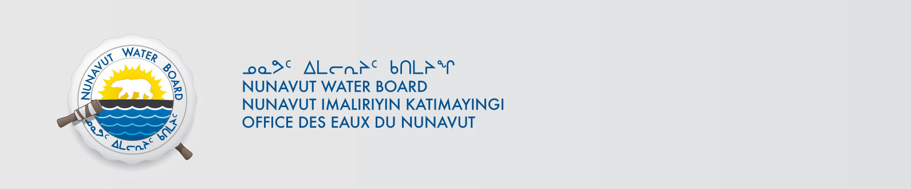

March 20, 2019 NWB File No: 2BE-GOT----

David Frenette
Agnico Eagle Mines Ltd.
C.P. 87, 765 chemin de la mine Goldex
Val-d’Or, Quebec J9P 4N9
E-mail: david.frenette@agnicoeagle.com

Subject: New Water Licence Application GOT Project

Dear Mr. Frenette:

The Nunavut Water Board (“NWB”) acknowledges receipt on March 14, 2019 of your new water licence application, for the GOT Project. This application has been assigned file number 2BE-GOT----. Please refer to this number on future submissions. Application documents received are as follows:

190314 2BE-GOT---- 149037 - LUP-Not a Significant Modification - screening not required
190314 2BE-GOT---- Area_under_application (2
190314 2BE-GOT---- Main application document_GOT
190314 2BE-GOT---- Non technical summary English
190314 2BE-GOT---- Non technical summary Inuktitut
190314 2BE-GOT---- Water Licence Application
190320 2BE-GOT---- Area to permit
190320 2BE-GOT---- Closure and Reclamation Plan_V1
190320 2BE-GOT---- Searchable General_Water_Licence_Application
190320 2BE-GOT---- Spill Contingency Plan 2BBMEA-2BEGOT_version 11
190320 2BE-GOT---- water licence application additional information

Please be advised that under the Agreement Between the Inuit of the Nunavut Settlement Area and Her Majesty the Queen in Right of Canada (Nunavut Agreement) Article 11, Section 11.5.9 and s. 76 (1) of Nunavut Planning and Project Assessment Act (NuPPAA), the proponent of a project governed by NuPPAA is also required to submit a project proposal document directly to the Nunavut Planning Commission (NPC or Commission) for the NPC’s determination regarding the applicable land use planning requirements and/or directions regarding whether the project is subject to screening by the Nunavut Impact Review Board. In particular, please note that as established under Articles 11, 12 and 13 of the Nunavut Agreement, NuPPAA and Part 3 of the Nunavut Waters and Nunavut Surface Rights Tribunal Act, until the project has completed the applicable land use planning and assessment process required by the NPC and the NIRB, the NWB cannot issue a water licence/approval.

The NWB confirms receipt of NPC conformity under NuPPAA on February 4, 2019 and NIRB determination through NPC under NuPPAA on February 4, 2019. This application is now ready for review and comments. Deadline for submissions is April 23, 2019.

Please call the undersigned at (867) 360-6338 or email to licensing@nwb-oen.ca if you have any questions.

Sincerely,

Richard Dwyer

Copy Kivalliq Distribution List

