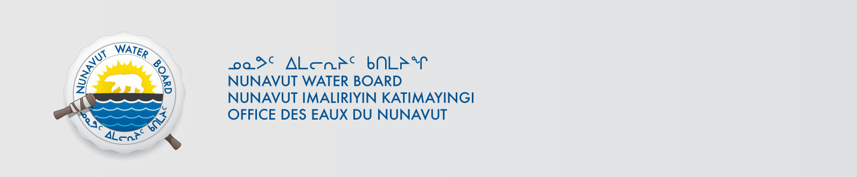

March 20, 2019 File No: NWB2ATU9899 2BE-GOT----

To: Hamlet, CLARC, HTO, RIA, Coop, and NorthernLocal Organizations – Request to Post Notices

The Nunavut Water Board requests that you post on a bulletin board, until April 23, 2019, the attached notices (in English), where they can be viewed by the public. The attached letter is for your information and does not require posting. Inuktitut notice will follow shortly.

Your time and effort is greatly appreciated.

Sincerely,

Richard Dwyer

Cc: Hamlet/Mayor of Baker (867) 793-2509
Kivalliq-IA (867) 793-2126
Baker Lake HTO (867) 793-2034
Northern Store (867) 793-2565
Sanavik Co-op (867) 793-2711

