

October 10, 2013
Eva Paul, Water Resources Officer
Aboriginal Affairs and Northern Development Canada
Nunavut Regional Office
P.O. Box 100 Iqaluit, NU X0A 0H0

Re: Inspection of Water Licence SBE-HBP1116

We write with respect to the above noted Water Licence inspection report dated August 12, 2013 which included matters requiring immediate action. We confirm that all materials, including fuel, tent frames, and related miscellaneous items have been removed from North Arrow Minerals’ Hope Bay Project Camp near Roberts Lake. Before and after photos of the area are attached as Figures A through H. We have additional photos that can be forwarded to you if desired.
Of particular note, the contractor was advised to investigate and address any spills at the site. They reported back on September 16 that they were unable to locate any indication of spills around the fuel drums. We requested they return to the site and investigate further, with particular attention paid to the area around the gas drum. Aircraft restraints and weather prevented a return to the property until October 4th, at which time the contractor recovered two pails of soil from the area of the gas drum (Figures I and J).
Please note we will file a more complete Annual Report documenting the clean-up activities prior to March 31, 2014.
Please contact me with any concerns, comments or additional required actions. I can best be reached at 604-668-8354 (direct), 604-889-5252 (mobile) or karmstrong@northarrowminerals.com.
Sincerely,
North Arrow Minerals Inc.
Per:

Ken Armstrong
President & CEO
Cc: Erik Allain, Manager of Field Operations, AANDC
Tracey McCaie, Manager of Lands Administration, AANDC
Baba Pedersen, Resource Management Officer, AANDC
Phyllis Beaulieu, Manager of Licensing, NWB
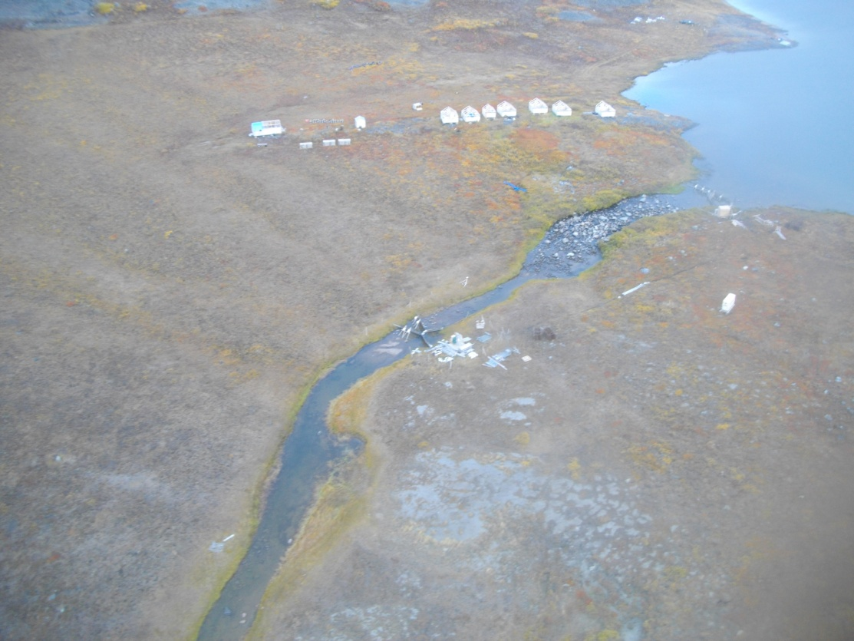
Figure A – Roberts Lake camp before clean up; looking East; note the materials in the foreground around and to the north of the river are TMAC’s.
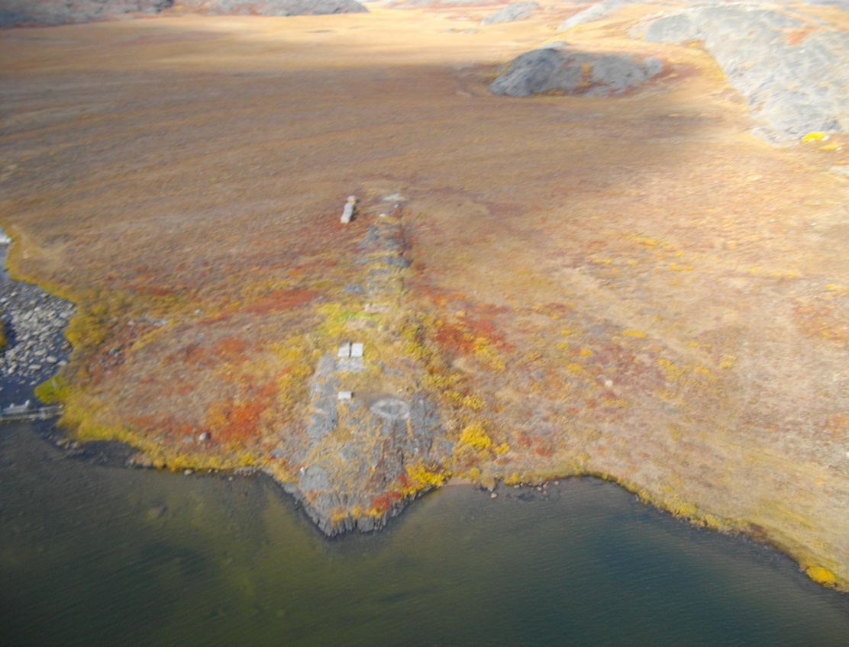
Figure B – Roberts Lake camp after clean up, looking north; drill core is visible in two areas.

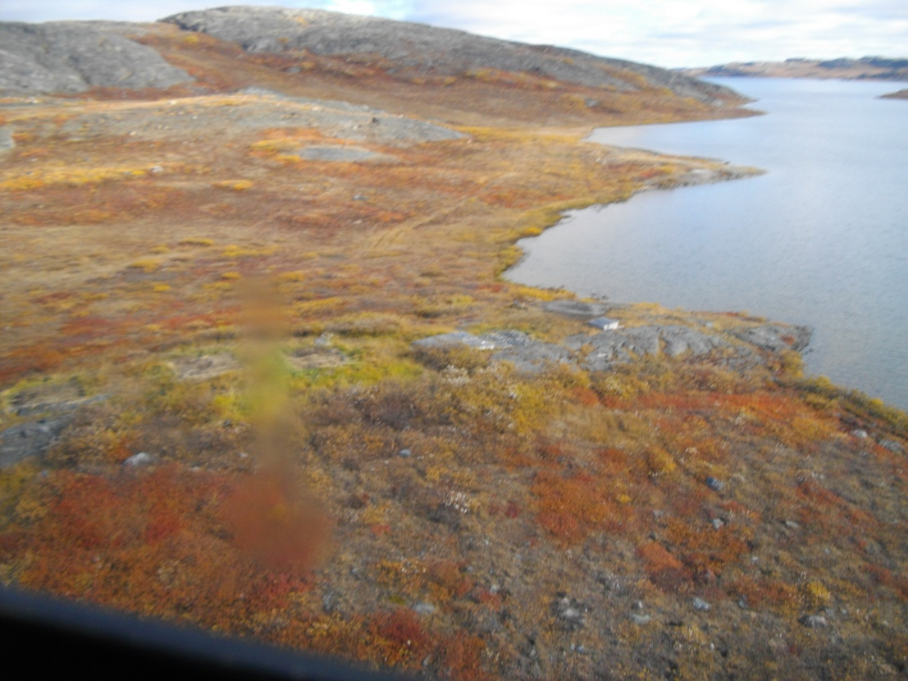
Figure C – Roberts Lake camp area after clean up; looking east over camp to the point on the lake where miscellaneous materials were also located.

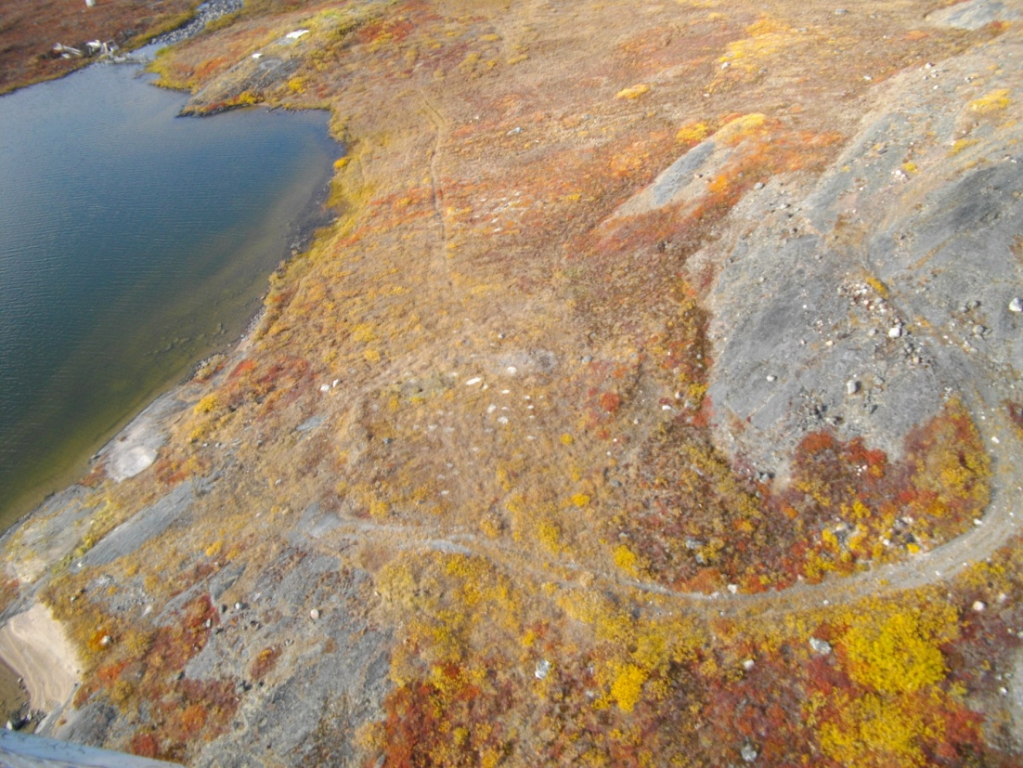
Figure D – Roberts Lake camp area after clean up; looking west; over the eastern areas where materials were located near the shore and the empty drum laydown.

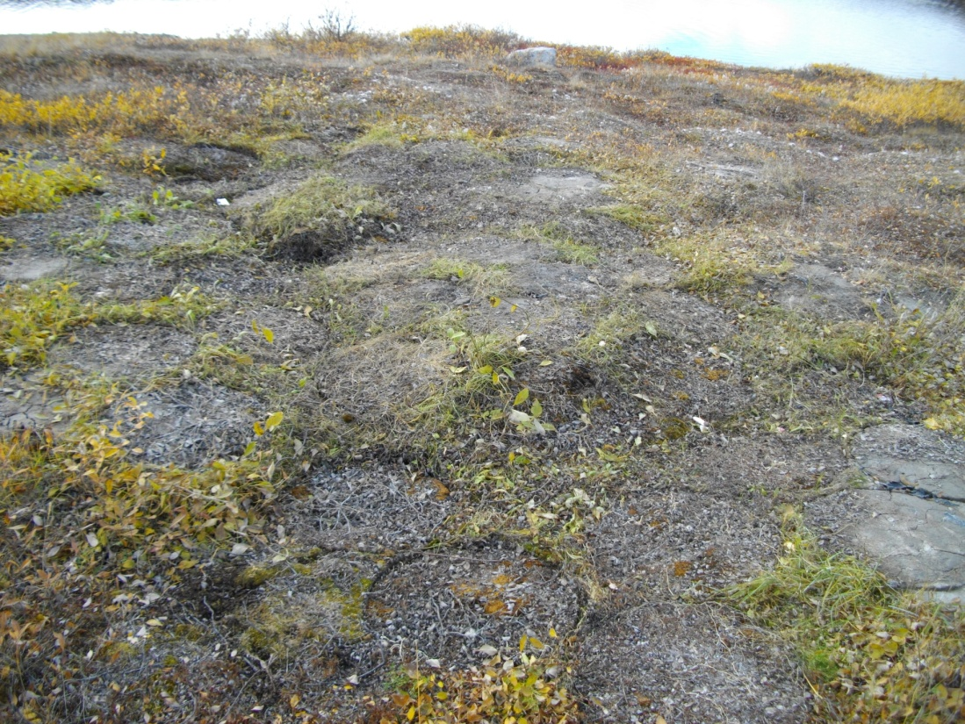
Figure E – Roberts Lake camp site after clean up; location of empty drum pile.

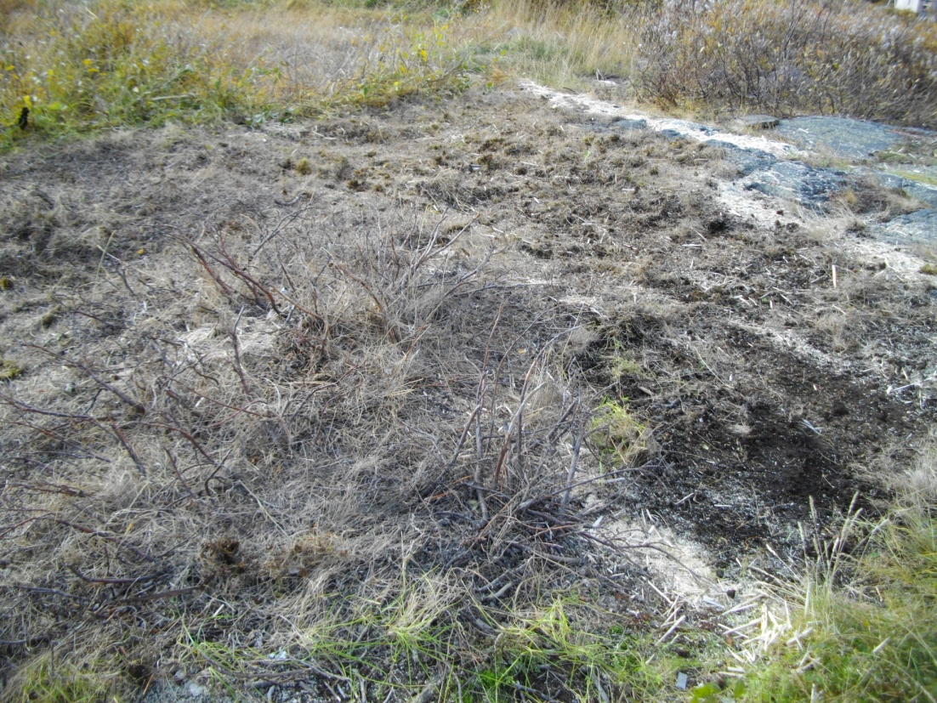
Figure F – Roberts Lake camp after clean up; example of floor removed.

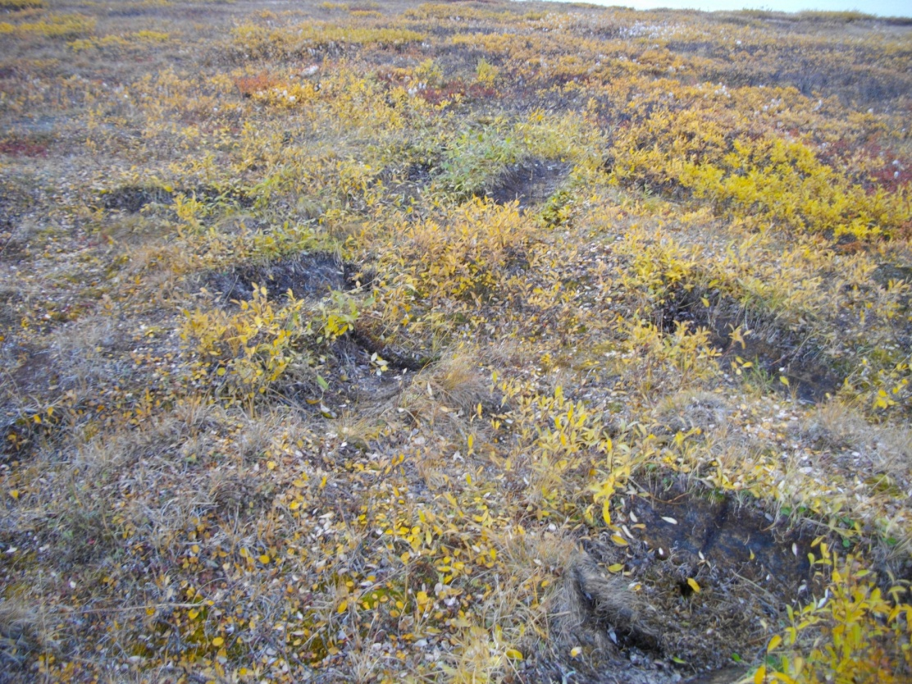
Figure G – Roberts Lake camp after clean up; gas and diesel drum location.

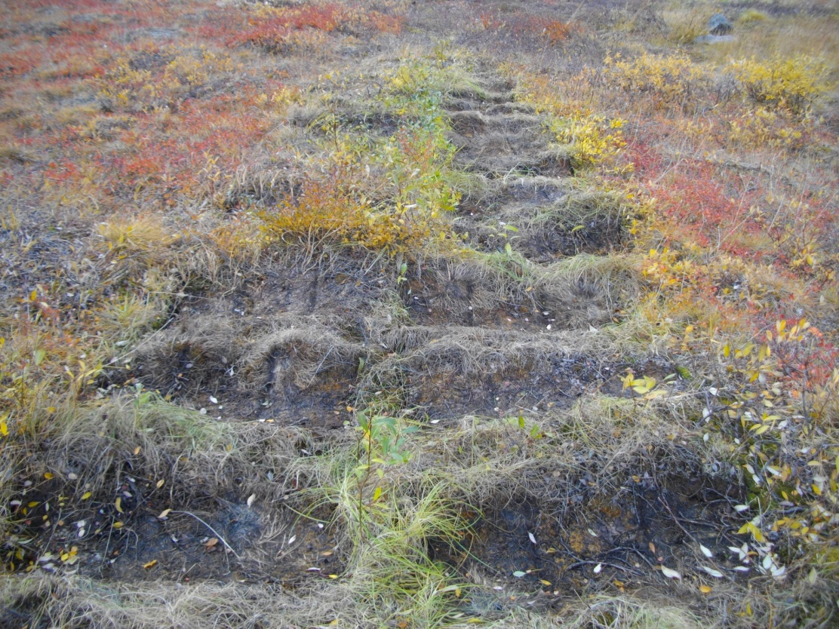
Figure H – Roberts Lake camp after clean up; location of jet B drums.

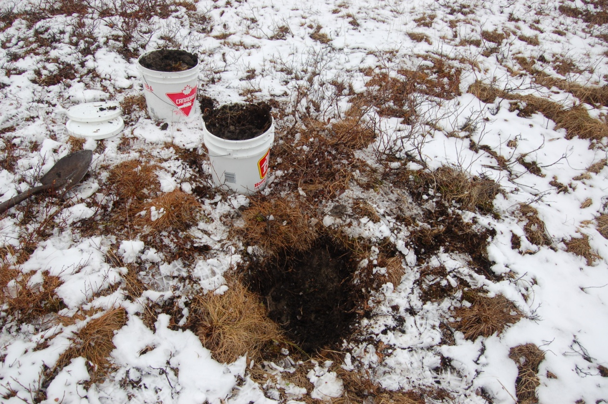
Figure I – Roberts Lake camp site; October soil collection

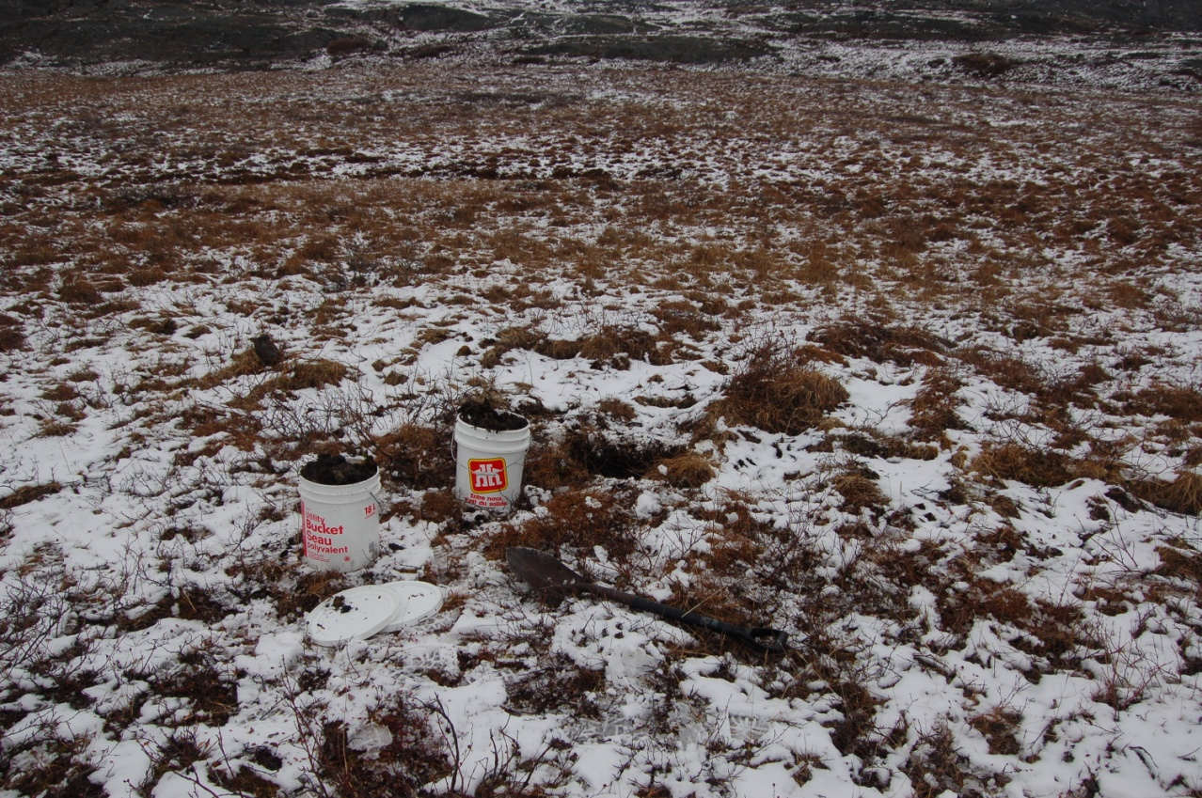
Figure J – Roberts Lake camp area; October soil collection

