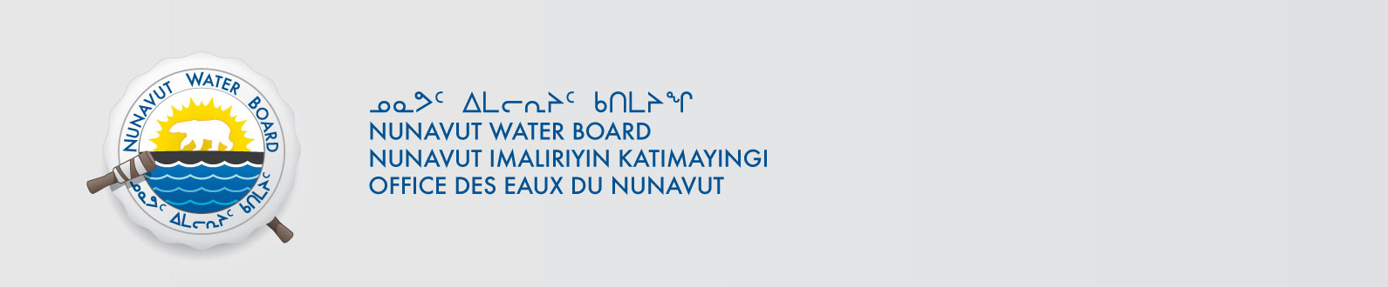

June 15, 2017 NWB File No: 2BE-HIG1217

Sarah Hasek
MMG Resources Inc.
PO Box 91460
West Vancouver BC V7V 3P1

Re: Acknowledgement and Receipt of Application Fee for renewal Water Licence Application – High Lake - Kitikmeot

Dear Ms. Hasek:

The Nunavut Water Board acknowledges receipt on June 15, 2017 of your Visa information for an application fee for the above project. Your information for payment has been forwarded to Indigenous and Northern Affairs Canada in Iqaluit for processing. A receipt will be issued through their office for fees totaling $30.00.

Please call the undersigned at (867) 360-6338 or e-mail licensing@nwb-oen.ca if you have any questions.

Sincerely,

Original signed by:

Richard Dwyer
Licensing Administrator

Cc: Ian Parsons, INAC

