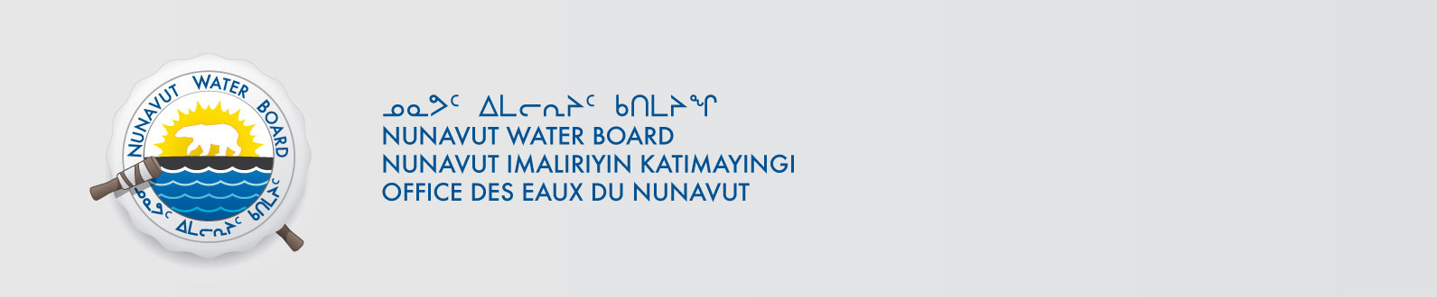

June 24, 2022 NWB File No: 2BE-HIG1722

Sarah Hasek
MMG Resources Inc.
PO Box 91460,
West Vancouver BC VC7V 3P1
E-mail: sarah.hasek@mmg.com

Re: Acknowledgement and Receipt of Application fee for water licence renewal

Dear Sarah Hasek:

The Nunavut Water Board acknowledges receipt on June 23, 2022 of your Mastercard information for an application fee for the above project. Your information for payment has been forwarded to Crown Indigenous Relations and Northern Affairs Canada in Iqaluit for processing. A receipt will be issued through their office for fees totaling $30.00.

Please call the undersigned at (867) 360-6338 or e-mail licensing@nwb-oen.ca if you have any questions.

Sincerely,

Richard Dwyer

Cc: Andrew Keim, CIRNAC

Margaret Mike, CIRNAC

Noodloo Turner, CIRNAC

