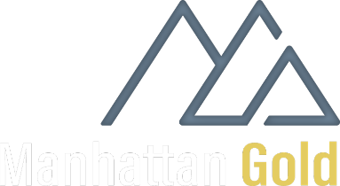

CAMP OPERATIONS AND MANAGEMENT PLAN
- Project and Camp Overview
Project Name: Hook Lake Gold and VMS Project.
Location Centre: Latitude 61° 39’ 10” N; Longitude 97° 22’ 52” W
Region: Kivalliq Region of Nunavut
Nearest Community: Arviat, NUN
Objectives and Timelines: The project involves exploration activities on both Inuit Owned Lands and Crown mineral claims, including Infrastructure, Field Exploration, and Assessment & Compliance. This is an exploration RC drilling program with some channel sampling conducted on the Hook Lake Gold and VMS property. The program start is expected to be in late June and is projected to be over a 60-day duration; 30 drillholes with 6000m total is planned.

Key Contacts:
MHC – Eric Sondergaard 403-809-4982, Samuel Vaughan 785-024-0281
AGL – Dave White 867-920-2729, Shanif Habib 778-829-9016, Evan Gladney 506-227-4738
Forest Helicopters - Scott Stevenson 807-407-1525
Ookpik Aviation (fixed wing) – Helen Kotelewetz 867-793-1399
62° North – Matt Vincent 867-446-7883
Northspan Explorations Ltd – Keenan Campbell 250-469-1739, Louis Blom 250-807-1959
Henik Lake Camp – 778-829-9016
Butler Contracting Ltd – Travis Duncan 250-532-3795

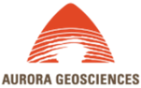

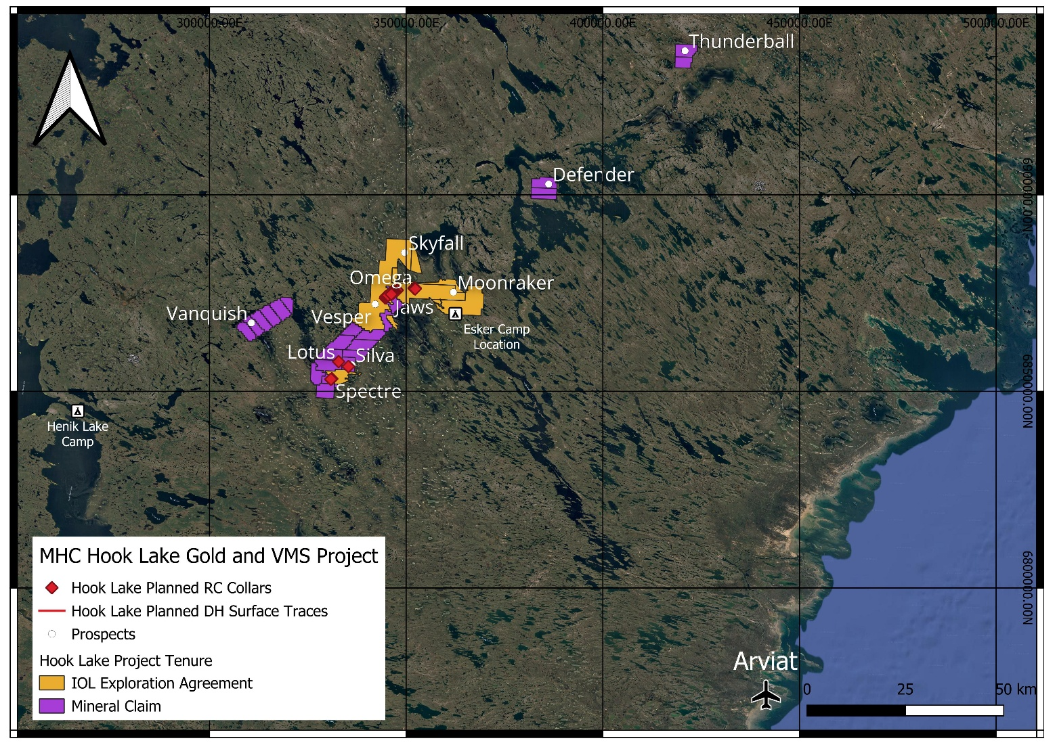
Regional Map displaying planned drillhole collars and project tenure boundaries, along with location of Arviat, Henik Lake Camp, and potential location of Esker Camp.

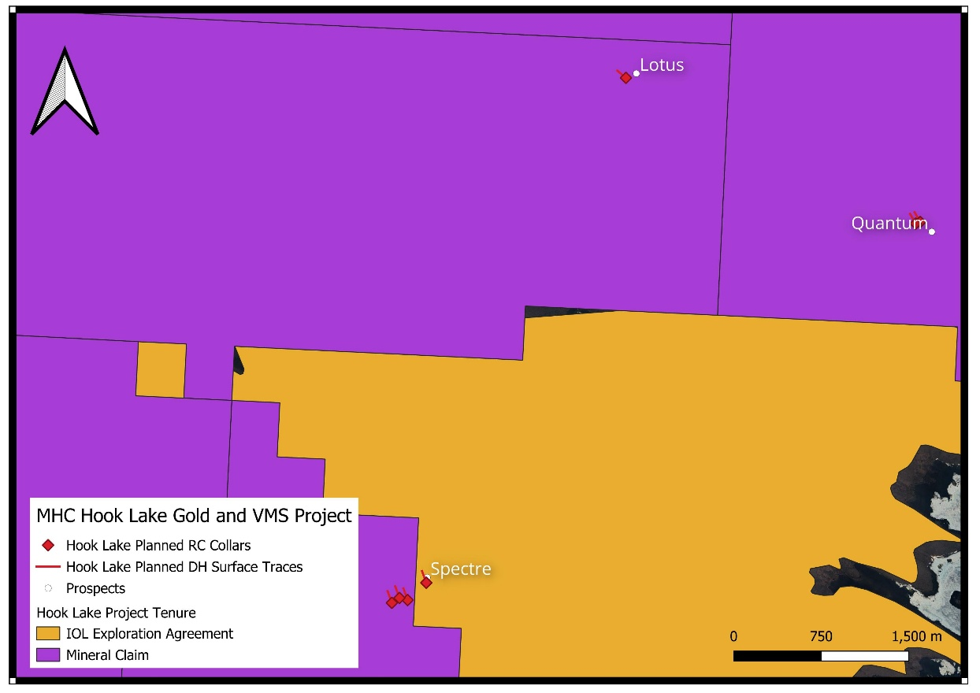
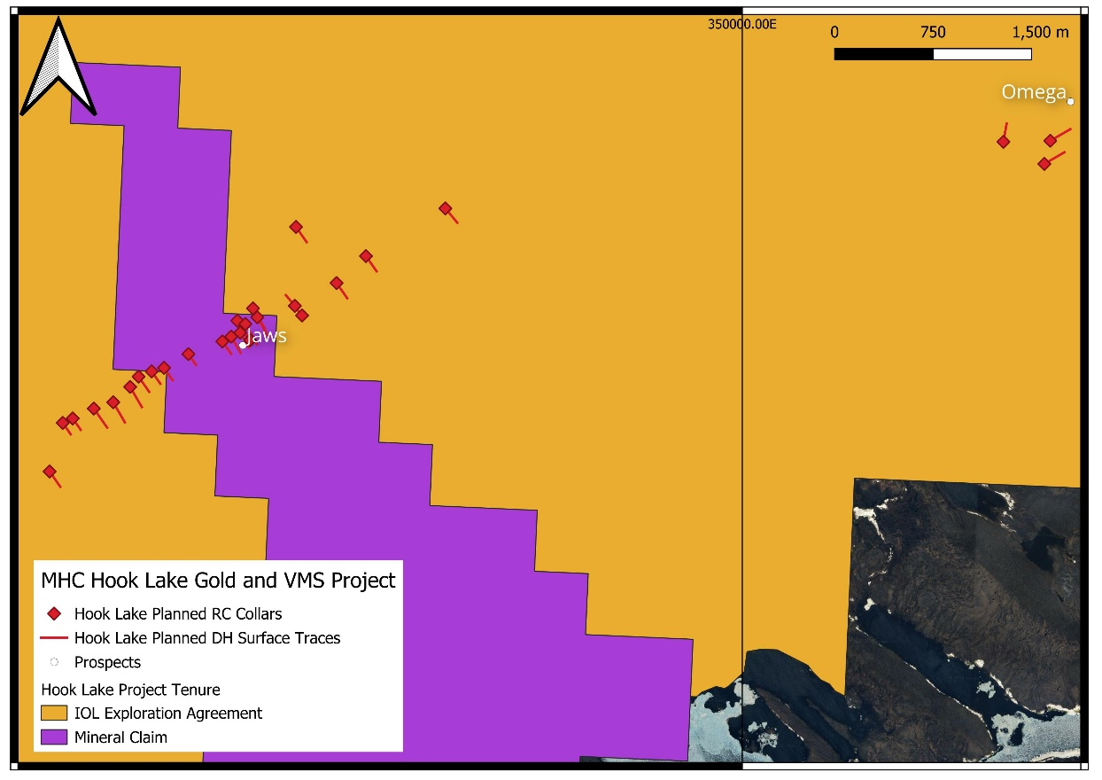
Zoomed in maps with planned drillhole collar locations and surface traces for the 2026 summer program.

- Camp Infrastructure
Site Selection: Henik Lake Camp (start of program) then potential new exploration camp on Esker (scouting flight scheduled). A new camp location would increase efficiency with operations and logistics, due to proximity to the tenure and drilling targets.
Layout Plan and Infrastructure: Weather haven tents will be built on sturdy wooden floors for sleepers, office, kitchen, dry and medical tent. Incinolet Electric incinerating toilets will be utilized to capture human waste and burn to ash for collection in waste bags for backhaul to the nearest community for disposal.
Local Accommodations: Two local hotels in Arviat will be used intermittently throughout the project, with most stays during start up while the camp infrastructure is under construction. Associated websites with relevant information are listed below.
Padlei Inns North - (https://innsnorth.com/index.php/2020/01/09/arviat/)
Katimavik Suites – (https://eplsgroup.com/katimavik-suites-page/)
Additionally, Henik Lake Camp will be used as the main camp until camp construction is completed. (https://heniklakeadventures.com/)

- Logistics and Supply Chain
The Hook Lake Project is a seasonal exploration program utilizing a temporary camp, currently established at the existing Henik Lake site with plans to relocate closer to exploratory drilling targets. The camp provides essential infrastructure, including dining, office space, core logging, and waste consolidation. Operations are accessed via Arviat using a combination of aircraft and seasonal ground transport, such as snowmobiles or tracked vehicles, as there are no all-weather roads. Water requirements are met using approved local sources in accordance with established authorizations.
Transportation: Both fixed wind and helicopter support will be utilized for the program. The fixed wing will be provided by Ookpik Aviation and helicopter support provided by Forest Helicopters. Fixed wing charters will transport groceries, camp supplies, office supplies, crew and fuel drums. Helicopter support will be used for drill moves, fuel barrel transfer to cache sites and crew changes.
Accommodation: The camp is currently being built to support a maximum of 24 people. Additionally, two hotels in Arviat will be used intermittently throughout the program duration to help with scheduling and crew change logistics, especially at the start of the program.
Catering: All meals will be made by a resident chef with grocery supplies purchased through Sysco.

- Environmental Management and Sustainability
Waste Management: The Waste Management Plan for the Hook Lake Project establishes procedures for handling waste—from reduction to disposal—for all personnel and contractors working in the project area. The primary objectives include: 1) Environmental Protection -Preventing contamination of land, water, snow, ice, and vegetation. 2) Safety & Compliance - Protecting communities and wildlife while adhering to all relevant permits, licenses, and land use authorizations. 3) Site Integrity – Minimizing wildlife attraction and supporting efficient seasonal closure and final reclamation.
Waste generated by the Hook Lake Project falls into four primary categories:
- Domestic & General: Includes standard camp refuse, food/putrescible waste, and packaging materials like cardboard, paper, wood, plastic, metal, and glass.
- Liquid & Human Waste: Comprises greywater from kitchens and wash facilities, as well as sewage and blackwater.
- Hazardous & Contaminated: Consists of used oil, lubricants, grease, filters, solvents, batteries, and materials contaminated by hydrocarbons (e.g., soil, snow, ice).
- Operational & Drilling: Includes incinerator ash, core cutting waste, drill cuttings, and drilling wastewater.

The Hook Lake Project will not utilize an on-site landfill. Instead, waste will be minimized and segregated at the source, with any materials that cannot be safely treated or disposed of on-site being backhauled to an approved waste management facility.

The Waste Management Plan for the Hook Lake Project is designed to ensure full compliance with a comprehensive suite of federal and territorial regulations, as well as project-specific authorizations.
- Federal Statutes: Adheres to key legislation including the Canadian Environmental Protection Act, Fisheries Act, Hazardous Products Act, and the Transportation of Dangerous Goods Act.
- Territorial Requirements: Complies with Nunavut-specific laws such as the Nunavut Waters and Nunavut Surface Rights Tribunal Act and Territorial Land Use Regulations.
- Environmental Guidance: Follows government standards for hazardous waste management, solid waste incineration, and technical guidelines for batch incineration.
- Project-Specific Authorizations: Incorporates all applicable licenses, leases, and permits regarding land and water use.

Waste can be divided into Combustible and Non-Combustible with the following protocols:
Combustible - Here is the summary of the combustible waste management protocols:
- Waste Management Strategy: All combustible waste—including paper, cardboard, wood, and food—will be reduced, reused, and strictly segregated at the source into categories (food, clean combustibles, recyclables, and hazardous) to maintain order and safety.
- Food Waste & Wildlife: To mitigate the primary risk of wildlife attraction, food waste must be incinerated daily; if incineration is not possible, it must be double-bagged and stored in secured, wildlife-resistant containers.
- Authorized Burning: Untreated wood, clean cardboard, and paper are approved for burning, though open burning should be minimized where practical.
- Prohibited Items: Plastics, treated wood, fuel-contaminated materials, aerosol cans, and batteries are strictly prohibited from being burned.
- Ash Management: Incinerator ash must be collected, sealed, and backhauled to an approved disposal facility to ensure proper off-site handling.

Non-Combustible - The management of non-combustible waste—such as metal, plastic, glass, and construction debris—focuses on reducing waste and ensuring secure removal:
- Reduction & Reuse: Prioritizing bulk purchasing and reusing containers or materials whenever safe and suitable.
- Handling & Disposal: Segregating waste at the source and consolidating materials for backhaul to an approved landfill or recycling facility.
- Wildlife & Environmental Protection: Double-bagging and securing all food-contaminated waste.
- Risk Mitigation: Preventing litter and wildlife attraction through regular site inspections, daily cleanup of remote work areas, and proper consolidation of backhaul loads.

Sewage and Blackwater: Sewage and blackwater management at the Hook Lake Project prioritizes environmental protection and regulatory compliance through the following practices:
- System Selection: Toilet systems—including pacto, incinerating, pit, or portable units—are selected based on site-specific factors such as camp size, seasonal conditions, and applicable permit requirements.
- Operational Standards: Pit toilets must be located at least 31 m from the Ordinary High-Water Mark of any waterbody (unless otherwise authorized) and must be sealed or secured when not in use.
- Waste Disposal: Depending on the system, waste is either incinerated using approved equipment or backhauled to an authorized facility in sealed containers or bins.
- Environmental Mitigation: To address risks like wildlife attraction, odour, and soil or water contamination, the project enforces strict protocols including regular inspections, secure storage, removal of waste from remote sites, and proper reclamation of pit toilets upon closure.

Greywater: The management of greywater, generated from kitchen, shower, and wash facilities (estimated at 5 m³/day), focuses on responsible on-site disposal and environmental protection:
- Disposal Strategy: Greywater will be discharged into an approved sump or infiltration area that demonstrates suitable capacity for the volume.
- Operational Controls:
  - Pre-treatment: To prevent wildlife attraction, all kitchen greywaters must pass through strainers or traps to remove food particles before entering the sump.
  - Siting: All sumps must be located at least 31 m from the Ordinary High-Water Mark of any waterbody, unless otherwise authorized.
  - Monitoring: Regular inspections are required to monitor for odour, erosion, overflow, and infiltration efficiency. Treatment agents (e.g., lime or lye) may be applied if odour or wildlife issues arise.
- Closure: All greywater sumps must be fully backfilled and reclaimed when the camp is decommissioned.
- Environmental Protection: These measures mitigate potential impacts, including nutrient enrichment of waterbodies, ground disturbance, and wildlife attraction.

Inspections and Record Keeping: Regular inspections and detailed record-keeping are required to ensure the Hook Lake Project meets operational and environmental standards:
- Regular Monitoring: The Camp Manager or a designated person is responsible for performing frequent inspections of all waste infrastructure, including storage areas, sumps, incineration areas, toilets, and secondary containment systems.
- Inspection Logs: Comprehensive records must be maintained for every inspection, documenting the date, inspector name, facility conditions (including signs of wildlife access or odour), waste volumes, corrective actions taken, and details of any spills or incidents. Documentation will be recorded in SiteDocs.
- Backhaul Documentation: A separate log tracks all waste removed from the site, recording the type and quantity of waste, removal date, method of transport, destination facility, and any required shipping documentation for regulated or hazardous waste.

Spill Contingency: The Fuel Spill Contingency Plan for the Hook Lake exploration program in Nunavut provides a structured action plan for potential spill events. Its primary objectives are to:
- Minimize Impacts: Reduce health and safety hazards, environmental damage, and clean-up costs.
- Define Procedures: Establish clear protocols for response organization, action planning, incident reporting, and training exercises, while detailing specific operational sites.
- Ensure Compliance: Require that all hazardous waste movement is accompanied by a Waste Manifest.

- Health, Safety and Security
First Aid Facilities: There will be 2 on-site medics accessible 24 hours a day, a dayshift and nightshift. Dayshift medic will remain in camp, and nightshift medic will accompany the drillers at the drill rig/survival shack for the duration of their shift - due to the helicopter pilots duty day hours and not flying during the night.

Emergency Evacuation: An ERP (Emergency Response Plan) will be available, and copies placed behind every door in each tent.

Wildlife Interaction: A bear-safety fence will be constructed around the camp. Every tent will be supplied with bear spray, airhorn, and bear bangers.
The wildlife mitigation and monitoring plan establishes strict guidelines to ensure minimal disturbance to wildlife in the Hook Lake Project area. Key points include:
- Location & Habitat: The project area is outside critical caribou calving grounds and contains no primary migratory bird nesting sites, though it does host several species of concern, including the wolverine, grizzly and polar bears, and various raptors.
- Plan Objectives: The strategy focuses on two main areas: implementing measures to mitigate disturbances to caribou and other wildlife and establishing a consistent monitoring program for all wildlife sightings.
- Mitigation Plan: The wildlife mitigation and monitoring plan for the Hook Lake Project establishes strict operational protocols to ensure minimal impact on local wildlife:
- Caribou Protection: All activities—including drilling, equipment movement, and flights—must be suspended immediately if caribou calving is observed. Drilling is prohibited within 5 km and fuel caches within 10 km of important caribou crossings, with a minimum flight altitude of 610 m maintained in the presence of caribou.
- Aviation Standards: Low-level flights should be avoided. Large bird concentrations require 1,000 m vertical and 1,500 m horizontal distancing. Nesting raptors must be avoided by at least 1.5 km from April 15 to September 1, and nest sites must be avoided entirely from late May through mid-July.
- Personnel Protocols: All staff must complete mandatory training on wildlife safety, waste management, and interaction reporting. Feeding wildlife and hunting are strictly prohibited for all employees.
- Bear Safety & Waste: Personnel must follow the Safety in Bear Country Manual and strictly adhere to proper food and garbage disposal procedures to minimize attractants.

Monitoring Plan: Wildlife monitoring and reporting protocols at the Hook Lake Project ensure consistent data collection and proactive wildlife management:
  - Monitoring & Documentation: All wildlife sightings (date, species, and coordinates) must be tracked on in-camp sheets and compiled into a master spreadsheet for inclusion in the annual report. Export any reports from SiteDocs to include in annual report.
  - Attractant Control: Strict food storage and waste management protocols are enforced to minimize wildlife interactions; any nuisance wildlife must be reported immediately.
  - Regulatory Reporting: At the end of the operational season, all wildlife observations must be submitted to the GN-DOE (Wildlife Division) Kivalliq regional contacts: Rob Harmer (Regional Manager) and Mitch Campbell (Biologist).

Fire Safety: A fire extinguisher will be in each tent on site and near any fuel sources and machinery, such as the camps generator or any potential fire hazards/risks.

- Site Reclamation and Closure
Decommissioning: At the end of each field season or during a temporary shutdown, AGL will ensure the site is secured and cleaned through the following measures:
- Waste Management: Consolidate and backhaul general and hazardous waste where practical; all remaining waste must be secured in sealed, wildlife-resistant containers.
- Wildlife Protection: Remove, incinerate, or securely store all food waste and wildlife attractants to prevent interactions.
- Infrastructure Shutdown: Empty, secure, or close toilet systems and inspect/secure all sumps to ensure environmental stability.
- Hazardous Materials: Ensure all fuel and hazardous materials are safely stored within secondary containment.
- Final Verification: Clean the camp area thoroughly and complete all required inspection and closure documentation.

Remediation: Final closure and reclamation for the Hook Lake Project focus on restoring the site to a clean and stable condition through the following procedures:
- Infrastructure Removal: All waste, equipment, fuel, hazardous materials, and temporary infrastructure will be removed from the site unless otherwise authorized.
- Site Remediation: Activities include backfilling dug sumps, reclaiming disturbed areas, and cleaning waste storage areas.
- Contamination Management: Any contaminated soil, snow, ice, or other materials will be transported to an approved disposal facility.
- Verification: Final site inspections will be conducted to ensure no waste or contamination remains, with all removal and reclamation activities fully documented to confirm compliance.

Reporting: The Fuel Spill Contingency Plan emphasizes immediate communication and reporting to manage spills during the Hook Lake exploration program effectively:
- Communication Protocol: Two-way and satellite radios will be set up at the drill rig and external fuel caches, allowing for immediate reporting of any spills to the Project Supervisor.
- Emergency Contact Information: Contact details for the NWT/NU 24-Hour Spill Report Line, government contacts, and company officials must be prominently displayed at all fuel sources and in the main camp facilities.
- Compliance & Documentation: All movements of hazardous waste must be accompanied by a Waste Manifest to maintain regulatory compliance.
- Spill report form must be filled out as completely as possible before making the report, then a report must be made Immediately to the Government of Nunavut 24-hour spill report line – 867-920-8130. The spill form will also be emailed to spills@gov.nt.ca.

