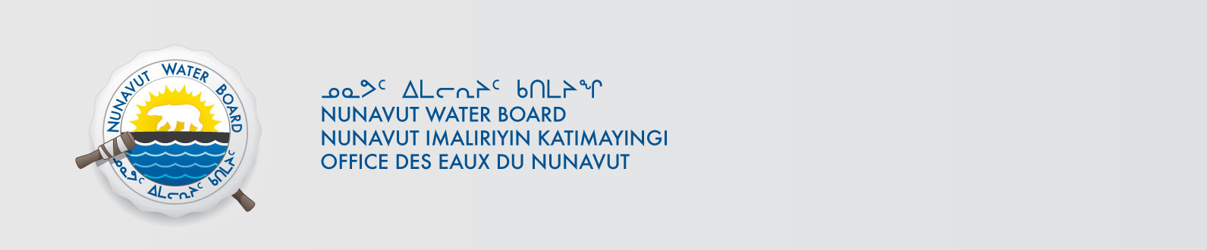
NWB File No: 2BE-HUC----

May 18, 2018

David Frenette
Agnico Eagle Mines Ltd.
C.P. 87, 765 chemin de la mine Goldex
Val-d’Or, Quebec J9P 4N9

E-mail: david.frenette@agnicoeagle.com

Re: Acknowledgement and Receipt of Application Fee and Water Use Fee Deposit for New Water Licence Application – Huckleberry Project - Kivalliq

Dear Mr. Frenette:

The Nunavut Water Board acknowledges receipt on May 17, 2018 of your application fee and water use fee deposit, cheque number 008890, for the above project. Your information for payment has been forwarded to Indigenous and Northern Affairs Canada in Iqaluit for processing. A receipt will be issued through their office for fees totaling $60.00 ($30.00 for administration & 30.00 for water use fee deposit). Full payment of the water use fee is required prior to issue of any water licence.

Please refer to the calculation for water use fees, in the Nunavut Waters Regulations, Section 12, to ensure that the correct fee has been submitted. A copy of this regulation is available from our ftp site or by contacting this office. This is an annual fee which is required to be submitted yearly on the anniversary of the issuance of your water licence.

Please call the undersigned at (867) 360-6338 or e-mail licensing@nwb-oen.ca if you have any questions.

Sincerely,

Richard Dwyer
Manager Licensing

Cc: Sarah Forté, INAC
Alice Pallister, INAC

