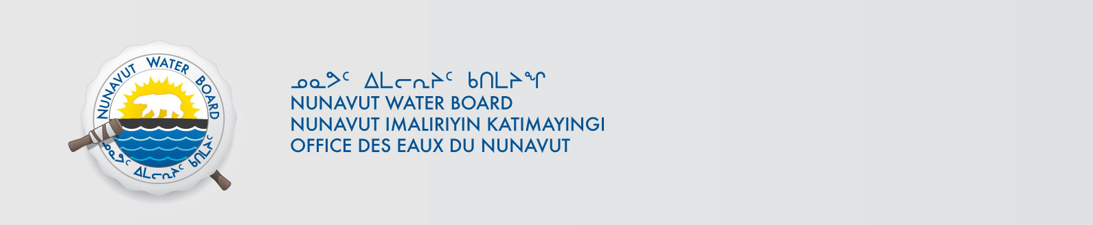

May 22, 2018 NWB File No: 2BE-HUC----

David Frenette
Agnico Eagle Mines Ltd.
C.P. 87, 765 chemin de la mine Goldex
Val-d’Or, Quebec J9P 4N9
E-mail: david.frenette@agnicoeagle.com

Subject: Application Acknowledgement for the Huckleberry Exploration Project

Dear Mr. Frenette:

The Nunavut Water Board (“NWB”) acknowledges receipt on May 15, 2018 of your new water licence application, for the Huckleberry Exploration Project. This application has been assigned file number 2BE-HUC----. Please refer to this number on future submissions. Application documents received are as follows:

- 180420 2BE-HUC---- Waste Management Plan
- 180420 2BE-HUC---- Main application document
- 180420 2BE-HUC---- Non-technical Summary English
- 180420 2BE-HUC---- Non-technical Summary Inuktitut
- 180420 2BE-HUC---- Power of Attorney AEM_signed
- 180420 2BE-HUC---- Water Licence Application
- 180420 2BE-HUC---- Water Management Plan HB_April2018
- 180515 2BE-HUC---- Spill Contingency Plan
- 180515 2BE-HUC---- Water Licence Application Revised
- 180522 2BE-HUC---- Closure & Reclamation Plan

Please be advised that under the Agreement Between the Inuit of the Nunavut Settlement Area and Her Majesty the Queen in Right of Canada (Nunavut Agreement) Article 11, Section 11.5.9 and s. 76 (1) of Nunavut Planning and Project Assessment Act (NuPPAA), the proponent of a project governed by NuPPAA is also required to submit a project proposal document directly to the Nunavut Planning Commission (NPC or Commission) for the NPC’s determination regarding the applicable land use planning requirements and/or directions regarding whether the project is subject to screening by the Nunavut Impact Review Board. In particular, please note that as established under Articles 11, 12 and 13 of the Nunavut Agreement, NuPPAA and Part 3 of the Nunavut Waters and Nunavut Surface Rights Tribunal Act, until the project has completed the applicable land use planning and assessment process required by the NPC and the NIRB, the NWB cannot issue a water licence/approval.

The NWB confirms receipt of NPC conformity under NuPPAA on November 22, 2017 and NIRB determination through NPC under NuPPAA on March 23, 2018. This application is now ready for review and comments. Deadline for submissions is June 22, 2018.

Please call the undersigned at (867) 360-6338 or email to licensing@nwb-oen.ca if you have any questions.

Sincerely,

Richard Dwyer
Manager Licensing

