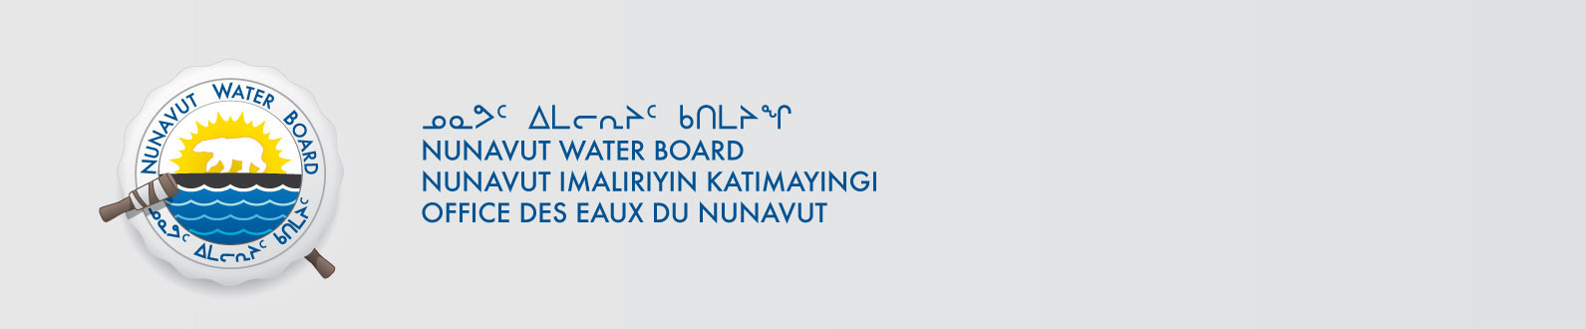

May 22, 2018 File No: NWB2ATU9899 2BE-HUC----

To: Hamlet, CLARC, HTO, RIA, Coop, and NorthernLocal Organizations – Request to Post Notices

The Nunavut Water Board requests that you post on a bulletin board, until June 22, 2018, the attached notices (in English and Inuktitut), where they can be viewed by the public. The attached letter is for your information and does not require posting.

Your time and effort is greatly appreciated.

Sincerely,

Richard Dwyer
Manager of Licensing

Cc: Hamlet/Mayor of Baker (867) 793-2509
Kivalliq-IA (867) 793-2126
Baker Lake HTO (867) 793-2034
Northern Store (867) 793-2565
Sanavik Co-op (867) 793-2711
Hamlet/Mayor Chesterfield (867) 898-9108
Kivalliq-IA (867) 898-9161
Aqigiq HTO (867) 898-9079
Northern Store (867) 898-9160
Pitsiulak Co-op (867) 898-9056
Hamlet/Mayor Rankin (867) 645-2146
Kivalliq-IA (867) 645-2348
Aqiggiaq HTO (867) 645-3257
Northern Store (867) 645-2082
Kissarvik Co-op (867) 645-2280

