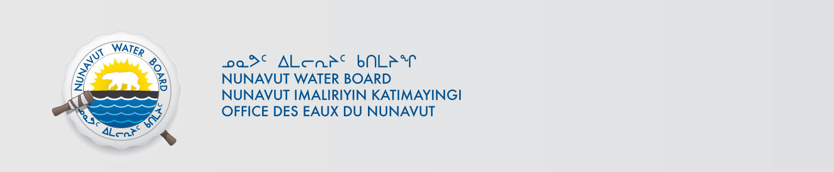

November 9, 2017 NWB File No: 2BE-IZO1217

Theodore Muraro
MMG Resources Inc.
PO Box 91460,
West Vancouver BC VC7V 3P1
E-mail: Theodore.Muraro@mmg.com

Subject: Renewal Application Izok Lake Project 2BE-IZO1217

Dear Mr. Muraro:

The Nunavut Water Board (“NWB”) acknowledges receipt on November 2, 2018 and November 8, 2017 of your water licence renewal application, for the Izok Lake Project. This application has been assigned file number 2BE-IZO1217. Please refer to this number on future submissions. Application documents received are as follows:

171102 2BE-IZO1217 148636 NPC Letter re Izok Lake Project-ILAE.pdf
171102 2BE-IZO1217 2016 Annual Report-ILAE.pdf
171102 2BE-IZO1217 Inuktitut Project Description-ILAE.docx
171102 2BE-IZO1217 Renewal Supplemental Info Pckg.pdf
171102 2BE-IZO1217 Waste Disposal Plan-ILAE.pdf
171102 2BE-IZO1217 Water Licence Renewal Application-ILAE.doc
171102 2BE-IZO1217 Water Licence Renewal Application-ILAE.pdf
171108 2BE-IZO1217 IZK A AND R PLAN 2014_revisedNOV13-ILAE.pdf
171108 2BE-IZO1217 IZK SPILL CONTINGENCY PLAN 2013-ILAE.pdf
171108 2BE-IZO1217 SLAVE EXPLORATION - WILDLIFE MANAGEMENT-ILAE.pdf

Please be advised that under the Agreement Between the Inuit of the Nunavut Settlement Area and Her Majesty the Queen in Right of Canada (Nunavut Agreement) Article 11, Section 11.5.9 and s. 76 (1) of Nunavut Planning and Project Assessment Act (NuPPAA), the proponent of a project governed by NuPPAA is also required to submit a project proposal document (which may include the water licence application) directly to the Nunavut Planning Commission (NPC or Commission) for the NPC’s determination regarding the applicable land use planning requirements and/or directions regarding whether the project is subject to screening by the Nunavut Impact Review Board. In particular, please note that as established under Articles 11, 12 and 13 of the Nunavut Agreement, NuPPAA and Part 3 of the Nunavut Waters and Nunavut Surface Rights Tribunal Act, until the project has completed the applicable land use planning and assessment process required by the NPC and the NIRB, the NWB cannot issue a water licence.

The NWB confirms receipt of NPC conformity under NuPPAA on October 30, 2017 and NIRB determination through NPC under NuPPAA on October 30, 2017. This application is now ready for review and comments. Deadline for submissions is December 11, 2017.

Please call the undersigned at (867) 360-6338 or email to licensing@nwb-oen.ca if you have any questions.

Sincerely,

Richard Dwyer
Licence Administrator

Cc: Kitikmeot Distribution List

