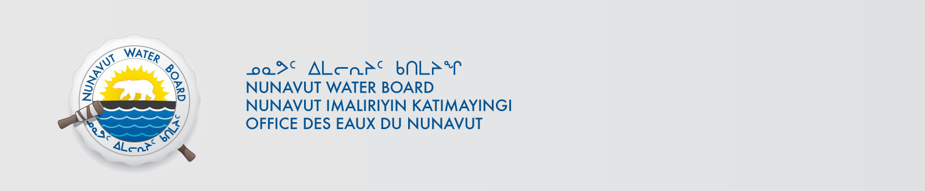
File No.: 2BE-IZO1217/TR/B2
2BE-HIG1217/TR/B2
May 3, 2013

Teodore J. Muraro
MMG Resources Inc.
26th Floor – 1177 West Hastings St.
Vancouver, BC V6E 2K3
Email: TED.MURARO@MMG.COM

Subject: Licence No. 2BE-IZO1217 “Izok Lake Project” Kitikmeot Region, Nunavut;
Licence No. 2BE-HIG1217 “High Lake Project” Kitikmeot Region, Nunavut;
Submission of 2012 Annual Reports

Dear Mr. Livingstone,

The Nunavut Water Board (“NWB” or “Board”) has reviewed the 2012 Annual Reports for the above mentioned projects that were submitted on January 25, 2013. The 2012 Report included the following documents with respect to the 2BE-IZO1217:
- Operating and Maintenance Manual for Forced Air Incineration System;
- Slave Exploration Wildlife Management Plan prepared November 2011;
- Waste Disposal Plan Slave Projects amended October 2012;
- Spill Contingency Plan Exploration Operations Izok, Hood and Gondor Projects Nunavut, Canada dated March 2011;
- Abandonment and Restoration Plan Izok Project dated March 2011; and
- Maps and Photos.

The following documents were included within the Licence 2BE-HIG12117 2012 Report:
- Slave Exploration Wildlife Management Plan prepared November 2011;
- Waste Disposal Plan Slave Projects amended October 2012;
- Spill Contingency Plan Exploration Operations High Lake and High Lk. East Properties Nunavut, Canada revised December 15th, 2011;
- Abandonment and Restoration Plan Exploration Operation High Lake/High Lk. East Camps Nunavut, Canada; and
- Maps.

The Annual Reports are generally found to be complete and meeting the reporting requirements of licenses 2BE-IZO1217 and 2BE-HIG1217. In addition, the NWB appreciates the inclusion of the photographs to help aid in the understanding of the activities that have taken place.
It is noticed that the Abandonment and Restoration Plan Izok Project is the one that was included with the application for Izok Project Water Licence renewal. However, Part I Item1 required an updated Plan or an Addendum to the Plan to be submitted for review. Although the NWB acknowledged that Amended Waste Disposal Plan Slave Projects provides procedures regarding the waste incineration, however, the next revision to the Abandonment and Restoration Plan should exclude the burning of site structures as a mean of disposal. Open burning is not a recommended mean for waste disposal.

Should you have any questions, please feel free to contact the undersigned at (867) 360-6338 Ext. 30 or k.kharatyan@nunavutwaterboard.org, at your earliest convenience.

Yours truly,

Original Signed By:

Karén Kharatyan
Technical Advisor

cc: Distribution List – Kitikmeot

