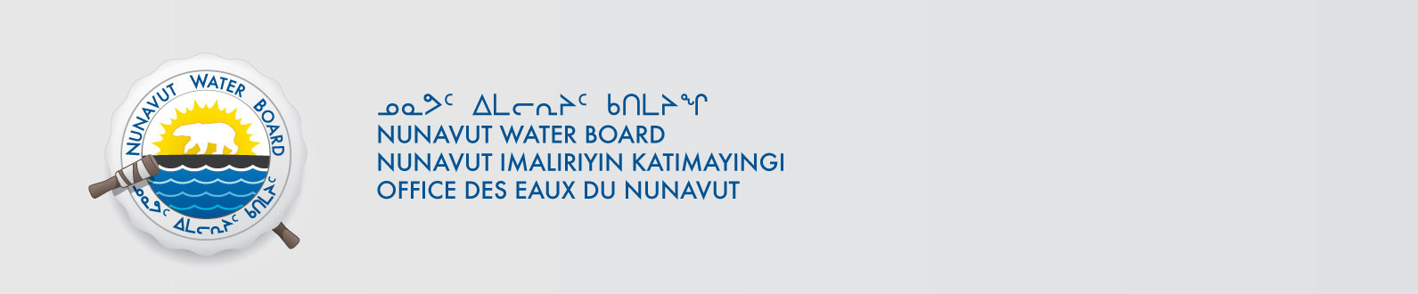
File: 2BE-IZO1217
March 10, 2014

Distribution List Kitikmeot and MMG Resources Inc

RE: NWB Licence No. 2BE-IZO1217

ERRATA
NWB2MEL0103
Please change the following in the recently approved water licence for the above file.

Decision Page ii

Change from
Project Extents
NW: Latitude: 68º 00’ 00’’ N Longitude: 111º 30’ 00’’ W
NE: Latitude: 68º 00’ 00’’ N Longitude: 109º 30’ 00’’ W
SE: Latitude: 66º 45’ 00’’ N Longitude: 109º 30’ 00’’ W
SW: Latitude: 66º 45’ 00’’ N Longitude: 111º 30’ 00’’ W

to

Project Extents
Latitude: 65º 00’ 00’’ N to 66º 20’ 00’’ N
Longitude: 111º 15’ 00’’ W to 113º 15’ 00’’ W

Should you have any questions, please feel free to contact the undersigned at (867) 360-6338 or licensing@nwb-oen.ca , at your earliest convenience.

Sincerely,

Original signed by:

Robin Ikkutisluk
Licence Administrator Assistant

cc: Distribution List – Kitikmeot

