December 5, 2013 NWB File No: 2BE-KAZ1011

Scott Stringer
Newmont Mining Corporation
P.O Box 2000
Yellowknife, NT X1A 2M1
E-mail: scott.stringer@newmont.ca

Re: Acknowledgement and Receipt of Application Fee – Cancellation of Water Licence – Baker Lake Basin Project

Dear Scott Stringer:

The Nunavut Water Board acknowledges receipt on August 12, 2013 of your application fee, cheque number 200000383, for the above project. Your payment has been forwarded to Aboriginal Affairs and Northern Development Canada in Iqaluit for processing. A receipt will be issued through their office for fees totaling $30.00.

Please call the undersigned at (867) 360-6338 or e-mail licensing@nunavutwaterboard.org if you have any questions.

Sincerely,

Original signed by:

Megan Porter
Licence Administrator Assistant

Enclosure

Cc: Jean Allen, AANDC
Rory MacDonald, AANDC
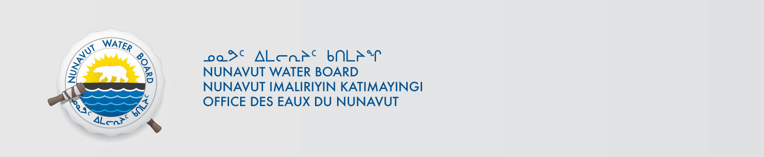
Melanie Netser, AANDC

