xxxx, 2013 NWB File No.: 2BE-KAZ1011

Mr. Scott Stringer
Newmont Mining Corporation
P.O. Box 2000
Yellowknife, NT X1A 2M1
Email: scott.stringer@newmont.com

Subject: Licence 2BE-KAZ1011 – Submission of Water Licence Closure Inspection

Dear Mr. Stringer:

The Nunavut Water Board (“NWB”) has completed a review of the above mentioned submission from Aboriginal Affairs and Northern Development Canada (“AANDC”) dated July 11, 2012. The report is based on observations made during a site visit of the closed and abandoned camp site related to the project, located in the Kivalliq Region, Nunavut. AANDC indicates that none of the remaining infrastructure associated with the camp was present on site, and no remediation issues were noted. AANDC recommends that this file may now be closed.

The NWB hereby informs all parties that the 2BE-KAZ1011 file is now closed. Any future activities on this site involving the use of water or the deposit of waste, will require a new licence. Should you have any questions, please feel free to contact the undersigned.

Sincerely,

Original signed by:

Phyllis Beaulieu
Manager of Licensing

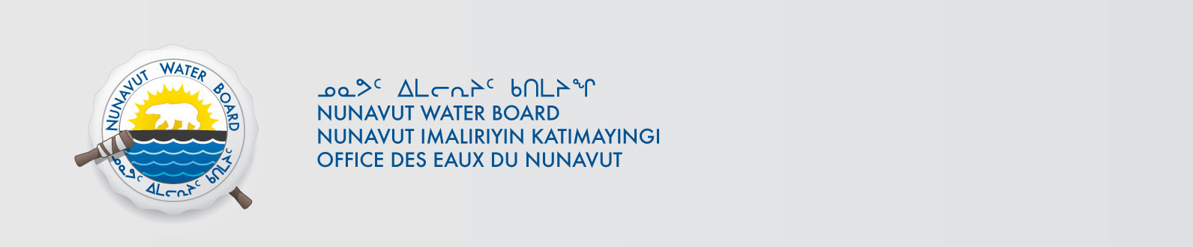
Cc: Distribution List –Kivalliq

