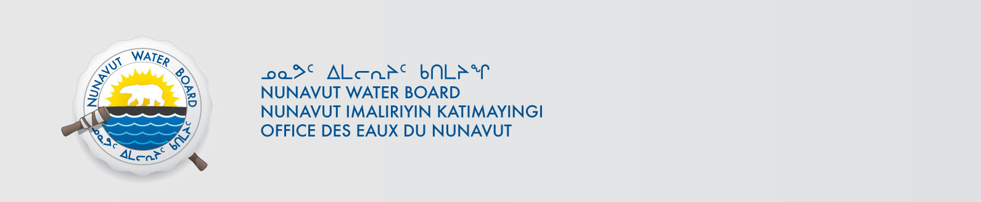
File No: NWB2ATU98992BE-KIG0812

April 8, 2015

To: Hamlet, CLARC, HTO, RIA, Coop, and NorthernLocal Organizations – Request to Post Notices

The Nunavut Water Board requests that you post on a bulletin board, until April 10, 2000May 8, 2015, the attached notices (in English and Inuktitut), where they can be viewed by the public. The attached letter is for your information only and does not require posting.

Your time and effort is greatly appreciated.

Sincerely,
Original signed by:

Robin Ikkutisluk
Licensing Administrator Assistant

Cc: Hamlet of Arviat (867) 857-2519
KIA (867) 857-2911
HTO (867) 857-2488
Northern Store (867) 857-2925 or 2679
Padlei Co-op (867) 857-2762
Hamlet of Rankin Inlet (867) 645-2146
KIA (867) 645-2348
HTO (867) 645-3257
Northern Store (867) 645-2082
Kissarvik Co-op (867) 645-2280
Hamlet of Chesterfield (867) 898-9108
KIA (867) 898-9161
HTO (867) 898-9079
Northern Store (867) 898-9160
Pitsiulak Co-op (867) 898-9056
Hamlet of Whale Cove (867) 896-9109
KIA (867) 896-9127
HTO (867) 896-9143
Issaluk Co-op (867) 896-9087
Hamlet of Baker Lake (867) 793-2509
KIA (867) 793-2126
HTO (867) 793-2034
Northern Store (867) 793-2565
Sanavik Co-op (867) 793-2711

