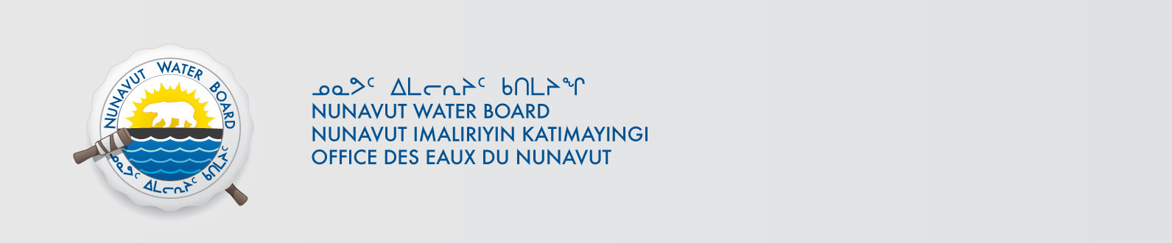

February 9, 2017 NWB File No: 2BE-KIK0608

Jonas Schuett
De Beers Exploration Canada
515 Consumers Road, Suite 300
Toronto, Ontario M2J 4Z2
Email: Jonas.schuett@debeergroup.com

Subject: Final Inspection – Cancellation of Licence and Closure of NWB File

Dear Ms. Schuett:

On September 28, 2015 the Nunavut Water Board (NWB) received a final water inspection report from Indigenous and Northern Affairs Canada (INAC) covering the above noted file. The report indicates there are no outstanding reclamation issues associated with the project. Further, there are no outstanding NWB administrative matters that require attention.

In accordance with section 43.(i)(c) of the Nunavut Waters and Nunavut Surface Rights Tribunal Act (NWNSRTA), the Board may cancel a licence in certain specific cases.

The NWB hereby notifies all parties that the aforementioned licence is now cancelled and that the corresponding NWB file is now considered closed. Any future relevant activities on this site will require a new water licence assessment.

Sincerely,

Licence Administrator

Cc: Kitikmeot Distribution List
INAC Enforcement

