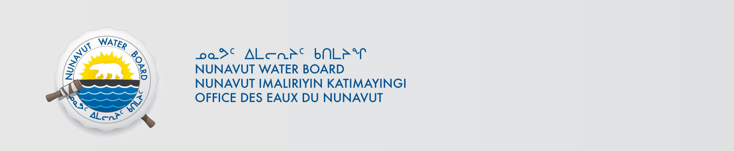

January 3, 2017 File No: NWB2ATU9899 2BE-KIK0608

To: Hamlet, CLARC, HTO, RIA, Coop, and NorthernLocal Organizations – Request to Post Notices

The Nunavut Water Board requests that you post on a bulletin board, until April 10, 2000February 3, 2017, the attached notice (in English and Inuktitut), where they can be viewed by the public. The attached letter is for your information only and does not require posting.

Your time and effort is greatly appreciated.

Sincerely,

Licensing Administrator

Cc: CLARC & KIA – Cambridge Bay (867) 983-2701
Mayor of Cambridge Bay (867) 983-2193
HTO – Cambridge Bay (867) 983-2427
Northern Store (867) 983-2452
Ikaluktutiak Co-op (867) 983-2085
CLARC & KIA – Kugluktuk (867) 982-3311
HTO – Kugluktuk (867) 982-5912
Hamlet of Kugluktuk (867) 982-3060
Northern Store (867) 982-3607
Kugluktuk Co-op (867) 982-3070

