

ABANDONMENT & RESTORATION PLAN

Luxx Project, NU

Date: December 11, 2017

TABLE OF CONTENTS

Page
1.0 INTRODUCTION 1
1.1 Description of Facility 1

2.0 ONGOING OPERATIONS, SEASONAL ABANDONMENT, FINAL ABANDONMENT AND RESTORATION PLANS……...……………….2

2.1 ONGOING OPERATIONS 2
2.1.1 Drill Hole Locations 2
2.1.2 Core Storage 2
2.1.3 Fuel Storage 2
2.1.4 Contamination Clean Up 2

2.2 FINAL ABANDONMENT AND RESTORATION 3
2.2.1 Drill Hole Locations 3
2.2.2 Fuel Storage 3

LIST OF FIGURES

Figure 1. Luxx Property Location Map 4
Figure 2. Luxx Property Land Use Area Map 5

1.0 INTRODUCTION

The following plan applies to the Luxx Project operated by North Arrow Minerals Inc. (“North Arrow”). This project, located on Crown Land in the East Keewatin Region of Nunavut, approximately 90 kilometres north of Rankin Inlet, consists of three mineral claims: K16219 (Luxx1), K16220 (Luxx2) and K15620 (Luxx3). Year-round access to the property is via plane, equipped with skis or floats, or helicopter. The property is bounded in a general sense by the following minimum and maximum latitudes/longitudes:

Min Lat (degree/minute) | 63º35’2.4” | Min Long (degree/minute) | -91º45’2.16”
Max Lat (degree/minute) | 63º37’30” | Max Long (degree/minute) | -91º38’53.52”

North Arrow intends to carry out exploration work including prospecting, mapping, ground geophysics, sampling and diamond drilling. Work will be confined to the current claim area. Individuals working on the property could reach seven.

1.1 DESCRIPTION OF DIAMOND DRILLING

Locations – Fuel will be stored a safe distance (>31m) from water bodies.

Size – The drill will be a lite-weight heli-portable model for quick dismantling and transport, similar in size and specifications to a Discovery 1 Diamond Core Drill.

Storage Capacity – A minor amount of fuel will be stored at drill sites (4 to 6 drums diesel, 1 drum Jet A/B), and removed promptly upon completion of each drill hole.

Description of the type and amount of potential contaminants normally stored at drill site:

JET A/B fuel for the helicopter – 205 litres (1 drum)
Diesel for the drill - 1,230 litres (6 drums)
Propane for the drill – 100 lbs (1 tank)
Motor Oil – 12 litres (l litre containers)
Antifreeze – 25 litres (5 litre containers)
Salt – 20-40 lbs (2 10-20 lb bags)
Lead Battery – 1 battery

Storage Location - Drums will be stored on flat stable terrain with secondary containment during the program to reduce chances of a leak. If possible a site will be chosen such that drainage would not be toward natural water bodies.

2.0 ONGOING OPERATIONS, SEASONAL ABANDONMENT, FINAL
ABANDONMENT AND RESTORATION PLANS

2.1 ONGOING OPERATIONS

The exploration season for the Luxx Project will typically run from March to the middle of September of each year, weather permitting. Restoration during operations for drilling, fuel storage and contamination clean-up is described below.

2.1.1 Drill Hole Locations

- Each drill hole will be restored to as close as possible, previous conditions after completion of the hole.
- If hole is drilled on-ice the drill cuttings will be scraped clean and removed to an on-land sump.
- All fuel drums and drilling equipment will be removed from the site immediately upon completion of each hole.
- Each drill site will be inspected to ensure that all garbage (combustible and non-combustible) has been collected and removed from the area.
- A final inspection of the site will ensure that there is no remaining material at the site upon completion of the drill hole.

2.1.2 Core Storage

- Drill core will either be stored in the field at a centralized location on Crown land, or will be backhauled to town and stored at an appropriate facility. This would be dependent upon the location of drill targets. The location of any core will be indicated in yearly land use reports.

2.1.3 Fuel Storage

- All fuel storage and handling is to be guided by the procedures set out in the Spill Contingency Plan for the Luxx Project.
- Empty fuel drums are to be regularly backhauled to town for proper disposal.

2.1.4 Contamination Clean Up

- Any soil around fuel caches or drill sites that has become contaminated will be treated as per North Arrow’s Spill Contingency Plan. Before and after photos will be taken to document the contamination and clean-up.

2.2 SEASONAL ABANDONMENT & RECLAMATION

At the end of the proposed program, all materials, fuel drums and the drill (if required) will be removed from the site. All garbage will be collected and removed and any fuel caches will be inventoried and inspected for any leaks. As work on the properties comprising the Luxx Project is currently still in the planning stages, it is not practicable at this time to subscribe to a definitive schedule for the conclusion of this land use operation, however upon its completion the following procedures will be followed to allow for proper abandonment and reclamation of the area:

2.2.1 Drill Hole Locations

- As per the ongoing restoration procedures all drill holes are to be restored to as close as possible, previous conditions immediately upon completion of the hole.

2.2.2 Fuel Storage

- All fuel storage and handling is to be guided by the framework set out in the Spill Contingency Plan for the Luxx Project.
- Upon completion of the land use operation all empty fuel drums will be removed from the area for proper disposal and any remaining fuel caches will be moved to an approved/permitted storage location.
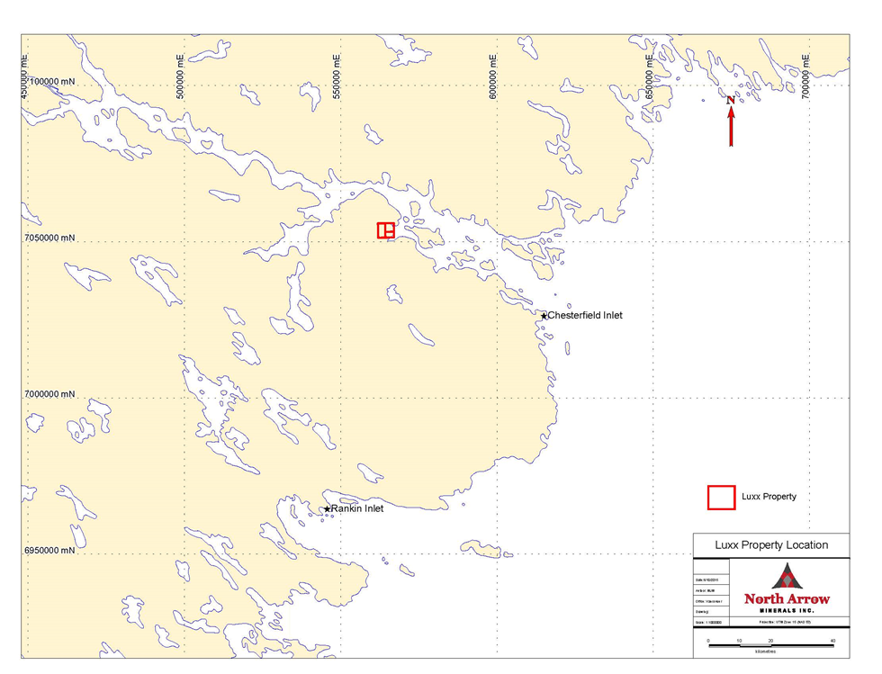
Figure 1: Luxx Property Location

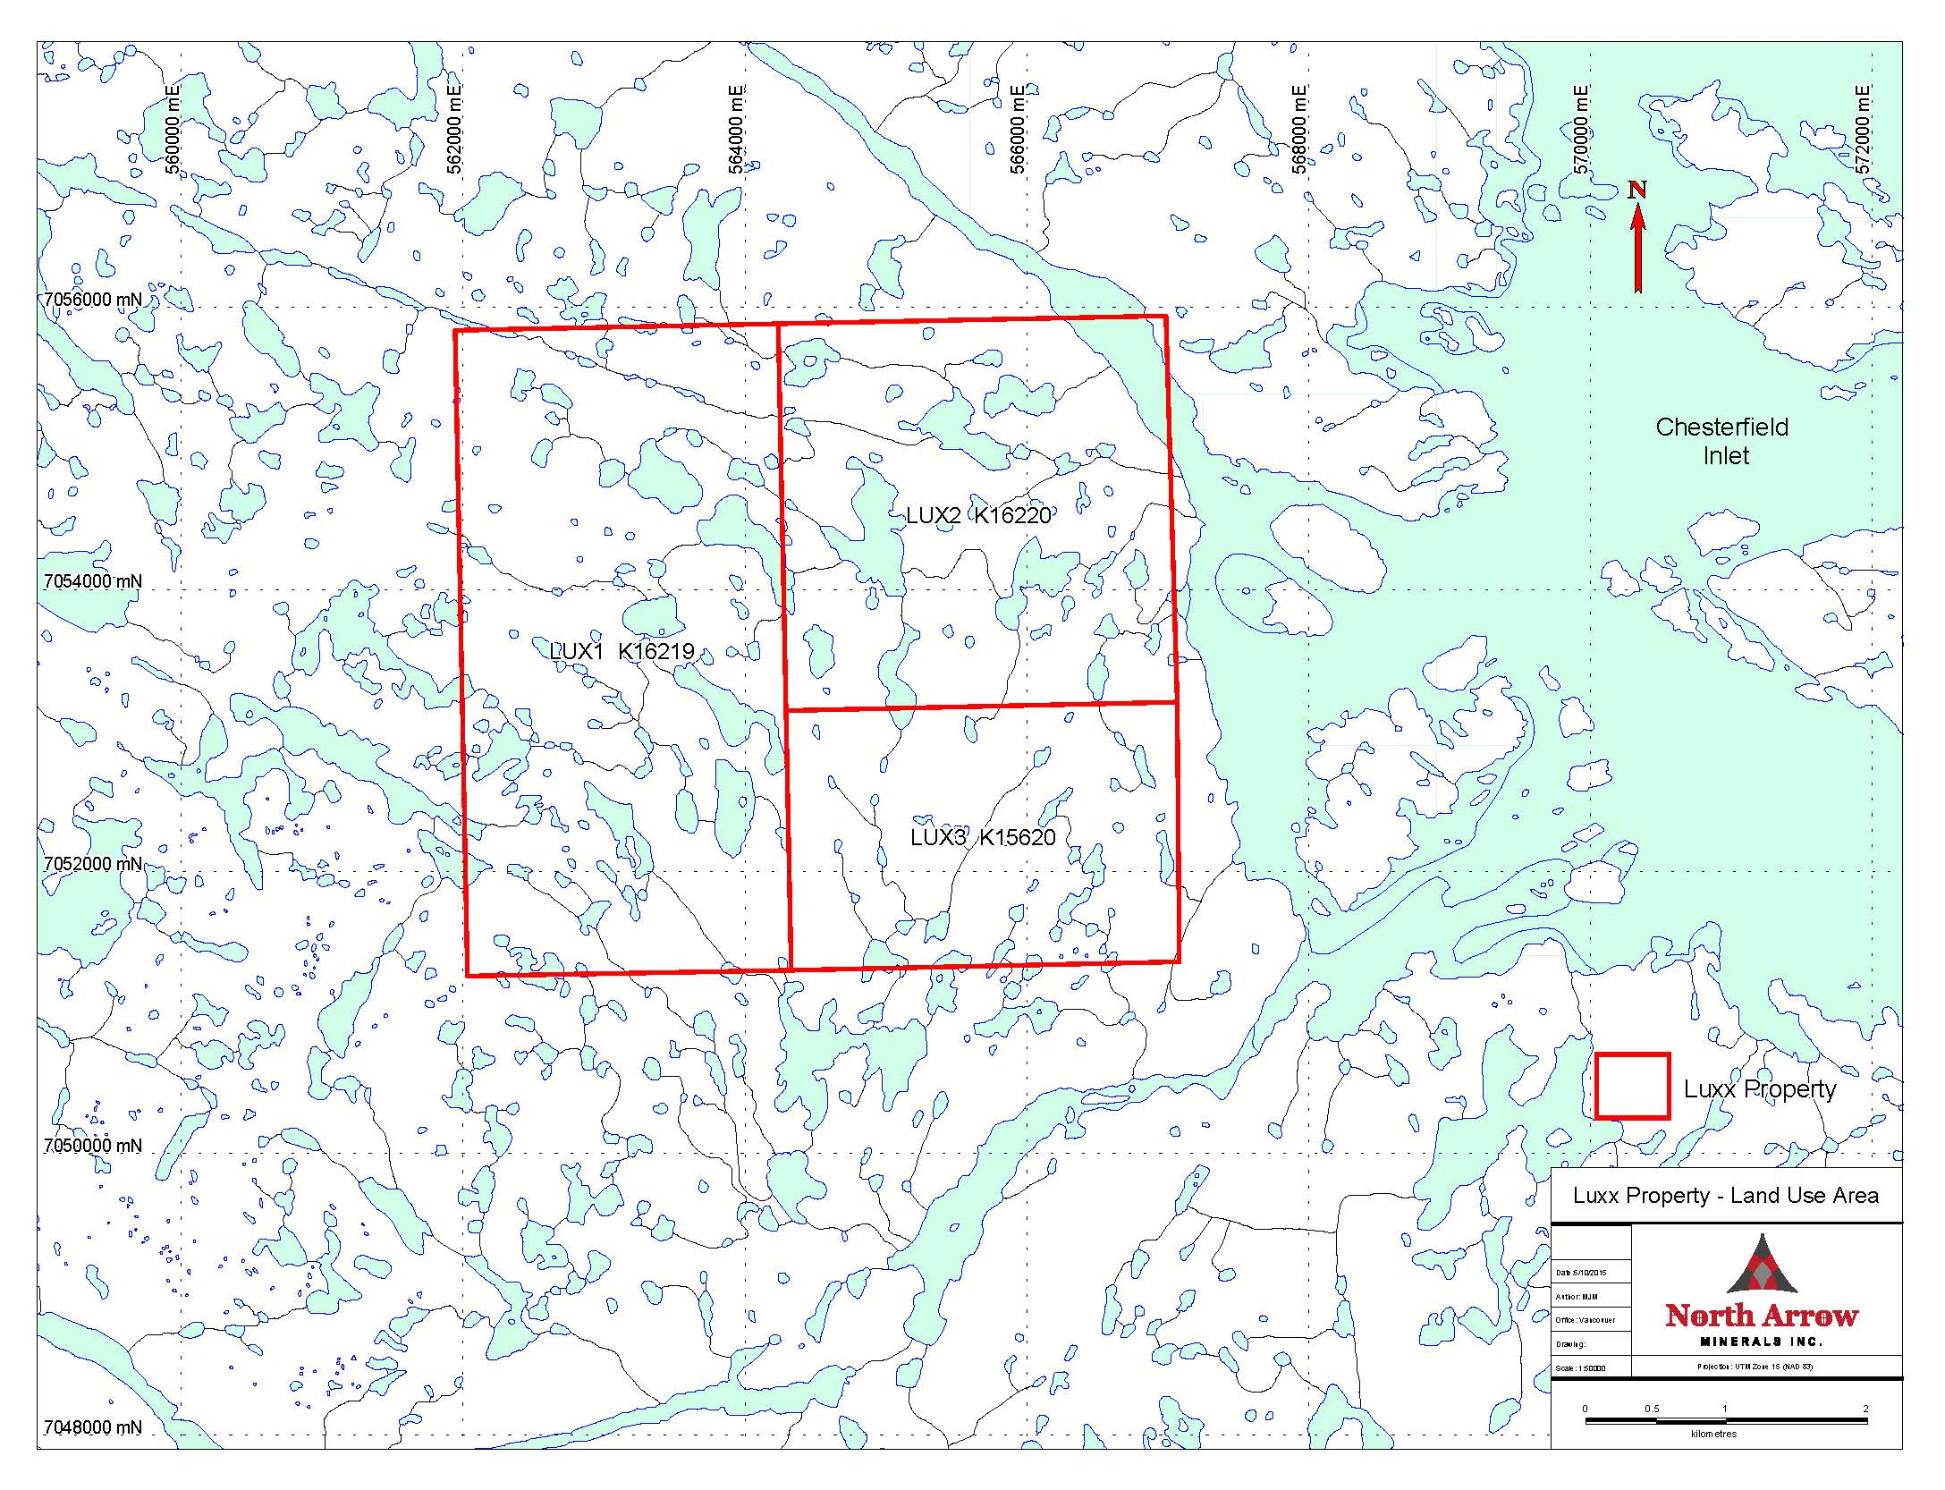
Figure 2: Luxx Property Land Use Area

