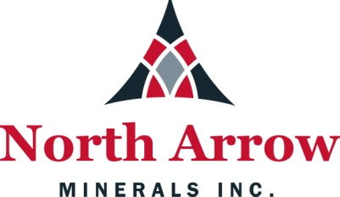

PROJECT SUMMARY
December 20, 2017

North Arrow Minerals Inc.
Suite 960 – 789 West Pender St.
Vancouver, BC V6C 1H2
Phone: 604-668-8355
Fax: 604-336-4813

Summary of Proposed Activities – Luxx Property, Kivalliq Region, Nunavut
Water License Renewal Application for License 2BE-LUX1618 / TYPE “B”

The land use activity being proposed is a drilling program on North Arrow Minerals Inc.’s (“North Arrow”) Luxx Project (“the Property”) and will involve the use of up to 50 cubic meters of water per day from viable lakes and streams close to yet to be determined drill locations. The Property is located approximately 60 km west of Chesterfield Inlet and 90 km north of the town of Rankin Inlet (Figure 1). The Property comprises three mineral claims on Crown Land and fits within National Topographic System (NTS) map sheet 55/O12. The original Two Year Water License (2BE-LUX1618 / TYPE “B”) was issued on July 15, 2016. It will expire July 14, 2018.

The proposed drilling will be conducted during the spring and/or summer months in 2018 and would be run out of Chesterfield Inlet – no camp is proposed as crews will stay in town. Personnel working on the project may vary and typical personnel requirements will likely include 1 project geologist (with the possibility of up to 2 geologists/geo-technicians), 1 helicopter pilot, 1 helicopter engineer and 4 or 5 contract drillers. The drill program would run for approximately 1-2 weeks and drilling will be done with a small diamond drill transported by helicopter.

The Luxx field program will be conducted in two phases. Phase 1 is planned for either spring or summer of 2018 and will involve drill-testing a small number of land-based and lake-based targets. Exact drill hole locations have yet to be determined however it is anticipated that three to four targets will be tested by three to six drill holes (approximately 500-1000 m of drilling). If results of this initial work are positive, a second phase of drilling (Phase 2) may be conducted later in the summer of 2018 or possibly at a later date. Phase 2, if warranted, would likely involve further delineation of targets identified from Phase 1 drilling, as well as drill-testing additional targets.

Fuel for the helicopter will be purchased from the airport, and drums of diesel for the diamond drill will need to be purchased and transportation arranged to Chesterfield Inlet or to a suitable site closer to the Property. Temporary storage berms or another type of secondary containment will be used at all fuel storage and drill sites.

Prior Exploration Activities
In August 2013, a North Arrow field crew consisting of three geologists visited the property and collected 62 till samples. The base of operations for the sampling was Rankin Inlet where helicopter flights and fuel for the sampling program were based from.

A small program in the summer of 2014 consisted of collecting 17 till samples with a limited amount of prospecting within the mineral claims. Again, Rankin Inlet served as the base of operations for the program.

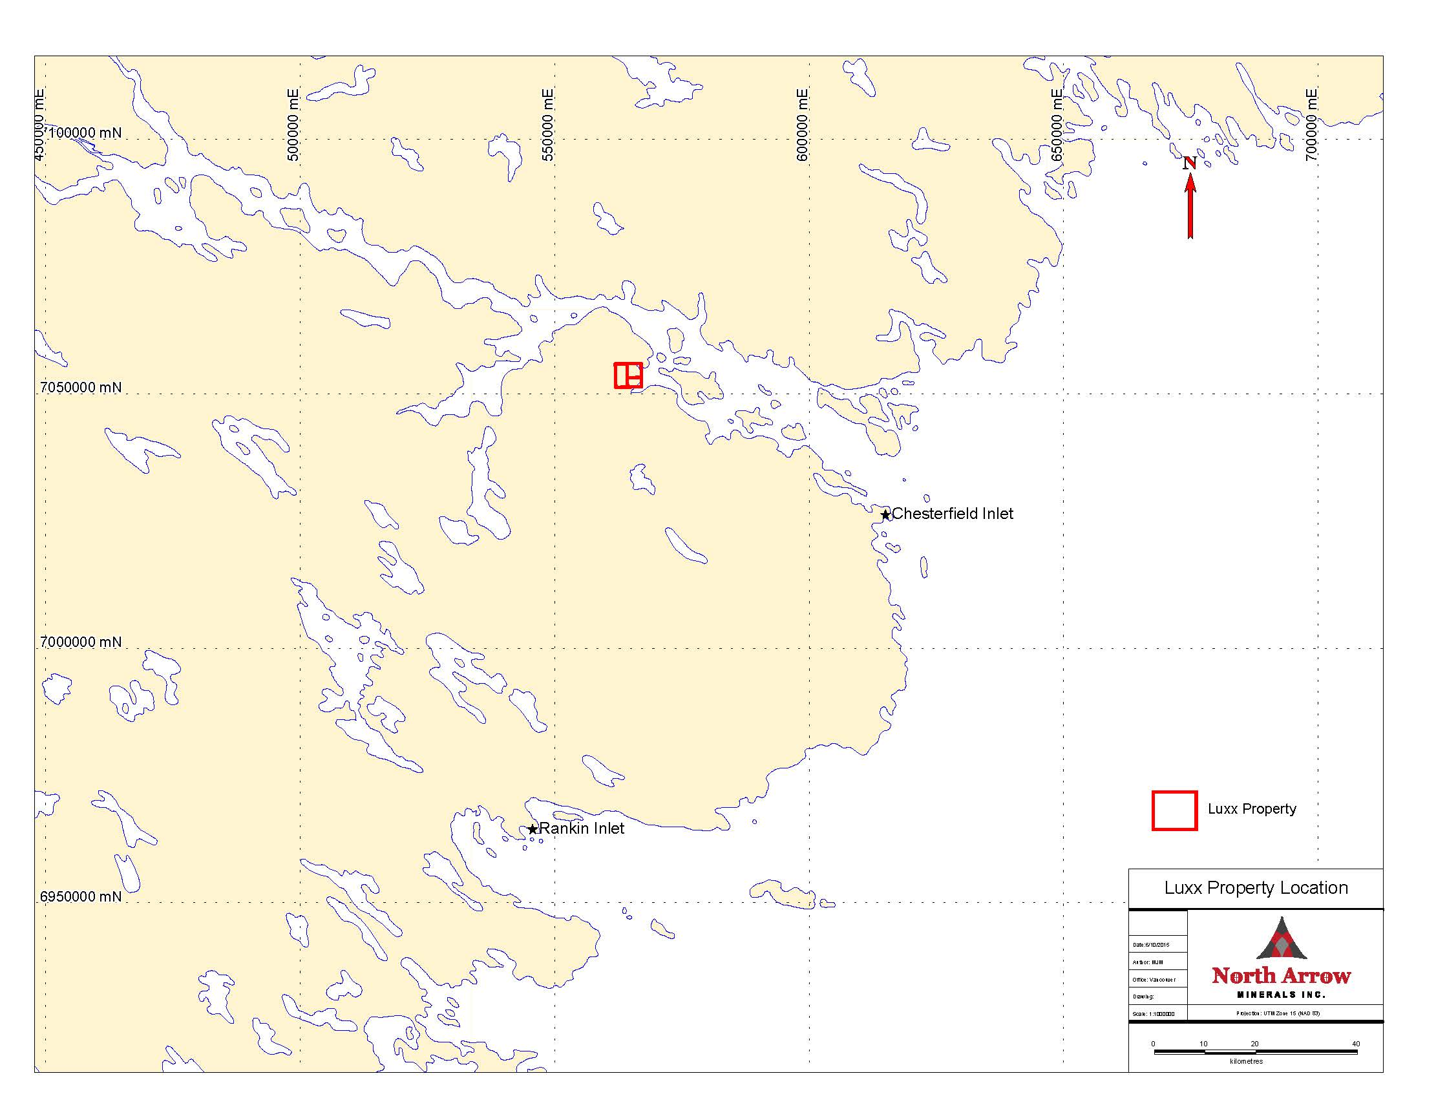
Figure 1: Luxx property location.

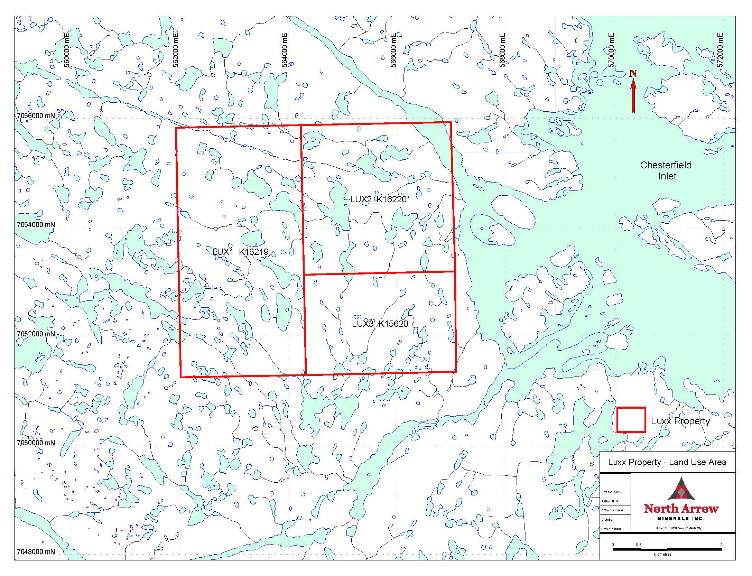
Figure 2: Luxx property land use area.

