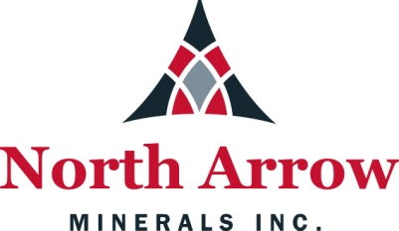

SPILL CONTINGENCY PLAN

LUXX PROJECT, NUNAVUT

Date: December 11, 2017

TABLE OF CONTENTS
Page
1. INTRODUCTION 1
1.1 Corporate Details 1
1.2 Term of Spill Contingency Plan 1
1.3 Purpose and Scope 1
1.4 North Arrow Minerals Inc. Environmental Policy 1

2. PROJECT AND SITE DESCRIPTION 2
2.1 Project Description 2
2.2 Current Permits/Licences 2
2.3 List of Hazardous Materials On-Site 2
2.4 Petroleum and Chemical Product Storage and Transport 3
2.5 Petroleum Product Transfer 3
2.6 Equipment 4
2.7 Existing Preventative Measures 4
2.8 Copies of Spill Contingency Plan 4

3. RESPONSE ORGANIZATION 5
3.1 Spill Response Team 6

4. REPORTING PROCEDURE 6

5. ACTION PLANS 8
5.1 Initial Action 8
5.2 Spill Response Actions – Diesel Fuel, Hydraulic Oil and Lubricating Oil 9
5.3 Spill Response Actions – Jet B Aviation Fuel 10

6. PROCEDURES FOR TRANSFERRING, STORING, AND MANAGING 12
SPILL-RELATED WASTES

7. PROCEDURES FOR RESTORING AFFECTED AREAS 12

8. TRAINING 12

LIST OF TABLES
Table 1 List of hazardous materials stored on-site, type of storage container, 3
the storage quantities, and storage locations where known
Table 2 Emergency Contacts 7

LIST OF APPENDICES
Appendix 1 NT/NU Spill Report Form and Instructions
Appendix 2 Map of Property
Appendix 3 MSDS Sheets

1. INTRODUCTION
This Spill Contingency Plan has been prepared specifically for the Luxx Project (NTS 55O/12) operated by North Arrow Minerals Inc. (“North Arrow”). The plan demonstrates that North Arrow Minerals Inc. will have appropriate response capabilities and measures in place to effectively address potential spills at its Luxx Project site.

1.1 Corporate Details

North Arrow Minerals Inc.

Suite 960 - 789 West Pender Street
Vancouver, BC V6C 1H2

1.2 Term of Spill Contingency Plan
This version of the North Arrow Minerals Inc. Spill Contingency Plan shall be in effect from date of acceptance of applicable land use permits. Any future changes and/or amendments will be submitted to the Nunavut Water Board and INAC/AANDC.

1.3 Purpose and Scope
The purpose of this Spill Contingency Plan is to provide a plan of action for all spills of hazardous materials that may occur on the Luxx Project, NU. This plan identifies key response personnel and their roles and responsibilities in the event of a spill, as well as the equipment and other resources available to respond to a spill. It details spill response procedures that will minimize potential health and safety hazards, environmental damage, and clean-up efforts. The plan has been prepared to ensure quick access to all information required in responding to a spill.

1.4 North Arrow Minerals Inc. Environmental Policy
It is the policy of North Arrow Minerals Inc. to comply with all existing laws and regulations to help ensure the protection of the environment. North Arrow Minerals Inc. cooperates with other groups committed to protecting the environment and ensures that employees, government, and the public is informed on the procedures followed to help protect the environment.

North Arrow Minerals Inc. endeavours to take every reasonable precaution toward ensuring the protection and conservation of the natural environment and the safety and health of all employees and contractors from any potential harmful effects of stored materials and operations.

The plan is presented to all staff during their on-site orientation sessions. All employees and contractors are aware of the locations of the plan on site at the Luxx Project and in North Arrow’s offices.

During the orientation meeting, training sessions are scheduled to ensure employees have an understanding of the steps to be undertaken in the event of a spill. All employees and contractors are shown where spill kits are stored, are aware of their contents and are trained in using spill equipment and responding to spills. The company is committed to keeping personnel up to date on the latest technologies and spill response methods.

2. PROJECT AND SITE DESCRIPTION
2.1 Project Description
This project, located in the East Kivalliq Region of Nunavut, approximately 90 kilometres north of Rankin Inlet, consists of predominately Crown lands (mineral leases) and Inuit-Owned Lands. Year-round access to the property is via plane, equipped with skis or floats, or helicopter. The property is bounded in a general sense by the following minimum and maximum latitudes/longitudes:

Min Lat (degree/minute) | 63º35’2.4” | Min Long (degree/minute) | -91º45’2.16”
Max Lat (degree/minute) | 63º37’30” | Max Long (degree/minute) | -91º38’53.52”

A map illustrating the regional context of the property and the project area is located in Appendix 2.

2.2 Current Permits/Licences

Permit/License No. | Regulatory Body | Type | Expiry
N2016C0005 | INAC | Land Use Permit - Drilling | March 10, 2018
2BE-LUX1618 | Nunavut Water Board | Water License Type B | July 14, 2018
15EN052 | NIRB | NIRB Screening

2.3 List of Hazardous Materials On-site
Fuel storage areas at the Luxx Project will include the main storage site adjacent to the camp helicopter landing pad; in addition small fuel caches will be located adjacent to active drill sites when drilling is underway. All containers of hazardous materials will be marked with North Arrow’s name.
Petroleum products and hazardous materials that will be considered in this Spill Contingency Plan include:
- Diesel fuel
- Jet “A/B” fuel
- Hydraulic oil
- Lubricating oil
- Propane
- Antifreeze

Table 1 presents a list of hazardous materials anticipated to be located at the Luxx Project site, the type of storage container, the maximum quantities stored, and the general location.

Table 1: List of hazardous materials stored on-site, type of storage container, the
storage quantities, and storage locations where known

Material | Storage Container | Maximum on-site | Storage Location and Uses
Diesel fuel | 205 litre drums | 6 (1,230 litres) | Six drums at active drilling sites, remainder in town at fuel storage facility
Jet A/B fuel | 205 litre drums | 1 (205 litres) | One drum at each active drilling site for emergency purposes
Oil (Engine and 2 stroke) | 1 litre container | 12 (12 litres) | Active drilling sites
Hydraulic Oil | 20 litre containers | 100 litres | At drill site – for drill hydraulic pressure
Propane | 1 tank | 100 lbs | Heaters for personnel when required
Antifreeze | 5 litre containers | 25 litres | At drill site - engine coolant

2.4 Petroleum and Chemical Product Storage and Transport
All fuel will be stored no closer than the regulated distance from the normal high water mark of any water body (>31 metres).

Other petroleum-based materials found on-site in very small quantities will be located in the drill shack. These include lubricants/oil/grease for the maintenance of the drilling equipment. The drill shack will be located over 31 metres from the normal high water mark of any water body when drilling land-based targets.

All fuel, oil and any chemicals are transported to site by plane and/or helicopter and to any drill sites by helicopter.

2.5 Petroleum Product Transfer
Manual and automatic pumps (and aviation fuel filters for jet fuel) are used for the transfer of all petroleum products. Smoking, sparks, or open flames are prohibited in fuel storage and fuelling areas at all times. Portable drip trays and appropriately sized fuel transfer hoses with pumps are used when refuelling aircraft or other equipment, to avoid any leaks/drips onto the land.

2.6 Spill Containment Equipment
Equipment available on site to assist in responding to a hazardous materials spill includes various hand held tools including shovels. In addition to these, one spill kit will be situated at each active drill site with additional spill kits located in Chesterfield Inlet and on the helicopter.

Spill kits are located wherever fuel is stored or used. The typical spill kit has a sorbent capacity of 240 litres and the contents include:

1 – 360 litre/79 gallon polyethylene over pack drum
4 – oil sorbent booms (5” X 10’)
100 – oil sorbent sheets (16.5” X 20” X 3/8”)
1 – drain cover (36” X 36” X 1/16”)
1 – Caution tape (3” X 500’)
1 – 1 lb plugging compound
2 – pair Nitrile gloves
2 – pair Safety goggles
2 – pair Tyvel coveralls
1 – instruction booklet
10 – printed disposable bags (24” X 48”)
1 – empty fuel drum

2.7 Existing Preventative Measures
Planning for an emergency situation is imperative, due to the nature of the materials stored on site as well as the remoteness of the site. Along with the preventative measures outlined below, adequate training of staff and contractors is paramount.

All hazardous materials arrive by air as needed throughout periods of active exploration. They are unloaded by airplane and helicopter pilots and North Arrow staff and contractors and carefully placed in the fuel storage and hazardous materials storage areas.

The designated fuel monitor conducts daily visual inspections to check for leaks or damage to the fuel storage containers, as well as for stained or discoloured soils/snow around the fuel storage areas and adjacent equipment. For example, lids/caps are checked for tight seals. A checklist is used to ensure no areas are missed.

2.8 Copies of Spill Contingency Plan
Several copies of the plan are will be kept on-site at the drill at all times, as well as in Chesterfield Inlet with the crews. As well, copies will also be located at North Arrow offices.

3. RESPONSE ORGANIZATION
The following is a flow chart to illustrate the sequence of events in the event of a hazardous material spill occurring at the Hope Bay Project.
Spill or Release identified by staff or contractors

Assess personal safety and safety of others

Identify product

Report Spill to On-Scene Coordinator/Project Manager
Notify Spill Response Team

Stop the spill if safely possible

Ensure spill does not enter water bodies

Notify NT-NU 24-Hour
Spill Report Line at 867-920-8130
Indian and Northern Affairs Canada Inspector (867) 975-4295

Notify Company and Regulatory Agencies

Recover as much hazardous material as possible

Record Incident Using NT-NU Spill Report Form
3.1 Spill Response Team
North Arrow will appoint a qualified On-Scene Coordinator and appropriate personnel to make up the Luxx Spill Response Team for the Luxx Project. The key personnel that make up the Luxx Spill Response Team are as follows:

In addition to the On-Scene Coordinator and the Project Manager, approximately 2-3 additional personnel will be available on site to assist in spill response and cleanup activities.

The responsibilities of the On-Scene Coordinator are as follows:
1. Assume complete authority over the spill scene and coordinate all personnel involved.
2. Evaluate spill situation and develop overall plan of action.
3. Activate the spill contingency plan
4. Immediately report the spill to:
NT-NU 24-Hour Spill Report Line (867) 920-8130
Indian and Northern Affairs Canada Inspector (867) 975-4295
Other regulatory agencies and North Arrow management (see Table 2 – Emergency Contacts).
5. Obtain additional manpower, equipment, and material if not available on site for spill response.

The responsibilities of the Project Manager are as follows:
1. Provide regulatory agencies and North Arrow management with information regarding the status of the cleanup activities.
2. Act as a spokesperson on behalf of North Arrow with regulatory agencies as well as the public and media.
3. Prepare and submit a report on the spill incident to regulatory agencies (including the INAC Inspector) within 30 days of the event.

4. REPORTING PROCEDURE
The On-Scene Coordinator must be notified immediately of any spill either by phone, radio, or in person.

The following is the spill reporting procedure:
1. Report immediately to the NT-NU 24-Hour Spill Report Line
(867) 920-8130
Indian and Northern Affairs Canada Inspector (867) 975-4295
And other regulatory agencies, and North Arrow management
(see Table 2 – Emergency Contacts)
2. Complete the NT-NU Spill Report Form and fax the report to Spill Report Line fax (867) 873-6924 or e-mail it to spills@gov.nt.ca

Table 2 – Emergency Contacts

CONTACT | TELEPHONE NUMBER
INAC - Land Use Inspector | (867) 975-4295
North Arrow Minerals Inc. | (604) 668-8355 (Office); (604) 336-4813 (Fax)
Environment Canada 24 hour Duty Officer | (867) 766-3737, (867) 873-8185 (Fax)
INAC – Water Resource Officer, Rankin Inlet | 867-645-2830
INAC – Nunavut Regional Office, Rankin Inlet | 867-645-2831
Custom Helicopters | (204) 338-7953
Rankin Inlet Fire Department | (867) 645-2525
RCMP, Chesterfield Inlet | (867) 898-0123
Kivalliq Health Centre | (867) 645-8300
On-Site Project Geologist | Information to be supplied once phone system is established on the property
Fisheries and Oceans | (867) 979-8007
Nunavut Department of Environment | (867) 975-7700
Manager, Pollution Control and Air Quality,  Environmental Protection, Govt of Nunavut | (867) 975-7748; (867) 975-7739 (Fax)

5. ACTION PLANS
5.1 Initial Action
The instructions to be followed by the first person on the spill scene are as follows:
- Always be alert and consider your safety first.
- If possible, identify the material that has been spilled. If you are not sure of the material, use caution and consider your safety first.
- Assess the hazard of people in the vicinity of the spill.
- If possible, safely try to stop the flow of material to minimize potential for environmental impacts.
- Immediately report the spill to the On Scene Coordinator.
- Resume any effective action to contain, mitigate, or terminate the flow of the spilled material.

The following pages include specific instructions to be followed in the response to various types of spills including diesel fuel, hydraulic oil, lubricating oil, gasoline, aviation fuel (Jet “B”), antifreeze, and propane.

5.2 SPILL RESPONSE ACTIONS
DIESEL FUEL, HYDRAULIC OIL, AND LUBRICATING OIL

Take action only if safety permits – stop the source flow if safe to do so and eliminate all ignition sources.
Never smoke when dealing with these types of spills.

On Land
Build a containment berm using soil material or snow and place a plastic tarp at the foot of the berm for easy capture of the spill after all vapours have dissipated.
Remove the spill by using absorbent pads or excavating the soil, gravel or snow.
Remove spill splashed on vegetation using particulate absorbent material.

On Muskeg
Do not deploy personnel and equipment on marsh or vegetation.
Remove pooled oil with sorbent pads and/or skimmer.
Flush with low pressure water to herd oil to collection point.
Burn only in localized areas, e.g., trenches, piles or windrows.
Do not burn if root systems can be damaged (low water table).
Minimize damage caused by equipment and excavation.

On Water
Contain spill as close to release point as possible.
Use containment boom to capture spill for recovery after vapours have dissipated.
Use absorbent pads to capture small spills.
Use skimmer for larger spills.

On Ice and Snow
Build a containment berm around spill using snow.
Remove spill using absorbent pads or particulate sorbent material.
The contaminated ice and snow must be scraped and shovelled into plastic buckets with lids, 205 litre drums, and/or polypropylene bags.

Storage and Transfer
All contaminated water, ice, snow, soil, and clean up supplies will be stored in closed, labelled containers. All containers will be stored in a well-ventilated area away from incompatible materials.

Disposal
All contaminated material will be transported to an appropriate disposal facility.
5.3 SPILL RESPONSE ACTIONS
GASOLINE AND JET A AVIATION FUEL

Take action only if safety permits – stop the source flow if safe to do so and eliminate all ignition sources.
Never smoke when dealing with these types of spills.

On Land
Build a containment berm using soil material or snow and place a plastic tarp at the foot of the berm for easy capture of the spill after all vapours have dissipated.
Remove the spill by using absorbent pads or excavating the soil, gravel or snow.
Remove spill splashed on vegetation using particulate absorbent material.

On Muskeg
Do not deploy personnel and equipment on marsh or vegetation.
Remove pooled gasoline or Jet A with sorbent pads and/or skimmer.
Flush with low pressure water to herd oil to collection point.
On advice from regulatory agencies, burn only in localized areas, e.g., trenches, piles or windrows.
Do not burn if root systems can be damaged (low water table).
Minimize damage caused by equipment and excavation.

On Water
Contain spill as close to release point as possible.
Use containment boom to capture spill for recovery after vapours have dissipated.
Use absorbent pads to capture small spills.
Use skimmer for larger spills.

On Ice and Snow
Build a containment berm around spill using snow.
Remove spill using absorbent pads or particulate sorbent material.
The contaminated ice and snow must be scraped and shovelled into plastic buckets with lids, 205 litre drums, and/or polypropylene bags.

Storage and Transfer
All contaminated water, ice, snow, soil, and clean up supplies will be stored in closed, labelled containers. All containers will be stored in a well-ventilated area away from incompatible materials.

Disposal
All contaminated material will be transported to an appropriate disposal facility.
5.4 SPILL RESPONSE ACTIONS
PROPANE

Take action only if safety permits. Gases stored in cylinders can explode when ignited.
Keep vehicles away from area.
Never smoke when dealing with these types of spills.

On Land
Do not attempt to contain the propane release.

On Water
Do not attempt to contain the propane release.

On Ice and Snow
Do not attempt to contain the propane release.

General
It is not possible to contain vapours when released.
Water spray can be used to knock down vapours if there is no chance of ignition.
Small fires can be extinguished with dry chemical of CO₂.
Personnel should withdraw immediately from area unless a small leak is stopped immediately after it has been detected.
If tanks are damaged, gas should be allowed to disperse and no recovery attempt should be made.
Personnel should avoid touching release point on containers since frost forms very rapidly.
Keep away from tank ends.

Storage and Transfer
It is not possible to contain vapours when released.

Disposal
All contaminated material will be transported to an appropriate disposal facility.
6.0 PROCEDURES FOR TRANSFERRING, STORING, AND MANAGING SPILL-
RELATED WASTES
In most cases, spill cleanups are initiated at the far end of the spill and contained moving toward the centre of the spill. Sorbent socks and pads are generally used for small spill cleanup. A pump with attached fuel transfer hose can suction spills from leaking containers or large accumulations on land or ice, and direct these larger quantities into empty drums. Hand tools such as cans, shovels, and rakes are also very effective for small spills or hard to reach areas. Heavy equipment can be used if deemed necessary but may be constrained by transportation to site constraints.

Used sorbent materials are to be placed in plastic bags for future disposal at an approved disposal facility. All materials mentioned in this section are available in the spill kits located on at the drill shack and in Chesterfield Inlet at the crew houses. Following cleanup, any tools or equipment used will be properly washed and decontaminated, or replaced if this is not possible.

For most of the containment procedures outlined in Section 5, spilled petroleum products and materials used for containment will be placed into empty waste oil containers and sealed for proper disposal at an approved disposal facility.

7.0 PROCEDURES FOR RESTORING AFFECTED AREAS
Once a spill has been contained, North Arrow will consult with the Indian and Northern Affairs Canada Inspector assigned to the property to determine the level of cleanup required. The Inspector may require a site-specific study to ensure appropriate cleanup levels are met. Criteria that may be considered include natural biodegradation of oil, replacement of soil and re-vegetation.

8.0 TRAINING
All employees working on the Luxx Project will be trained in the safe operation of all machinery and tools to help prevent hazardous material spills. All employees on site will also be required to participate in an orientation session, during which all locations of the spill plan and spill kits will be provided. An overview of the plan will be provided by the On-Scene Coordinator leading the orientation session. Specific training sessions are scheduled for individuals directly involved in handling hazardous materials to ensure they know all steps to be undertaken in handling these materials, as well as the steps involved in the event of a spill, including the proper use of spill kits.

.

APPENDIX 1

NT/NU Spill Report Instructions and Form
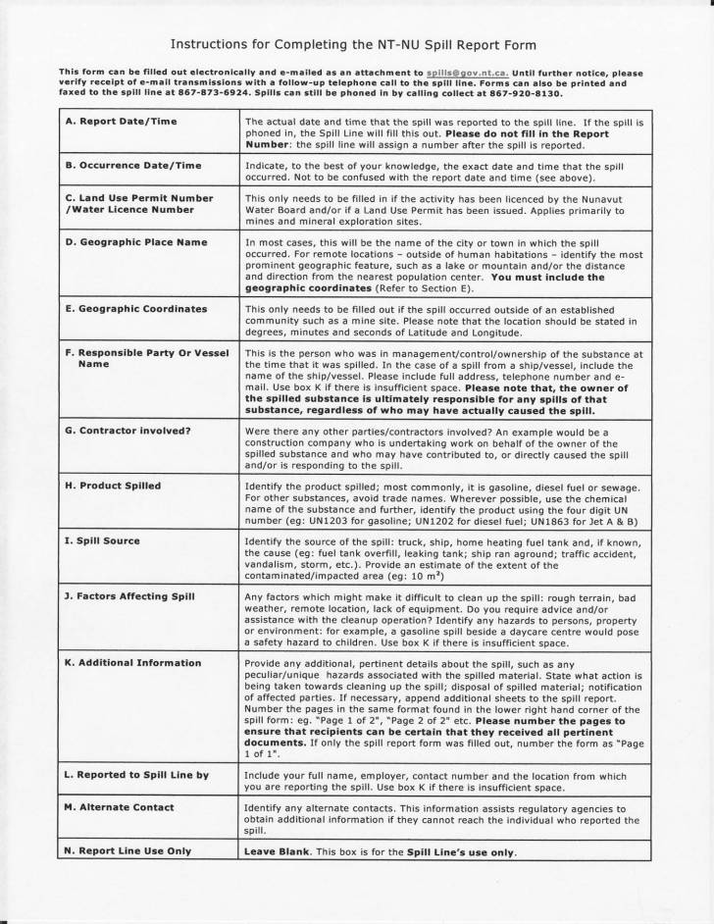
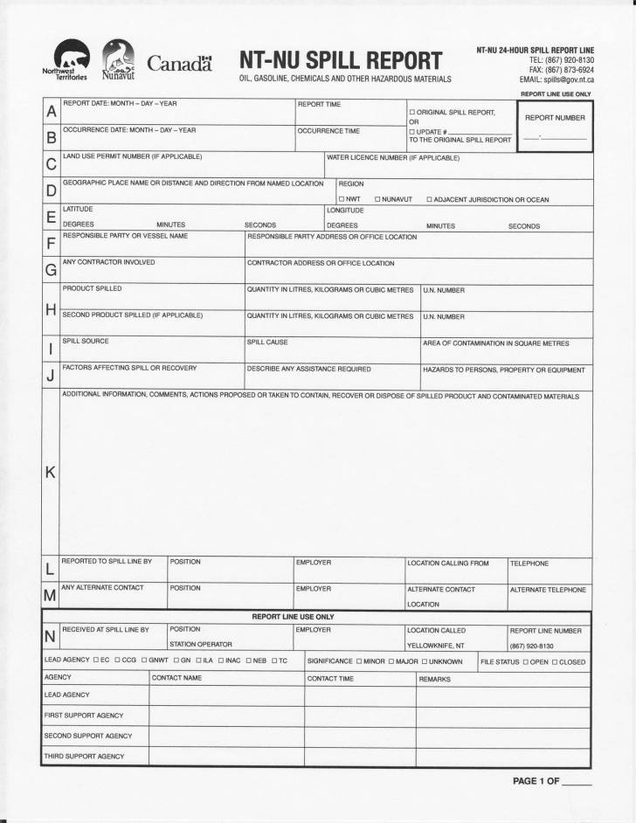

APPENDIX 2

Property Location Map

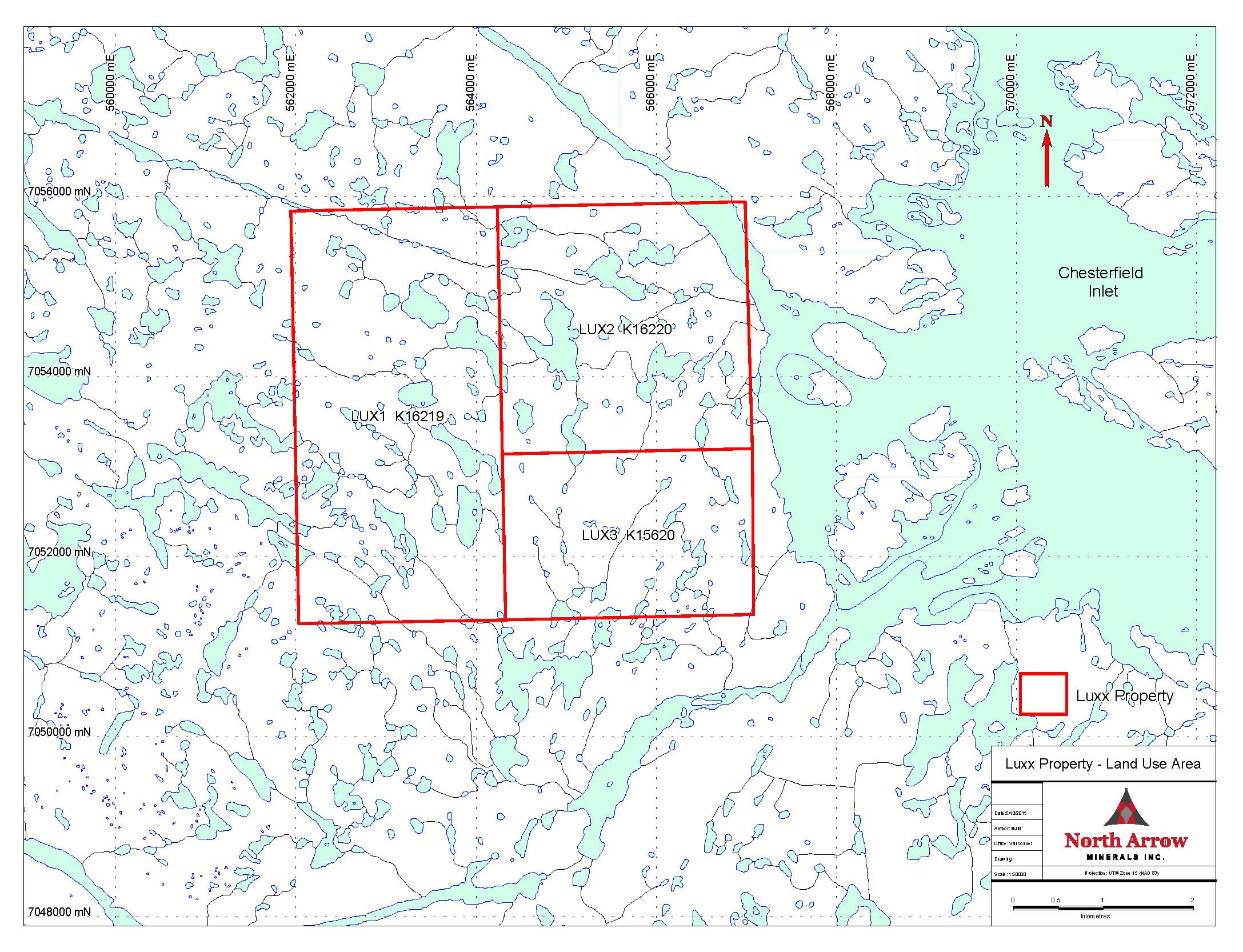

APPENDIX 3

MSDS Sheets

