NWB File No: 2BE-LUX1618

January 25, 2018

Nick Thomas
North Arrow Minerals
Investor and Community Relations Manager
Suite 960 - 789 West Pender St.
Vancouver BC V6C 1H2
E-mail: nthomas@northarrowminerals.com

Re: Acknowledgement and Receipt of Application Fee and Water Use Fee 2BE-LUX1618 – Luxx Project

Dear Mr. Thomas:

The Nunavut Water Board acknowledges receipt on January 25, 2018 of your credit card information for an application fee and water use fee for the above project. Your information for payment has been forwarded to Indigenous and Northern Affairs Canada in Iqaluit for processing. A receipt will be issued through their office for fees totaling $395.00 ($30.00 for administration & $365.00 for water use fee 2016 and 2017).

Please refer to the calculation for water use fees, in the Nunavut Waters Regulations, Section 12, to ensure that the correct fee has been submitted. A copy of this regulation is available from our ftp site or by contacting this office. This is an annual fee which is required to be submitted yearly on the anniversary of the issuance of your water licence.

Please call the undersigned at (867) 360-6338 or e-mail licensing@nwb-oen.ca if you have any questions.

Sincerely,

Original signed by:

Richard Dwyer
Licence Administrator

Cc: Sarah Forté, INAC
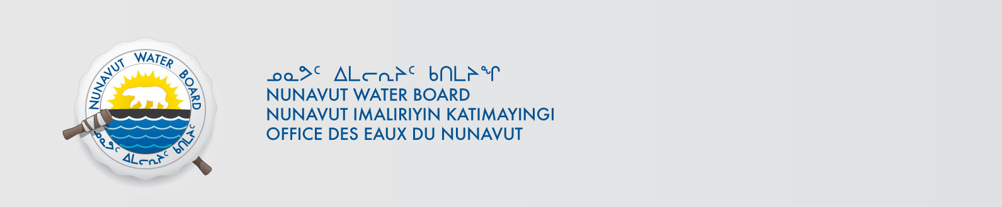
Noodloo Turner, INAC

