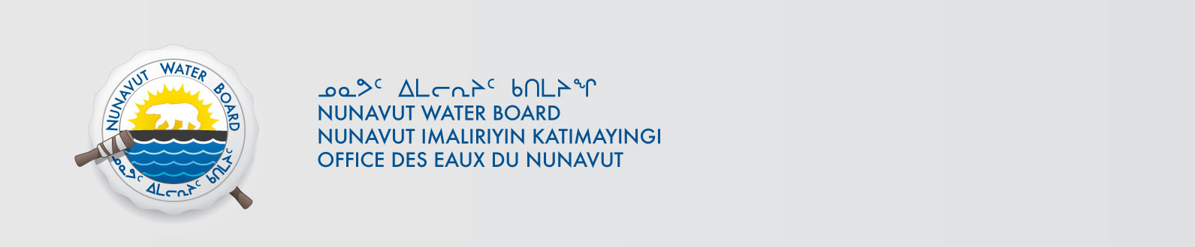

May 17, 2017 NWB File No: 2BE-LUX1618

Nick Thomas
North Arrow Minerals
Investor and Community Relations Manager
Suite 960 - 789 West Pender St.
Vancouver BC V6C 1H2
E-mail: nthomas@northarrowminerals.com

Subject: 2BE-LUX1618 Water Licence Renewal Application North Arrow Minerals Luxx Project

Dear Mr. Thomas:

The Nunavut Water Board (“NWB”) acknowledges receipt on January 16, 2018 of your renewal water licence application, for the Luxx Project. This application has been assigned file number 2BE-LUX1618. Please refer to this number on future submissions. Application documents received are as follows:

180116 2BE-LUX1618 AR Plan-ILAE.pdf
180116 2BE-LUX1618 Condensed Interim Financial Statements-ILAE.pdf
180116 2BE-LUX1618 Cover Letter_Dec 20, 2017_signed-ILAE.pdf
180116 2BE-LUX1618 English Summary-ILAE.pdf
180116 2BE-LUX1618 Environmental Procedures Plan-ILAE.pdf
180116 2BE-LUX1618 Inuktitut Summary-ILAE.pdf
180116 2BE-LUX1618 Spill Plan-ILAE.pdf
180116 2BE-LUX1618 Water Licence Renewal Application-ILAE.pdf

Please be advised that under the Agreement Between the Inuit of the Nunavut Settlement Area and Her Majesty the Queen in Right of Canada (Nunavut Agreement) Article 11, Section 11.5.9 and s. 76 (1) of Nunavut Planning and Project Assessment Act (NuPPAA), the proponent of a project governed by NuPPAA is also required to submit a project proposal document (which may include the water licence application) directly to the Nunavut Planning Commission (NPC or Commission) for the NPC’s determination regarding the applicable land use planning requirements and/or directions regarding whether the project is subject to screening by the Nunavut Impact Review Board. In particular, please note that as established under Articles 11, 12 and 13 of the Nunavut Agreement, NuPPAA and Part 3 of the Nunavut Waters and Nunavut Surface Rights Tribunal Act, until the project has completed the applicable land use planning and assessment process required by the NPC and the NIRB, the NWB cannot issue a water licence.

The NWB confirms receipt of NPC conformity under NuPPAA on January 5, 2018 and NIRB determination through NPC under NuPPAA on January 5, 2018. This application is now ready for review and comments. Deadline for submissions is March 9, 2018

Please call the undersigned at (867) 360-6338 or email to licensing@nwb-oen.ca if you have any questions.

Sincerely,

Richard Dwyer
Licence Administrator

Cc: Qikiqtani Distribution List

