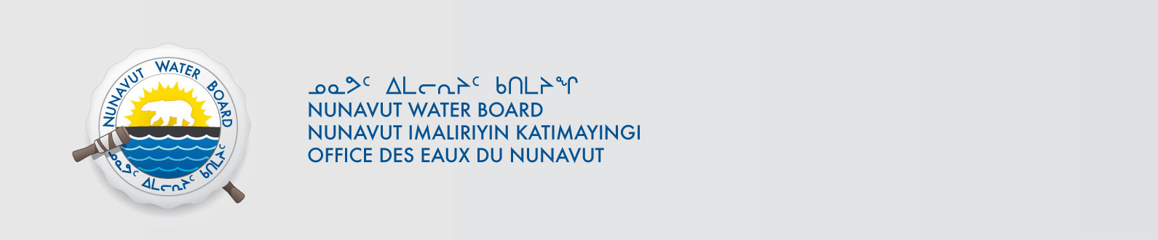

February 8, 2018 File No: NWB2ATU9899 2BE-LUX1618

To: Hamlet, CLARC, HTO, RIA, Coop, and NorthernLocal Organizations – Request to Post Notices

The Nunavut Water Board requests that you post on a bulletin board, until March 9, 2018, the attached notices (in English and Inuktitut), where they can be viewed by the public. The attached letter is for your information and does not require posting.

Your time and effort is greatly appreciated.

Sincerely,

Richard Dwyer
Licence Administrator

Cc: Hamlet/Mayor Arviat (867) 857-2519
Kivalliq-IA (867) 857-2911
Arviat HTO (867) 857-2488
Northern Store (867) 857-2925
Padlei Co-op (867) 857-2762
Hamlet/Mayor Baker (867) 793-2509
Kivalliq-IA (867) 793-2126
Baker Lake HTO (867) 793-2034
Northern Store (867) 793-2565
Sanavik Co-op (867) 793-2594
Hamlet/Mayor Chesterfield (867) 898-9108
Kivalliq-IA (867) 898-9161
Aqigiq HTO (867) 898-9079
Northern Store (867) 898-9160
Pitsiulak Co-op (867) 898-9056
Hamlet/Mayor Rankin Inlet (867) 645-2148
Kivalliq-IA (867) 645-2348
HTO (867) 645-3257
Kissarvik Co-op (867) 645-2280
Northern Store (867) 645-2082

