

Follow Up Report –

February 2nd 2018 MEL-07 Treated Water Discharge

Description of Exceedance:
On February 2nd, during an inspection of the exploration camp retention tanks it was noticed by a member of the Site Services team that water was flowing on to Meliadine Lake near the discharge area of the sewage treatment plant. The environment department and site services supervisor were notified immediately and an inspection was conducted to determine the source of the water. It was discovered that a valve at the base of one of the retention tanks had been left open, resulting in the draining of the contents of all four tanks, which are connected in series. Discharge from the sewage treatment plant had been suspended since November 2017 due to exceedances.
Samples were collected from a melt channel in the ice, and sent for laboratory analysis. A spill report was issued on February 2nd 2018 through the NT-NU Spill Report. As a response to the spill report issued, Christine Wilson (INAC) visited the Meliadine Exploration Camp on February 2nd 2018, and was unable to collect a representative sample, as there was no pooling on the surface of the ice.
Jeff Tulugak (KIA) also inspected the spill area on February 2nd, 2018. A telephone inquiry was received by Craig Broom (Environment Canada) and Dan Gorton provided an account of the spill information available to date on February 5th, 2018.
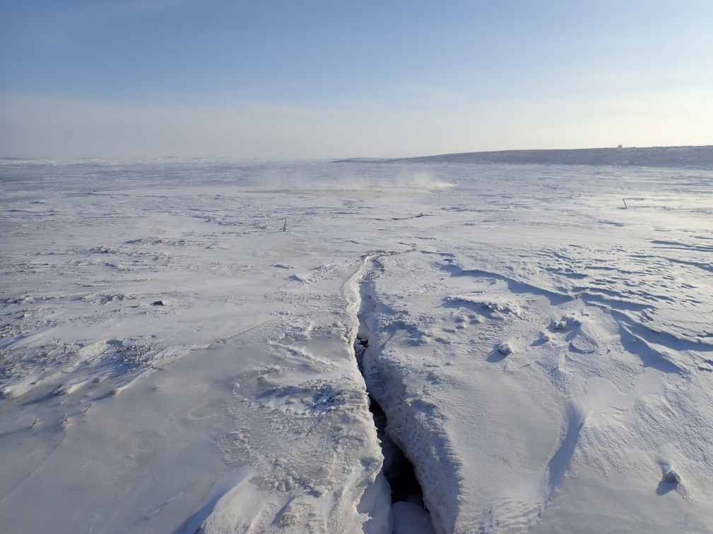
Picture 1: Channel formed by release water flowing through ice into Meliadine Lake.
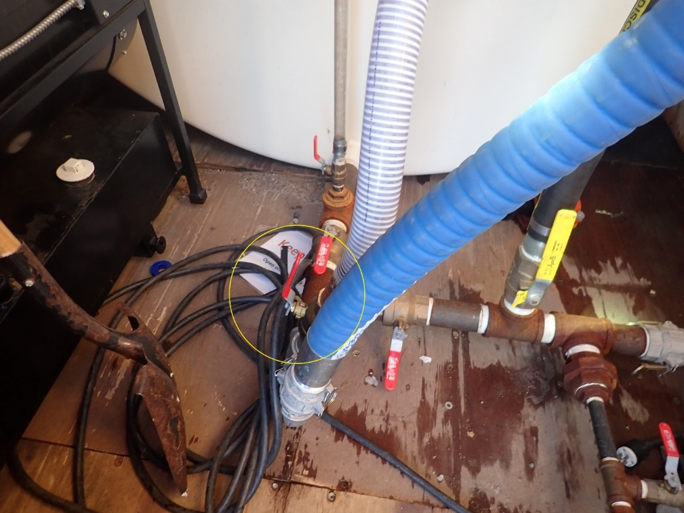
Picture 2: Release valve left open causing the spill.

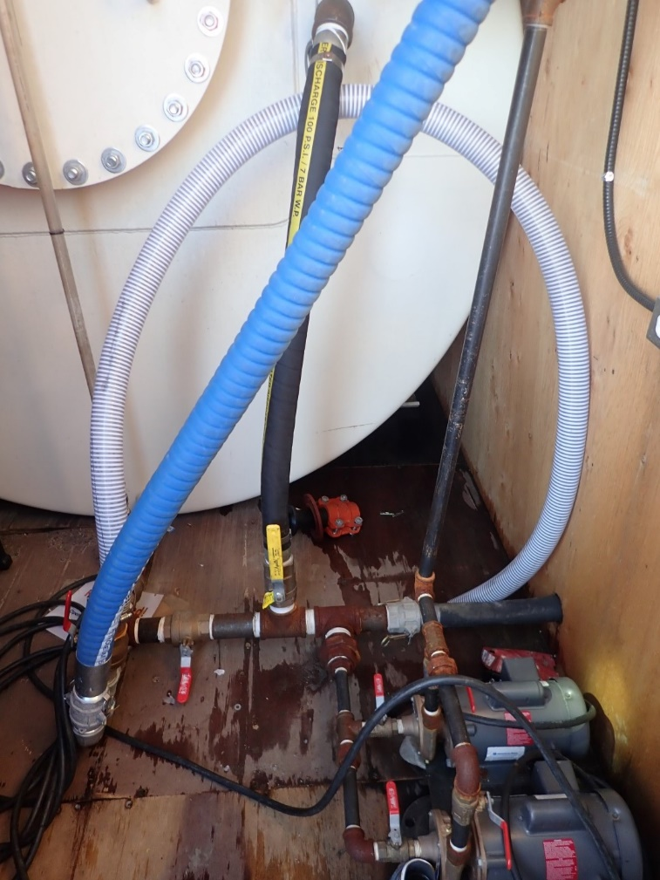
Picture 3: Discharge hose connected to retention tank release valve.
Samples were collected from the STP release valve on February 2nd, shortly after the release occurred. The samples did not arrive at the laboratory within the recommended 24 hours timeframe for fecal coliform analysis. The delay was due to the delivery not being picked up at the airport by the receiving party. Total coliforms were expressed in MPN as opposed to CFU, which are the recommended units in the water license. Although these are not the preferred units, they can be converted.
Table 1: Laboratory analysis of retention tank treated water samples collected at spill site.
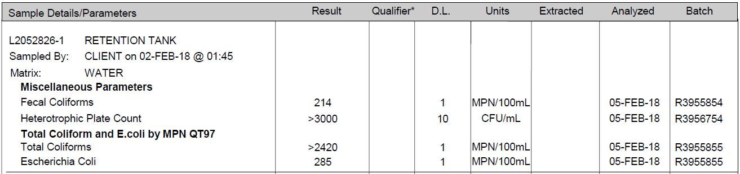
Table 2: Laboratory analysis of retention tank treated water in months leading up to the event.
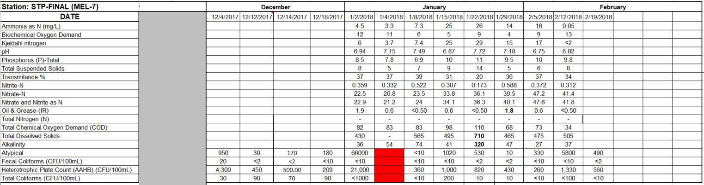
The sample collected from the retention tank discharge had 214 MPN/100mL fecals and 285 MPN/100mL E.coli.

Spill Discharge Location:
The MEL-07 effluent discharges to land at a location situated approximately 65 m from the ordinary high water mark of Meliadine Lake (see Figure 1). Once the effluent reaches the end of the pipe, it travels along a rock channel intended to reduce the flow and prevent erosion. The effluent will then follow the rock channel to Meliadine Lake. It is expected that with the extreme cold temperatures on February 2nd, and the fact that the effluent discharges to land first, the bacteria would likely not have survived.

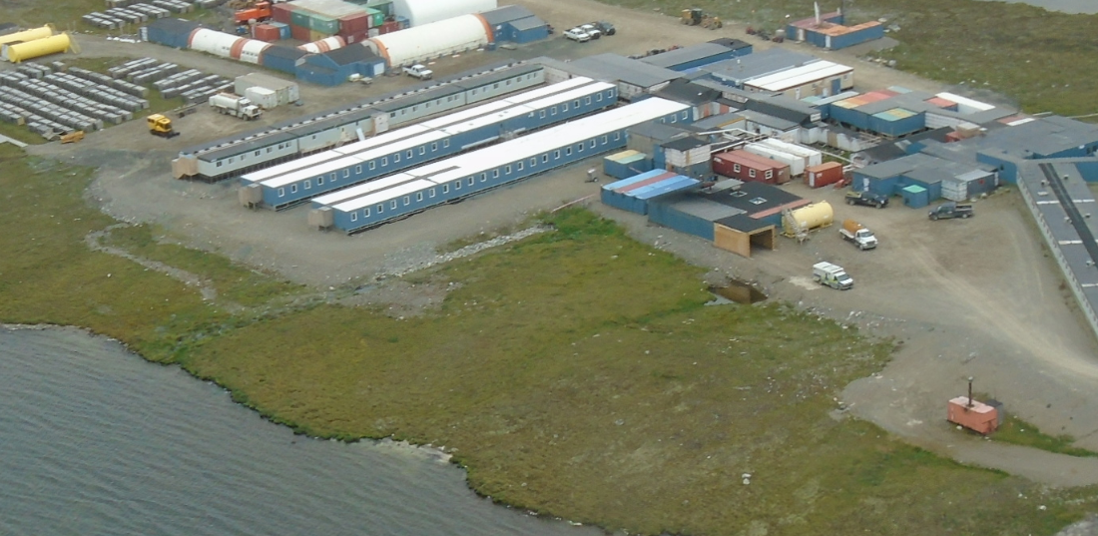
End of pipe MEL-07
Rock Channel
Figure 1: View from above - MEL-07 discharge configuration with rock channel and flow path to Meliadine Lake

Spill cause:
Investigation into the release was inconclusive. However, it is believed that a water truck operator failed to close the release valve after transferring water to a truck.

Spill response:
The release was deemed to be caused by human error. The release valve is now fitted with a locking mechanism. A supervisor now keeps a register to record which operator is in possession of the key.

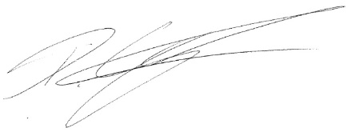
Dan Gorton, Environmental Coordinator, AEM

