2BE-MLL1217 / Renewal ApplicationNWB2MEL01--
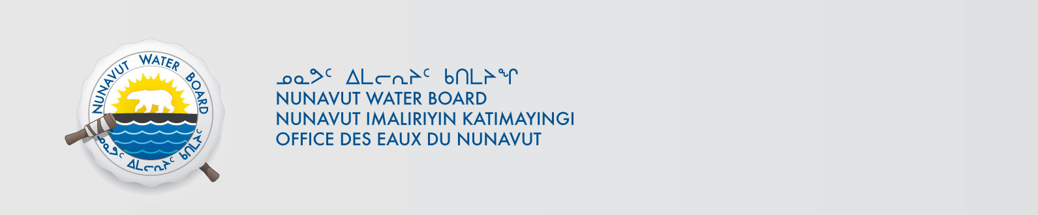
March 31, 2017
Merle Keefe
Environmental Engineer
Sabina Gold & Silver Corporation
Suite 375 555 Burrard Street, Box 220
Vancouver, BC V7X 1M7
E-mail: mkeefe@sabinagoldsilver.com

Subject: Sabina Gold & Silver Corporation – WMC International Limited Wishbone-Malley Project – Renewal– Type “B”, Kitikmeot Region

Dear Mr. Keefe:

The Nunavut Water Board (NWB) provides notice that, on February 17, 2017, a renewal an application for a licence renewalapplication for a Type “B” water license January 5, 2001for water use and/or waste disposal associated with exploratory drillingactivities in the Kitikmeot region of Nunavut was filed by Sabina Gold & Silver Corporation. By way of this correspondence, the Board invites parties to provide the NWB with their comments with respect to the application as outlined below. The application consists of the following documents:
- Application for Water Licence Cover Letter Renewal Received February 17, 2017
- Attachment 1 Application for Water Licence Received February 17, 2017
- Attachment 2 Location Map Received February 17, 2017
- Attachment 3 NPC Email Regarding Conformity December 8, 2011 Received February 17, 2017
- Attachment 4 NIRB August 5, 2010 Exemption Letter Files Received February 17, 2017
- Attachment 5 INAC Land Use Permit Inspection Report Received February 17, 2017
- Attachment 6 Non-Technical Summaries English, Inuktitut, Inuinnaqtun Received February 17, 2017
- Attachment 7 Certificate of Good Standing Received February 17, 2017
- Attachment 8 A& R Plan Received January 31, 2017
- Attachment 9 Comprehensive Spill Contingency Plan Received February 17, 2017
- Attachment 10 Comprehensive Waste Management Plan Received February 17, 2017
- Attachment 11 Comprehensive Hazardous Materials Management Plan Received February 17, 2017
- Land Use Permit N2012C0003 Extension Approval Received February 17, 2017

The application can be obtained from our ftp site at the following link:
ftp://ftp.nwb-oen.ca/registry/2%20MINING%20MILLING/2B/2BE%20-%20Exploration/2BE-MLL1217%20Sabina/
As noted in the NWB’s earlier correspondence, under the Agreement Between the Inuit of the Nunavut Settlement Area and Her Majesty the Queen in Right of Canada (Nunavut Agreement) Article 11, Section 11.5.9 and s. 76 (1) of Nunavut Planning and Project Assessment Act (NuPPAA), the proponent of a project proposal governed by the Nunavut Agreement and NuPPAA that requires a water licence is required to submit a project proposal document (which may include the water licence application) directly to the Nunavut Planning Commission (NPC or Commission). The NPC then reviews the project proposal and makes a determination regarding the applicable land use planning requirements and/or provides direction regarding whether the project proposal is subject to screening by the Nunavut Impact Review Board (NIRB). Under Articles 11, 12 and 13 of the Nunavut Agreement, NuPPAA and Part 3 of the Nunavut Waters and Nunavut Surface Rights Tribunal Act (NWNSRTA), until the project proposal has concluded the applicable land use planning and assessment process required by the NPC and the NIRB, the NWB cannot issue a water licence.
On this basis, the NWB, while previously acknowledging the receipt of the application, waited for the Commission’s determination and recommendations before proceeding to the next steps in the NWB’s processing of the application. Please be advised that on March 22, 2017 the NWB received the required determinations and recommendations from the Commission.

Now that the application has concluded the pre-licensing steps required under the Nunavut Agreement, NuPPAA and the NWNSRTA, the NWB is proceeding to the next steps in processing the application, including providing the attached Notice of Application which will be published in due course. In addition, to ensure this application is dealt with in a timely fashion, the NWB has forwarded notice of all documentation received by the NWB in respect of the application to regulators and Council of the Municipality(ies) most affected by the project. The NWB is also inviting interested parties to make representations about the application, including information requests, identifying issues of water user compensation and providing technical review comments directly to the NWB within twenty-four (24) days from the date of this letter; on or before April 24, 2017 at licensing@nwb-oen.ca.

After the NWB receives and reviews the comments received, the Board may provide additional procedural instructions regarding the next steps in the Board’s processing of the application. Please note that throughout the Board’s consideration of the application, the NWB retains the right to request additional information and studies, as set out under ss. 48(1)-(3) of the NWNSRTA. If additional information will be requested, the NWB’s technical staff will contact the applicant to discuss the Board’s request in detail.

If the applicant or parties have questions regarding technical matters, please contact directly Sean Joseph, the Technical Advisor for the file, at 604-321 8185 or by email to sean.jospeh@nwb-oen.ca.

Sincerely,

Ida Porter
Licence Administrator

Enclosure: Notice of Application

Cc: Distribution List – Kitikmeot

