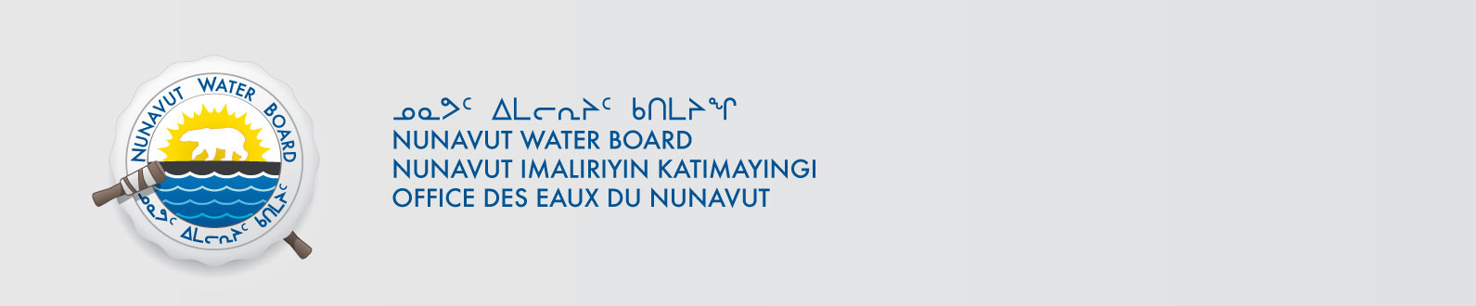

April 23, 2013 NWB File No: 2BE-MOU0914

Mr. Bogdan Nitescu, PhD
Geologist & Geophysicist
Hornby Bay Mineral Exploration Ltd.
Suite 1010, 130 Adelaide St. West
Toronto, ON M5H 2P5
E-mail: bnitescu@hornbybay.com

Re: Acknowledgement and Receipt of Water Use Fees for Water Licence Application –
2BE-MOU0914

Dear Mr. Nitescu:

The Nunavut Water Board acknowledges receipt on March 20, 2013 of your water use fees, cheque number 004033, for the above project. Your payment has been forwarded to Aboriginal Affairs and Northern Development Canada in Iqaluit for processing. A receipt will be issued through their office for fees totaling $237.25 for water use fees.

Please refer to the calculation for water use fees, in the Northwest Territories Waters Regulations, Section 9, to ensure that the correct fee has been submitted. A copy of this regulation is available from our ftp site or by contacting this office. This is an annual fee which is required to be submitted yearly on the anniversary of the issuance of your water licence.

Please call the undersigned at (867) 360-6338 or e-mail licensing@nunavutwaterboard.org if you have any questions.

Sincerely,

Original signed by:

Phyllis Beaulieu
Manager Licensing

Cc: Ian Parsons, AANDC
Jean Allen, AANDC
Rory MacDonald, AANDC

