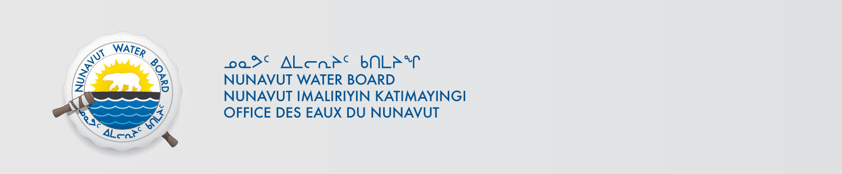

October 18, 2017 NWB File No: 2BE-PET1114

Glen Dickson Alan Sexton
Meliadine Gold Corp. GeoVector Management Inc.
1500-885 West Georgia Street 312-10 Green Street
Vancouver BC V6C 3E8 Nepean ON K2J 3Z6
E-mail: gdickson@goldore.ca E-mail: info@geovector.ca

Subject: Final Inspection – Cancellation of Licence and Closure of 2BE-PET1114

On June 9, 2017 the Nunavut Water Board (NWB) received a final water inspection report from Indigenous and Northern Affairs Canada (INAC) covering the above noted file. The report indicates there are no outstanding reclamation issues associated with the project. Further, there are no outstanding NWB administrative matters that require attention.

In accordance with section 43.(i)(c) of the Nunavut Waters and Nunavut Surface Rights Tribunal Act (NWNSRTA), the Board may cancel a licence in certain specific cases.

The NWB hereby notifies all parties that the aforementioned licence is now cancelled and that the corresponding NWB file is now considered closed. Any future relevant activities on this site will require a new Water Licence or Approval Without a Licence.

Sincerely,

Richard Dwyer

Cc: Kivalliq Distribution List

