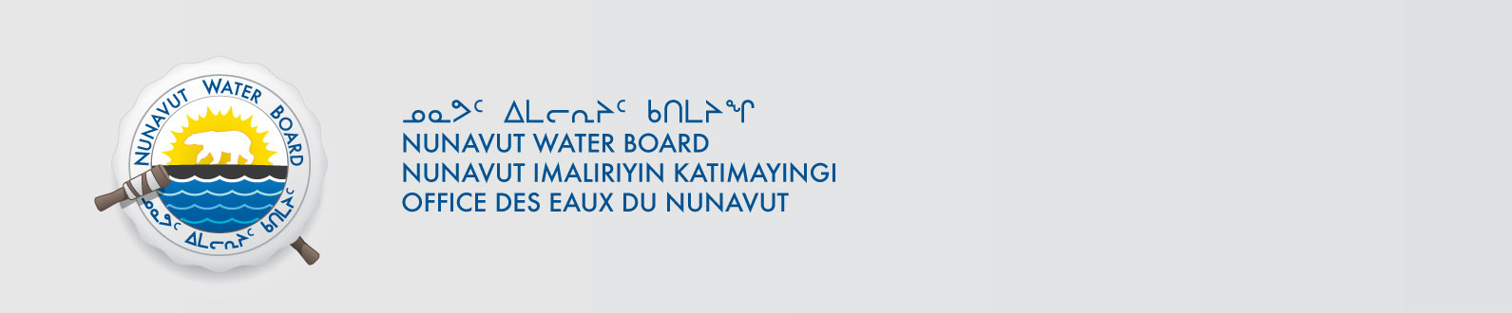

July 18, 2017 NWB File No: 2BE-QIL1217

Michael MacMorran
North Arrow Minerals Inc.
Suite #960-789 West Pender Street
Vancouver BC V6C 1H2
E-mail: mmacmorran@northarrowminerals.com

Subject: Renewal Application Naujaat Project

Dear Mr. MacMorran:

The Nunavut Water Board (“NWB”) acknowledges receipt on April 11, 2017 of your renewal water licence application, for the Naujaat Project. This application has been assigned file number 2BE-QIL1217; please refer to this number on future submissions. Application documents received are as follows:

- 170411 2BE-QIL1217 148542 - LUP - Renewal - No Conformity or Screening Required
- 170411 2BE-QIL1217 Mel Project_2016 Project Summary_ENGLISH
- 170411 2BE-QIL1217 Mel Project_2016 Project Summary_INUKTITUT
- 170411 2BE-QIL1217 Naujaat 2017 Drilling_Abandonment and Restoration Plan
- 170411 2BE-QIL1217 Naujaat 2017 Drilling_Spill Contingency Plan
- 170411 2BE-QIL1217 North Arrow Minerals Financial Statements January2017
- 170411 2BE-QIL1217 North Arrow Minerals Renewal Application

Please be advised that under the Agreement Between the Inuit of the Nunavut Settlement Area and Her Majesty the Queen in Right of Canada (Nunavut Agreement) Article 11, Section 11.5.9 and s. 76 (1) of Nunavut Planning and Project Assessment Act (NuPPAA), the proponent of a project governed by NuPPAA is also required to submit a project proposal document (which may include the water licence application) directly to the Nunavut Planning Commission (NPC or Commission) for the NPC’s determination regarding the applicable land use planning requirements and/or directions regarding whether the project is subject to screening by the Nunavut Impact Review Board. In particular, please note that as established under Articles 11, 12 and 13 of the Nunavut Agreement, NuPPAA and Part 3 of the Nunavut Waters and Nunavut Surface Rights Tribunal Act, until the project has completed the applicable land use planning and assessment process required by the NPC and the NIRB, the NWB cannot issue a water licence.

The NWB confirms receipt of NPC conformity under NuPPAA on April 11, 2017 and NIRB determination through NPC under NuPPAA on April 11, 2017. This application is now ready for review and comments. Deadline for submissions is August 18, 2017.

Please call the undersigned at (867) 360-6338 or email to licensing@nwb-oen.ca if you have any questions.

Sincerely,

Richard Dwyer
Licensing Administrator

Cc: Kivalliq Distribution List

