NWB File No: 2BE-QIL1722
April 19, 2018

Michael MacMorran
North Arrow Minerals Inc.
Suite #960-789 West Pender Street
Vancouver BC V6C 1H2
E-mail: mmacmorran@northarrowminerals.com

Re: Receipt of Water Use Fee 2BE-QIL1722 Naujaat Project

Dear Mr. MacMorran:

The Nunavut Water Board acknowledges receipt of your credit card information for water use fees for the above project. Your information for payment has been forwarded to Indigenous and Northern Affairs Canada in Iqaluit for processing. A receipt will be issued through their office for fees totaling $511.00:

- 2BE-QIL1217 2017-2018 $146.00
- 2BE-QIL1722 2018-2019 $365.00

Please refer to the calculation for water use fees, in the Nunavut Waters Regulations, Section 12, to ensure that the correct fee has been submitted. A copy of this regulation is available from our ftp site or by contacting this office. This is an annual fee which is required to be submitted yearly on the anniversary of the issuance of your water licence.

Please call the undersigned at (867) 360-6338 or e-mail licensing@nwb-oen-ca if you have any questions.

Sincerely,

Richard Dwyer
Manager Licensing

Cc: Sarah Forté, INAC

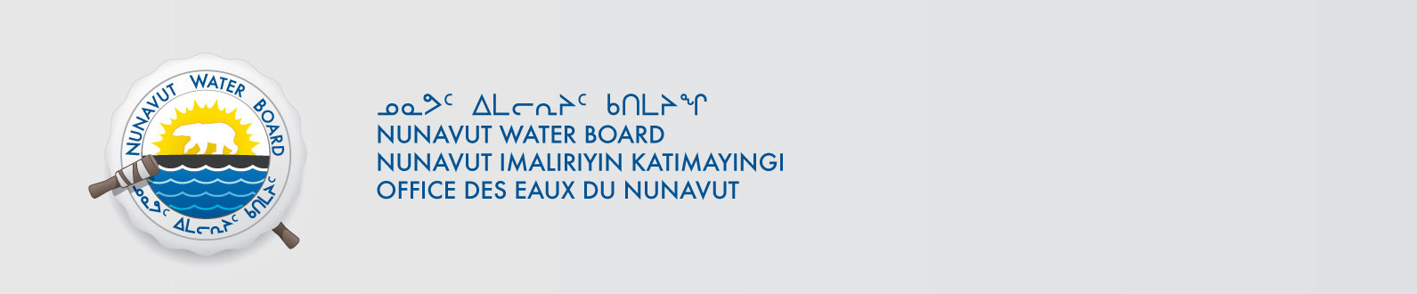
Alice Pallister, INAC

