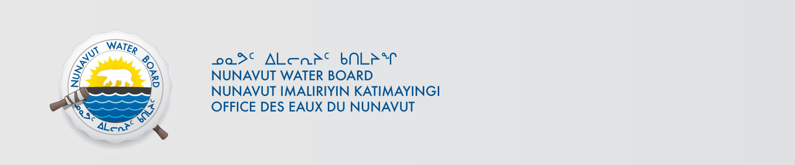

January 24, 2020 NWB File No: 2BE-REP0507

BHP Group Limited
171 Collins Street
Melbourne Victoria 3000
Fax: (61 3) 9609 3015

Subject: Final Inspection – Cancellation of Licence and Closure of 2BE-REP0507

On November 26, 2014 the Nunavut Water Board (NWB) received a final water inspection report from Crown Indigenous Relations and Northern Affairs Canada (CIRNAC) covering the above noted file. The report indicates there are no outstanding reclamation issues associated with the project. Further, there are no outstanding NWB administrative matters that require attention.

In accordance with section 43.(i)(c) of the Nunavut Waters and Nunavut Surface Rights Tribunal Act (NWNSRTA), the Board may cancel a licence in certain specific cases.

The NWB hereby notifies all parties that the aforementioned licence is now cancelled and that the corresponding NWB file is now considered closed. Any future relevant activities on this site will require a new Water Licence or Approval Without a Licence.

Sincerely,

Richard Dwyer
Manager Licensing

Cc: Kivalliq Distribution List
CIRNAC Enforcement

