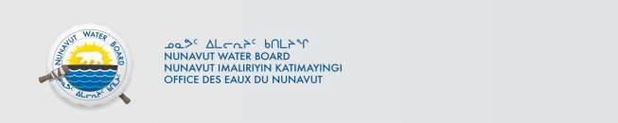

January 22 2025 NWB File No: 2BE-SKG2329

Dave White
Aurora Geosciences Ltd. 3506 McDonald Drive Yellowknife NT X1A 2H1
E-mail: dave.white@aurorageosciences.com
Agha Shahzad Perves
Viridis Minerals and Mining Inc. 2900-550 Burrard Street Vancouver BC V6C 0A3
E-mail: agha@viridismining.com.au

Re: Acknowledgement and Receipt of Water Use Fee – Viridis Minerals and Mining Inc.South Kitikmeot Gold Project

Dear Dave White:

The Nunavut Water Board acknowledges receipt on January 20, 2025 of cheque number 010387, for the above project, as payment for:

- 2023 Water Use Fee $123.30
- 2024 Water Use Fee $1061.25

Your payment has been forwarded to Crown Indigenous Relations and Northern Affairs Canada in Iqaluit for processing. A receipt will be issued through their office for fees totaling $1184.55.

Please call the undersigned at (867) 360-6338 or e-mail licensing@nwb-oen.ca if you have any questions.

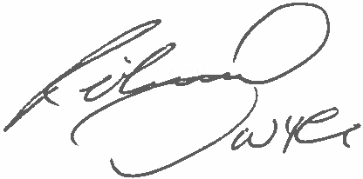
Sincerely,
Richard Dwyer

Copy Andrew Keim, CIRNAC Margaret Mike, CIRNAC CIRNAC Inspectors

