NWB File No: 2BE-STO2025
March 18, 2019

Thomas Ullrich  Aston Bay Holdings Inc.  303-80 Richmond St. W  Toronto, ON M5H 2A4  thomas.ullrich@astonbayholdings.com | Tara Gunson  Apex Geoscience Ltd.  100-11450 160 St NW  Edmonton, AB T5M 3Y7  E-mail: tgunson@apexgeoscience.com

Re: Acknowledgement and Receipt of Water Use Fee– Aston Bay Property - Qikiqtani

Dear Ms. Gunson:

The Nunavut Water Board acknowledges receipt November 27, 2024 of your credit card information for water use fees for the above project. Your information for payment has been forwarded to Crown Indigenous Relations and Northern Affairs Canada in Iqaluit for processing. A receipt will be issued through their office for fees totaling $1091.35:

2024 Water Use Fee $1091.35

Please refer to the calculation for water use fees, in the Nunavut Waters Regulations, Section 12, to ensure that the correct fee has been submitted. A copy of this regulation is available from our ftp site or by contacting this office. This is an annual fee which is required to be submitted yearly on the anniversary of the issuance of your water licence.

Please call the undersigned at (867) 360-6338 or e-mail licensing@nwb-oen-ca if you have any questions.

Sincerely,

Richard Dwyer
Manager Licensing

Cc: Margaret Mike CIRNAC

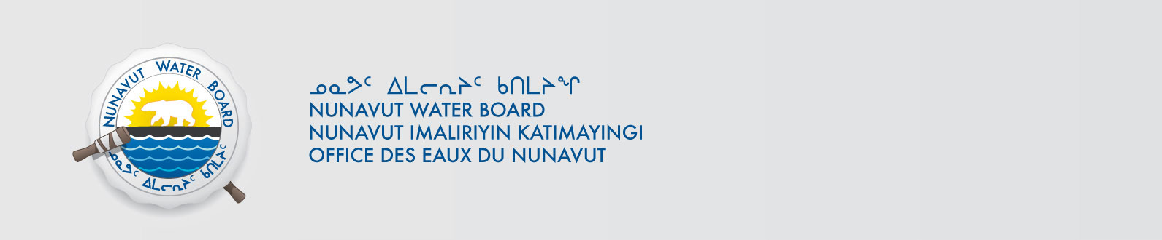
Andrew Keim CIRNAC

CIRNAC Inspectors

